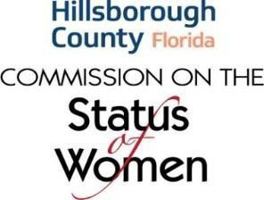

Tuesday, May 28, 2024, In-Person Meeting
8:00 a.m. - 10:00 a.m.

A G E N D A

- Welcome

- Public Comment

- Metropolitan Ministries: Natalie Melillo, Director of Corporate Partnerships (tentative)

- Review & Approval of Meeting Recap – April 23, 2024

- Chair’s Report (Lee Lowry)

- Friends of the COSW Financial Report (Johanne Castagan)

- 2024 YEA! Award

- Commission on Human Trafficking

- Old Business

- New Business

- Adjourn

Next Regular COSW Meeting:
June 25, 2024
Location – Fred Karl County Center, 26th floor Rm. A

