UNINCORPORATED HILLSBOROUGH COUNTY ONLY

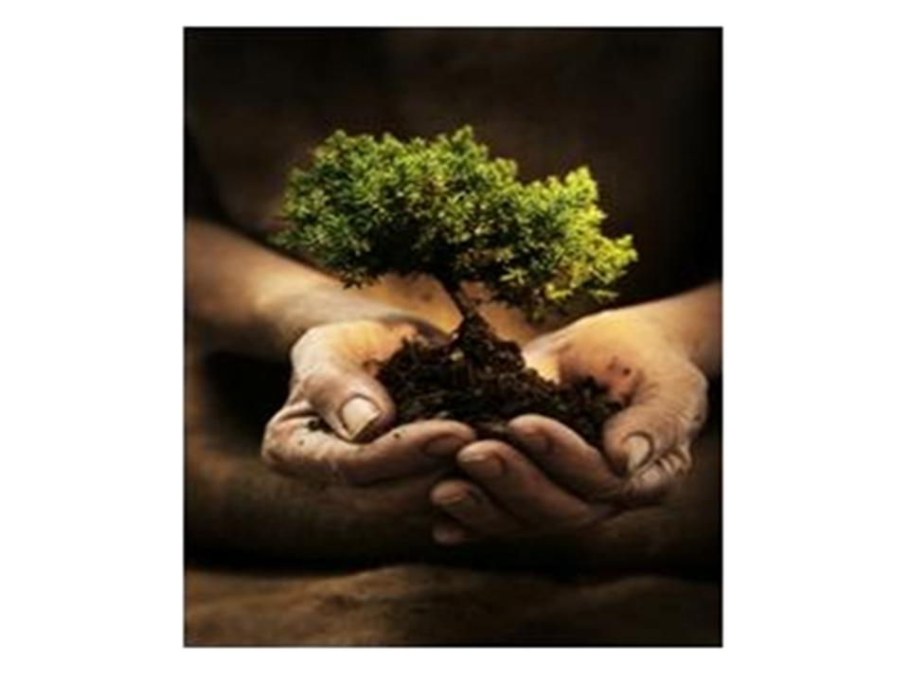

Hillsborough County

Neighborhood Tree Program

Mini-grant Application

AVAILABLE FUNDING
The Hillsborough County Board of County Commissioners (BOCC) announces the availability of grant funds from the Environmental Restoration Fund for neighborhood tree planting projects. This is a matching grant program, being administered through Neighborhood Relations in collaboration with the Transportation and Land Development Review Division of the Planning and Growth Management Department and the Cooperative Extension Services. This grant is only for associations in Unincorporated Hillsborough County. Applications will be accepted on a continuous basis and evaluated for eligibility and allocation as received until available funds have been depleted. If you need additional space, feel free to attach a maximum of three subsequent pages. Applications and supporting material must be submitted on 8½ x 11 white paper. Submit one copy of the grant application and supporting material. You may send the application by email or fax. Applicants may receive funding under this program only once every two (2) years. The maximum individual award will be $2,500 per association.

PROGRAM PURPOSE
The purpose of this matching grant program is to encourage the planting of trees within public or private common areas exposed to the community population. The Board of County Commissioners recognizes that the planting of trees proves invaluable to the overall welfare of our communities. Trees provide numerous environmental benefits such as oxygen production, air pollution control, noise abatement, rainfall dispersion to control flooding and aesthetic and wildlife enhancement. For these reasons and many more valuable attributes, this program encourages the planting of trees in community-maintained areas and road rights of way within or adjacent to the neighborhood.

ENTITIES ELIGIBLE TO APPLY
Neighborhood, Civic, Homeowner Associations, Community Development Corporations and Special Taxing Districts located in Unincorporated Hillsborough County are eligible to apply for funding.
Homeowner Associations must be released from their developer.

PROJECTS FOR CONSIDERATION

Neighborhood leaders are invited to propose projects that will add trees in community-maintained areas and/or road rights of way within or adjacent to the neighborhood. This area could be either community-owned or county owned and community-maintained. Proof of ownership and/or county maintenance agreements must be attached.

OTHER REQUIREMENTS AND CONSIDERATIONS
- A water source for the new plantings must be available.

- A maximum of 50% of the Tree Program Mini-Grant monies may be spent on drought tolerant shrubbery.

- Applicants are required to provide a minimum match of 50% of the funds requested, either as cash or in-kind services.

- Match above 50% is encouraged.

- Applicants are required to involve residents to provide volunteer manpower in the planting, care and maintenance of the trees.

- Type and size of plantings is required for County Forester approval. The applicant is not required to get this approval before applying; Neighborhood Relations staff will arrange for the review upon receipt of the application.

- Consideration will be given to including native vegetation and shrubbery as compliments to trees to prevent run-off and retain moisture.

- Cypress mulch will not be an allowable expense, for conservation reasons. Other types of mulch are allowable.

- All plantings must account for required vehicular clearance recovery and unobstructed vehicle lines of sight.

- Any permits necessary for the project are the responsibility of the association.

- Awardees are encouraged to utilize agriculture programs in the public schools as a potential source for trees.

- Awardees will be required to sign a maintenance agreement with the County, agreeing to water, fertilize, prune and provide other care to ensure the survival to the trees and shrubbery that are planted through this program.

- Awardees will be required to submit a report, including before and after photographs, and an inventory of tree and other plantings with a description of their condition to Neighborhood Relations on completion of the plantings, and annually thereafter for two years. Tree survival success and the transmittal of required monitoring reports for the awarded grant will be considered when determining eligibility for subsequent mini-grant application requests. Monitoring report forms will be provided upon project approval.

- Neighborhood Relations encourages applicants to combine this project with installation of micro-irrigation through the Low Volume Irrigation Mini-grant Program.

- Road right of way plantings will require technical review and the issuance of a Right of Way Use Permit by Public Works Department. A copy of the Permit must be provided at the signing of the Letter of Understanding.

- A specific area that the applicant represents must be identified and evidence of local resident involvement and concurrence will be required.

PROJECTS NOT QUALIFIED

Some examples of the types of projects/budget items that do NOT qualify for funding are listed below:

- Projects proposed to remove or move currently planted trees.
- Projects proposed to purchase palms.
- Projects proposed to be completed on private property, subsequently benefiting an individual property owner.
- Projects begun prior to Board of County Commissioners approval.
- Projects presented without evidence of association Board of Directors (Trustee) approval.

PROGRAM PROCEDURES
- A Letter of Understanding between the applicant and the Neighborhood Relations must be executed before any costs can be incurred which will be paid for by this grant.

- Documentation of plan approval by the County Forester will be required before any payment will be authorized. Neighborhood Relations Staff will coordinate plan approval with the County Forester.

- Association is responsible for any necessary permits.

- Payment options are:
Reimbursement by the County for association expenditures
Issuance of a Purchase Order to a vendor
Payment to a vendor with a County Purchasing Card

- Before and after photos, a report, and an inventory of the tree and other plantings, with documentation of their condition will be required to be submitted to the Office of Neighborhood Relations by the applicant upon completion of the project, and annually for two years after that.

APPROPRIATE TREES
- The size of the trees must be appropriate to the proposed location. The trees must be chosen from the following list of trees. Only 50% of the Tree Program Mini-Grant awarded monies may be spent on shrubs (hedge material). Palms will not be covered under this grant.

Shade Trees: These trees generally obtain a mature height of 25-75 feet.
Common Name | Botanical Name | Characteristics
Ash, green | Fraximus Pennsylvanica | N D
Elm, American | Ulmus Americana | N D
Elm, winged | Ulmus alata | N D
Hickory, pignut | Carya glabra | N D
Maple, Florida | Acer barbatum | N
Maple, red | Acer rubrum | N F D
Magnolia, southern | Magnolia grandiflora | N F E
Oak, laurel | Quercus laurifolia | N D
Oak, live | Quercus virginiana | N E
Oak, sand live | Quercus geminata | N E
Oak, post | Quercus stellata | N E
Oak, shumard | Quercus shumardii | N D
Oak, turkey | Quercus laevis | N D
Pine, longleaf | Pinus palustris | N E
Pine, sand | Pinus clausa | N E
Pine, Slash | Pinus elliottii | N E
Sugarberry | Celtis laevigata | N D
Sweetgum | Liquidambar styraciflua | N D
Sycamore | Platanus occidentalis | N D
N – Native F – Flowering E – Evergreen D – Deciduous

Ornamental Trees: These trees generally obtain a mature height of 15-25 feet.

Common Name | Botanical Name | Characteristics
Acacia | Acacia sp. | F E
Bottlebrush | Callistemon viminalis | F E
Chickasaw plum | Prunus angustifolia | N F D
Crape myrtle | Lagerstroemia indica | F D
Elm, drake | Ulmus parvifolia | D
Flowering dogwood | Cornus florida | N F D
Fringe tree | Chionanthus virginicus | N F D
Holly, American | Ilex opaca | N F E
Holly, dahoon | Ilex cassine | N F E
Holly, East Palatka | Ilex attenuata | N F E
Holly, yaupon | Ilex vomitoria | N F E
Jerusalem thorn | Parkinsonia aculeate | F E
Loblolly bay | Gordonia lasianthus | N F E
Loquat | Eriobotrya japonica | F E
Ligustrum (tree form) | Ligustrum lucidum | F E
Oak, myrtle | Quercus myrtifolia | N E
Podocarpus | Podocarpus macrophyllus | E
Red cedar | Juniperus silicicola | N E
Redbud | Cercis Canadensis | N F
River birch | Betula nigra | N D
Sparkleberry | Vaccinium arboretum | N F E
Summer haw | Crataegus flava | N D
Wax myrtle | Myrica cerifera | N E
Weeping willow | Salix babyloncia | D
N – Native F – Flowering E – Evergreen D – Deciduous

Street Trees
Common Name | Botanical Name
Blackgum | Nyssa sylvatica
Cypress, bald | Taxodium distichum
Cypress, pond | Taxodium ascendens
Elm, winged | Ulmus alata
Magnolia, southern | Magnolia grandiflora
Maple, Florida | Acer barbatum
Maple, red | Acer rubrum
Oak, laurel | Quercus laurifolia
Oak, live | Quercus virginiana
Oak, shummard | Quercus shummardii
Podocarpus | Podocarpus macrophyllus
River birch | Betula nigra

Screening Trees

Common Name | Botanical Name
Loblolly bay | Gordonia lasianthus
Magnolia, southern | Magnolia grandiflora
Oak, laurel | Quercus laurifolia
Oak, live | Quercus virginiana
Oak, sand live | Quercus geminata
Pine, longleaf | Pinus palustris
Pine, sand | Pinus clausa
Pine, slash | Pinus elliottii
Red cedar | Juniperus silicicola
Redbay | Persea borbonia
Sweetbay | Magnolia virginiana

Hedge Material: Only 50% of the Tree Program Mini-Grant monies may be spent on hedge material.
Common Name | Botanical Name | Characteristics
Walter viburnum | Viburnum obovatum | DT N F
Coffeeberry | Rhamus californi | DT
Coontie | Zamia pumila | DT N
Dwarf yaupon holly | Ilex vomitoria “Nana” | DT N
Fakahatchee grass | Tripsacum dactyliodes | DT N
Florida anise | Illicum floridanum | DT N
Gallberry | Ilex glabra | N
Indian hawthorn | Raphiolepis indica | DT F
Marsh grass | Spartina bakeri | DT N F
Muhly grass | Muhlenbergia capillaries | DT N F
Pittosporum | Pittosporum tobira | DT F
Rain of gold | Galphimia glauca | DT F
Red fountain grass | Pennisetum sp. | DT
Sandankwa viburnum | Viburnum suspensum | DT N
Sea oats | Uniola paniculata | DT N
Silverleaf | Leucophyllum dactyloides | DT N
Silverthorn | Elaeagnus pungens | DT F
Sirnpson's stopper | Myrcianthes fragrans | DT N F
Sweetshrub | Calycanthus floridus | DT F
Texas sage | Leucophyllum frutescens | DT F
DT – Drought Tolerant N – Native F - Flowering

INSTRUCTIONS

Please submit the application pages that follow. Read each question carefully and respond in the spaces provided. Contact the Office of Neighborhood Relations (813) 272-5860 if you have any questions.

A. ORGANIZATION INFORMATION

- Organization Name: __________________________________________________________

a) Type of Organization __ Neighborhood, Community, Civic or Homeowners Association
__ Special Tax District
__ Community Development Corporation

- Has the organization named above been legally incorporated in the State of Florida? __Yes __ No
(This is not a requirement for funding but may influence implementation process options.)

- If yes, what is its Federal Tax Identification Number? ___ ___ - ___ ___ ___ ___ ___ ___ ___
Address: __________________________________________________________________________
City/Zip Code: ______________________________________________________________________

2. President/Chairperson’s Name:______________________________________________________
Address: __________________________________________________________________________
City/Zip Code: ______________________________________________________________________
Phone: ____________________________________________________________________________
(Home) (Work) (Fax)
E-mail address: (if applicable) _________________________________________________________
3. Additional Contact Person Name & Title: _______________________________________________
Address: __________________________________________________________________________
City/Zip Code: ______________________________________________________________________
Phone: ____________________________________________________________________________
(Home) (Work) (Fax)
E-mail address: (if applicable) _________________________________________________________
4. Management Company Name, if applicable: ____________________________________________
Property Manager’s Name: ____________________________________________________________
Address: __________________________________________________________________________
City/Zip Code: ______________________________________________________________________
Phone: __________________ Fax: _________________ E-mail:______________________________
5. Lawn Maintenance/Landscape Company, if applicable: ___________________________________
Contact Name: _____________________________________________________________________
Address: __________________________________________________________________________
City/Zip Code: ______________________________________________________________________
Phone: __________________ Fax: _________________ E-mail:______________________________
6. Neighborhood/Subdivision Location and Boundaries Location_____________________________
North boundary: ____________________________South boundary: ___________________________
East boundary: ______________________________West boundary: __________________________
General location (e.g., Brandon, Lutz, Ruskin): ____________________________________________
County Commission District: ___________ (http://arcgis-ext.hillsboroughcounty.org/fmr/)
B. PROPOSED PROJECT INFORMATION

1. Project Summary: Describe the project area where the trees will be planted. Please include an
inventory of current trees and plants in the area. Attach a diagram that shows the location of the area within the development, and a diagram of where you plan to plant the trees obtained through this grant. Indicate the type and approximate size of intended plantings. Type and size of plantings is required for County Forester approval. The applicant is not required to get this approval before applying; Neighborhood Relations staff will arrange for the review upon receipt of the application.

Project Location (check one): Association Owned Common Area _______
County Right of Way _______
Other _______
________________________________________________________________________________________________________________________________________________________________________________________________________________________________________________________________________________________________________________________________________________________________________________________________________________________________________________________________________________________________________________________________________________________________________________________________________________________________________________________________________________________________

2. Maintenance Plan: Describe your maintenance plan.

__________________________________________________________________________________________
__________________________________________________________________________________________
__________________________________________________________________________________________
__________________________________________________________________________________________

3. Neighborhood Demographics: Describe the make-up of your neighborhood, including the number of
homes, % single-family dwellings, etc.
_________________________________________________________________________________________________________________________________________________________________________________________________________________________________

- Board Authorization and Community Notification: Describe the process used to obtain Board of
Directors (Trustee) authorization and efforts to advise and seek input from residents in your community. (newsletter articles, door-to-door flyers, survey, etc.)
________________________________________________________________________________________________________________________________________________________________________________________________________________________________________________________________________________________________________________________________________________________________________________________________________________________________________________________________________________________________________________________________________________________________________________________________________________________

- Additional sources of funding: Describe other sources of funds (e.g. association dues collected)
available to you? If so, what kind and how much will be contributed?
_________________________________________________________________________________________________________________________________________________________________________________________________________________________________

6. Volunteer Labor: Indicate whether or not you will use volunteer labor, and if so, how many hours are you committing?

__________________________________________________________________________

7. Prior Funding: Have you been funded by prior Hillsborough County Neighborhood Mini-Grant
cycles? Yes ___ No ____

If Yes, when? What was the nature of that project/program? Describe the outcomes of that project.
___________________________________________________________________________
___________________________________________________________________________
___________________________________________________________________________
___________________________________________________________________________

8. Water Source: A water source for new plantings must be available. Describe the source of water to be used (city/county, community well, reclaimed). The applicant association must agree in writing to water, fertilize, prune and otherwise maintain the trees planted with funds from this grant. Technical assistance on the proper way to plant and care for your new trees will be provided by County foresters.
___________________________________________________________________________
___________________________________________________________________________
___________________________________________________________________________

9. Conservation Program Marketing: Describe what type of outreach, marketing and community awareness your community would be willing to coordinate in conjunction with this program (i.e. host planting and care workshop within the community, door-to-door distribution of flyers, article(s) in neighborhood newsletter, and testimonials in the Neighborhood Connection). We want you to help us spread the word about this program.
___________________________________________________________________________
___________________________________________________________________________
___________________________________________________________________________
___________________________________________________________________________
___________________________________________________________________________

C. BUDGET

Tree Mini-grant $ Requested $____________________
Maximum: $2500.00
Proposed funding sources and expenditures - Please be sure to provide quotes or other documentation to explain each line item. Do not include sales tax in your calculations. Volunteer hours may be calculated at $18 per person per hour. Volunteers do not receive money for their work. The $18 per person per hour is only for budgeting proposes.

A maximum of 50% of the Tree Program Mini-Grant monies may be spent on shrubs (hedge material). Food and drink cannot be included in Mini-Grant Funds, but can be listed under Other Funding Sources.

Example of proposed budget:
DESCRIPTION OF BUDGET ITEMS | FUNDING SOURCES TO BE USED
DESCRIPTION OF BUDGET ITEMS | Mini-Grant  Funds | Other Funding Sources | Total
30 8’ Long Leaf Pines @ $100 each | $2,000.00 | $1,000.00 | $3,000.00
Mulch | $500.00 |  | $500.00
Volunteer Labor 45 hrs@$18/hr |  | $810.00 | $810.00
Total Budget: | $2,500.00 | $1,810.00 | $4,310.00

Proposed Expenditures
DESCRIPTION OF BUDGET ITEMS | FUNDING SOURCES TO BE USED
DESCRIPTION OF BUDGET ITEMS | Mini-Grant  Funds | Other Funding Sources | Total
Total Budget: | $ | $ | $

D. CERTIFICATION

I hereby certify that the above information is correct and represents the consensus of the residents in the area described. I further certify that I have read the requirements and instructions in this application package and understand and agree to them.

(Signature of President is required)

Name: _____________________________________Date: __________________________

E. APPLICATION SUBMISSION

Tree Grant Applications will be accepted on a continuous basis and evaluated for eligibility and allocation as received until available funds have been depleted. If you need additional space, feel free to attach a maximum of three subsequent pages. Applications and supporting material must be submitted on 8½ x 11 white paper. You may send the application by email or fax.

By mail to: Neighborhood Relations
601 E Kennedy Blvd, 28th Floor
Tampa, Florida 33602

By fax to: (813) 276-2621

Questions may be directed to Neighborhood Relations at (813) 272-5860.

