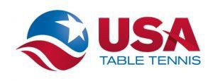Myrtle Beach
Table Tennis Tournament
June 1st, 2024
Williams-Brice Building
105 Independence Drive
Conway, SC 29528

SPONSORED BY

Myrtle Beach Table Tennis Club (MBTTC)

Chanticleer Table Tennis Club (CCTTC)
SANCTIONED BY USA Table Tennis as a Zero Star Tournament
Tournament Director and Umpire: Michael Fu Man Yip (CU)
ELIGIBILITY: Open to all members of the USATT. Non-members may join the USATT by including the membership fee with their entry fee. Players who are not current USATT members may buy a basic USATT Membership pass for $25.
DEADLINE: Monday May 27th, 2024. Entry fees must accompany the entry form (unpaid entries will be removed after reminder email). $5 charge for any entries received or paid for after May 27th, 2024. Refunds available until May 27, 2024 with a $10 processing fee (Administrative Fee of $5 will not be refunded). No refunds after entry deadline May 27th, 2024.
CONTACT: Michael Fu Man Yip by e-mail: michaelfumanyip@gmail.com

REGISTRATION: Register online @ omnipong.com. Do not enter without paying for events that are selected. Unpaid entries will be removed. No mail-in, in-person, or phone registration is available for this event without contacting tournament director for instructions.

Events | Max Entries | Time | 1st | 2nd | 3rd | 4th | Fee
U2100 | 32 | 9:00 AM | $100 | $50 | $25 | $10 | $25
U1800 | 32 | 3:00 PM | $100 | $50 | $25 | $10 | $25
U1500 | 32 | 11:00 AM | $100 | $50 | $25 | $10 | $25

Format: All events will start with round robin groups. Two (2) players from each group will advance to single elimination playoffs.
Ratings: Unrated players should submit an estimated rating and the source of the rating upon entering an event.
Matches: All games will be to 11 points, best of 5 games.

RULES: The Laws of Table Tennis as published by the ITTF and all USATT regulations will be enforced. EQUIPMENT: Only USATT approved equipment will be used: 8 Butterfly tables; white ★★★ Butterfly R40 Premium 40+ (plastic) balls; Wooden floor. NOTE: RACKETS: one side of the racket must be an ITTF approved
racket covering that is not black, the other side must be black.
CLOTHING: The USATT Dress Code applies. The main color of the body of the shirt or shorts may not be white. Please dress in appropriate athletic attire. Designs or lettering that are distracting to an opponent or are offensive will not be permitted. Socks and rubber-soled, non-marking, shoes must be worn.
REPORTING AND STARTING TIMES: Players must register at the desk at least 15 minutes before their events. Players not on time may be defaulted for the entire event (and replaced by an alternate) at the discretion of tournament director.

PRACTICE: The gym will be open for practice at 8:00 a.m.
UMPIRES: Umpire will be provided on request if available.
CANCELLATION: The committee reserves the right to cancel the tournament or modify the format and prize money based on entries received. All entrants will be refunded if the tournament is cancelled.
Location: Williams-Brice Building, 105 Independence Drive, Conway, SC 29528
Parking: Parking is at the center with overflow parking near the facility in the campus.
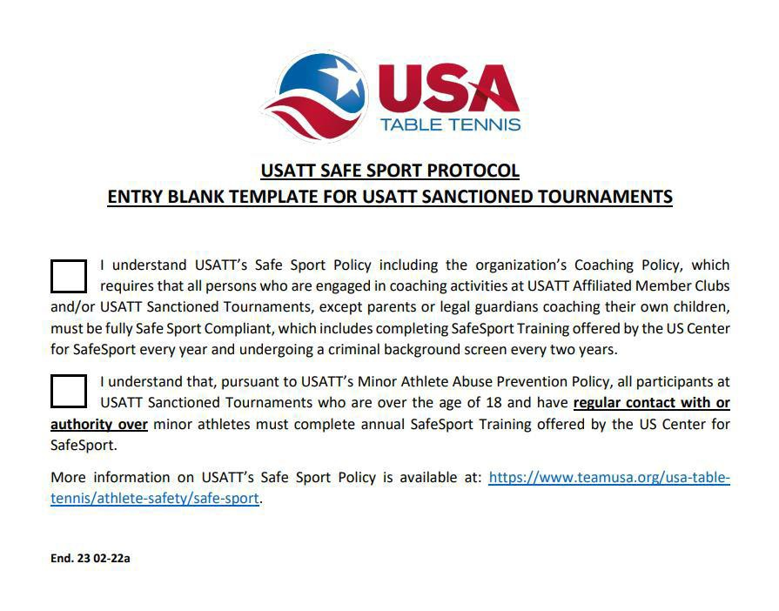

Name Phone Street
Rating

City, State, ZIP USATT# ; Expires:

Email address:
USATT membership Pro $75 1 yr ❏; Basic $25 1 yr ❏;
Club

Date of birth (required for all memberships) USATT fees: $

Please check event | Events | Time | Fee | Amount
 | U2100 | 9:00 AM | $25
 | U1800 | 3:00 PM | $25
 | U1500 | 11:00 AM | $25
 |  |  | Admin Fee | $5
 |  |  | Total Entry Fee:

Please include your club to help us separate you from other club members

Donation to support USATT National Team Programs $

Please enter me in the above event(s). My fees in the amount of $ are enclosed.

I agree to comply with all USATT regulations. I accept full responsibility for my participation. I have signed or will sign the USATT form, Release and Waiver of Liability.

signature

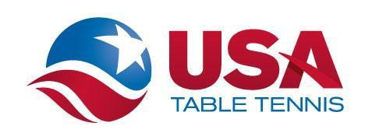

Communication of USATT Safe Sport Policy To All Participants
at USATT Sanctioned Events

Full Information for USATT’s Safe Sport Policy is available on the Athlete Safety Section of the USATT website:
https://www.teamusa.org/usa-table-tennis/athlete-safety/safe-sport.
This page includes links for:
- The USATT Safe Sport Policy, including the Minor Athlete Abuse Prevention Policy [“MAAPP”];
- The SafeSport Code for the Olympic and Paralympic Movements;
- The US Center for SafeSport’s Toolkit for Parents;
- USATT Safe Sport Compliance Protocol (Who Must Be Safe Sport Compliant and How a Person Becomes Safe Sport Compliant); and
- Frequently asked Questions Regarding Safe Sport Compliance.
PERSONS IN POSITIONS OF AUTHORITY MUST BE FULLY SAFE SPORT COMPLIANT
Under USATT Safe Sport Policy, persons holding certain Positions of Authority must complete Training offered by the US Center for Safe Sport (once per year) and undergo a criminal background screen (every two years). The list of Positions of Authority requiring full Safe Sport Compliance is set out in USATT’s Safe Sport Policy and the Athlete Safety Section of the USATT Website.
ADULT PARTICIPANTS REQUIRING SAFESPORT TRAINING
Under the provisions of MAAPP, all Adult Participants (over the age of 18) who have regular contact with or authority over minor aged athletes must complete the Training offered by the US Center for SafeSport on an annual basis (“Safe Sport Trained”). All persons over the age of 18 participating in a USATT Sanctioned Tournament must self-identify on the Tournament Entry Form as to whether they are required to be SafeSport Trained and, if so, whether they have completed such Training.
MANDATORY REPORTING
There are certain circumstances where reporting a potential Safe Sport violation is mandatory. These circumstances include: (i) child abuse; (ii) sexual misconduct; (iii) emotional and physical misconduct; (iv) criminal charges and/or dispositions involving sexual misconduct or misconduct involving minors; (v) any abuse of the Safe Sport process. Child abuse must be immediately reported to local law enforcement. To learn more about the appropriate agency to submit a report of child abuse, log onto: https://www.childwelfare.gov/topics/responding/reporting.
HOW TO REPORT SAFE SPORT VIOLATION
Persons can report a suspected violation of USATT’s Safe Sport Policy to:
- The US Center for SafeSport at www.SafeSport.org (or by phone during regular business hours at: 720-531-0340); and/or
- The USATT Athlete Protection Officer Mark Thompson (mark.thompson@usatt.org) (719-329-4200).
USATT MINOR‐AGE ATHLETE COACHING POLICY
Unless it is a Parent or Legal Guardian coaching his or her own child, NO ADULT is permitted to coach a minor‐age athlete at USATT Sanctioned Events unless that person is fully Safe Sport Compliant. This Policy will be enforced during all USATT Sanctioned Tournaments.
End. 23 02-15a

