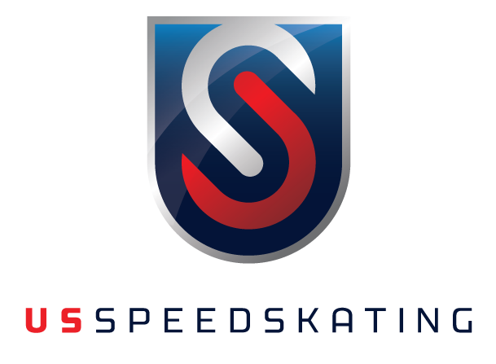

**US Speedskating, 5662 S Cougar Lane, Kearns, UT 84118**

**P: (801) 417-5260 / F: (801) 417-5361**

To Whom It May Concern:

I, , hereby declare that I am a citizen of , and have never skated in a national competition in that country.

Signature of Athlete .

Signature of Parent (if athlete is under 18) .

Date .