MINUTES- PNW WSO COUNCIL 11/17/2024 (next meeting scheduled for 3rd Sunday of January 2025 unless otherwise determined) –
Present: Lauren Hatmaker, Kim Douglas, Mira Kwon Gracia, Derek Kress, Celia (Huddart) Montgomery, Isaac Marron
Not Present: Chelsea Hopkins, Jenn Sprague
Memo of Understanding (MOU) for PNW WSO Championships 2025 update draft– Jenn Sprague:
Jenn Sprague prepared an updated draft for our review and sent it via email. Celia Montgomery reviewed it and said it seemed like what we had been discussing throughout the year. Mira Kwon Gracia will upload to google docs for our review/response/edits. We can use this MOU to share with interested bidders for WSO championship 2025.
WSO Championship 2024 Survey: General discussion about feedback we’ve received as council members directly, through social media, and via meet director’s survey response. Meet director’s survey was limited to athletes and a cap on responses through free Survey Monkey. Question raised if WSO council should send a separate survey now. Mira KG shared her opinion that 6 weeks (now) is too late for a survey response. Group discussed adding the WSO council led survey to the MOU, using a google form (like the recent spending survey) via BARS, and executing it directly following the WSO championship in 2025. Group consensus reached to o survey and promote on social media in 2025.
WSO Championship 2025 – are bids open? 2024 meeting minutes reviewed by group and determined we previously voted to have bids open directly following the closure of previous championships. Lauren H raised the question by PNW WSO meet director requesting bids to be awarded farther in advance to make venue selections easier. Group discussed and no decision was made at this time. General discussion about inquiries by Zach of DOP Strength to host WSO championship next November in same venue he is hosting USPA regional championship. He is asking if there are any USAW meet directors who would like to use the same venue nearby. Mira KG expressed concern about vetting other sports and whether they are following same drug testing / clean sport rules as USAW. Lauren H asked if it would be similar to the Arnold Sports Festival or another USAW event where a competition shared space with a CrossFit competition or another sport which may not drug test in the same ways. Mira KG offered to ask JP Nicoletta at USAW if USAW has a particular position about this type of sports festival. Lauren H will prepare social media posts regarding bids being opened for 2025.
Coaching Scholarship Awards 2025 (application window 2/1-/2/28/25) with 4 BIPoc and 4 Women’s scholarships awarded by PNW WSO and USAW and previously approved. Budget proposals have included additional “open” scholarships and yet to be voted. Isaac M noted that our minutes in January approved for 2024 and ongoing until voted against by future budget votes.
2025 Budget Discussion: JP Nicoletta and Christina Drown from USAW have been meeting with WSO Presidents and some WSO Councils in preparation for budget proposals. Although JP and Christina had thought they could attend this WSO meeting, there was a conflict and JP/Christina met with Lauren H as WSO President preliminarily on 11/7/24. Lauren H reported on that meeting and included a summary of recent communications first: in 2024, USAW informed the WSO councils that they would be doing away with a straight $5 per renewing member or other dividends as “income” awarded to the WSO councils to spend in our region. USAW has repeatedly stated that the funds we currently have in our sub account (approximately $25k at this time) is the WSO region’s money to spend. JP and Christina advised us to consider the sustainability of budget proposals. The USAW board of directors (1/2 of whom are ending their tenure on 12/31/24) have yet to finalize budget determinations or decisions for 2025. The councils have been asked to prepare budget proposals for 2025 for our region to spend (a) funds we have already accumulated and (b) programs we want to implement, support, and supervise for our region. In preparation for Lauren’s meeting with JP and Christina on 11/7, she reviewed the following:
- Survey responses from Kim D’s recent BARS email and google form link supported by the council;
- PNW WSO Sept meeting minutes discussing our proposal to measure spending initiatives by how they fit within the grassroots application of the USAW mission statement;
- Mira’s google doc with notes from October’s council meeting and some of the survey responses focused on DE & I support initiatives and Membership Growth
- BARS data about PNW WSO region in the last 12 months:
  - Revenue generated by membership renewals 1000 avg annually, ranging from $55-95/year (including the coaching memberships below);
  - 45 valid USAW club memberships annually;
  - 470 valid USAW coach memberships/certifications annually;
  - 18 competitions annually;
  - Maxed our WSO championships annually since 2022 (sold out 250 spots in less than 5 weeks in 2022 and 2024 and sold out 125 spots in less than 6 weeks at a smaller venue in 2023);
  - Generated between $100-130k annually from above activities and relationships in our region.
  - Grew our technical official members and engagement at USAW meets. Promoted several technical officials to National, IWF2 and IWF1, every year.
Lauren H prepared a rough draft income / expense statement, using an Excel template, illustrating the strength and revenue generation for our region and expenses in three categories (or spending buckets):
- Box A “Support Athletes in High Level Competition”:
  - Youth Athlete Development fund,
  - Youth Travel to international competitions, and
  - scholarships for local and national competitions;
- Box B “Support & Promote WL Community and Barbell Use”:
  - Coaching Scholarships
  - USAW Membership Scholarships
  - Mock Meet Promotional and Support
- Box C “Educate WL Community and Barbell Use”:
  - Referee clinics;
  - How to run a competition;
  - Technical official grants;
  - Website
  - Database management;
  - Records Support
Lauren explained that JP reinforced that the amount currently in our sub account is ours to determine how to use. USAW suggested applying our WSO development fund to the grassroots level as USAW is continuing to develop the national team program. Lauren explained that her draft income statement, which she emailed to the WSO council, was a starting point and a working document for everyone to engage and discuss.
Council members expressed confusion that we are being asked to create a budget without income allotted to us. Lauren’s reported that USAW doesn’t have a budget number to tell us but we know how much income our regions generates. We should ask for funding to support the grassroots mission statement in our region at the level we can support logistically. We are the ones who are representing our regional constituents and we are the ones that will have to implement the programs we choose to support, whether through volunteer coordination or our personal volunteering. Mira will follow up with JP and request a budget allocation number as well as a due date for our budget proposal for 2025.
Old business: Mira asked Lauren to follow up with JP about filing an ethics complaint against Todd Lyons who owes the WSO equipment or a refund. Lauren asked Mira if she’d do that since she was planning to email JP about other items. Lauren hasn’t been involved in the follow up with Todd Lyons or Dynamic Equipment but has been aware of the ongoing discussions.
Open Discussion: Lauren asked if any of the council had any other items to discuss and there were no responses. The meeting adjourned until January 2025 unless something “urgent” arises.
PNW WSO Budget Tracker
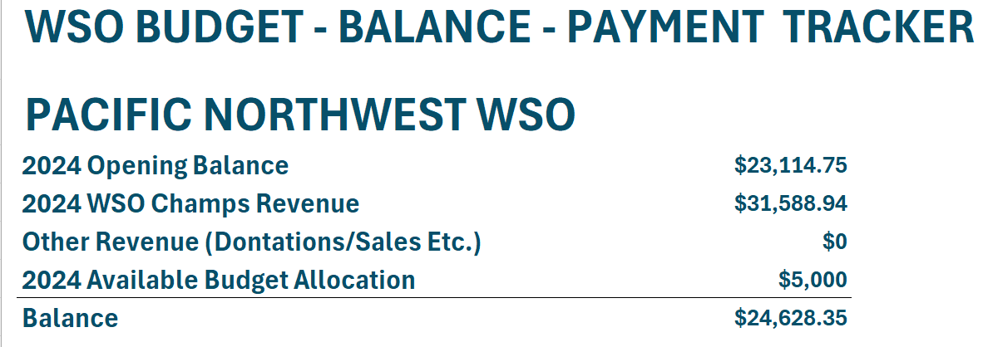

Added notes 11/22/24 from Mira and call with JP Nicoletta:
1. We have what is in our account to spend as we wish in whatever timeframe we choose. On an ongoing basis, beyond that, we should create budget strategy to reflect budget allocation more in line with the old rebate approach. Ie if we had 1000 member we would get $5 per, so our budget vision should be more in line with that number for sustainability. We can ask for more money and if the ask is approved we may very well receive more than the ~$5k. The Usaw board meets 12/14 so they need a budget strategy well before that so we have some time to possibly negotiate. Kim’s hosting a zoom Sunday if anyone wants to join in to help shape budget strategy. Link in our what’s app group chat.

2. Usaw does not care if we host a wso championships with a non drug tested event. So Lauren would you like to communicate that to dop? Since you have the email line open?

3. Todd Lyons has not been a part of Usaw in 12 years. No ethics violation warranted. We are “out” the money. Maybe a report to the bbb, but not sure if anyone has time to do that. If we had paid by cc we could refuse the charges but only up to 2 years after the fact so not sure what or if anything can be done.

POST NOTE:
Ongoing budget committee work (Kim Douglas, Isaac Marron, Mira Kwon Gracia) met by zoom and created a budget draft for the councils input. The council had access to review and voted to approve the budget draft during the week of 12/2/24 by google form vote (administered by Kim D).

