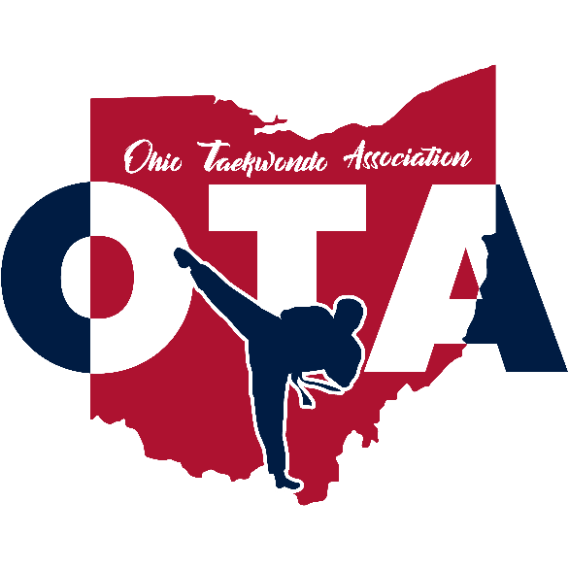

**2025 USATKD Ohio State Championship**

**USA Taekwondo Sanctioned 12.0 Event**

**March 29th, 2025**

[Dublin Jerome High School](https://www.google.com/maps/dir/4RMG%2B5G,+8300+Hyland-Croy+Rd,+Dublin,+OH+43016/@40.1337364,-83.2597773,12z/data=!4m8!4m7!1m0!1m5!1m1!1s0x8838eb6f2b26b003:0xd59996bfd808a4f7!2m2!1d-83.1773764!2d40.1337656?entry=ttu&g_ep=EgoyMDI1MDEyNy4wIKXMDSoASAFQAw%3D%3D)

8300 Hyland-Croy Rd, Dublin, OH 43016

**IMPORTANT INFORMATION**

**This will be a 1-day event.**

**Saturday, March 29th, 2025**

**Note:** For Recognized Sports Poomsae, all color belt and 6–11-year-old Black Belt divisions will only have two rounds, prelim and final. For any division with more than 9 competitors, the top 8 competitors will advance to the final round. For any division with less than 9 competitors, all competitors will advance straight to the final round. Competitors will perform one Poomsae for prelim and one Poomsae for the final round. Designated Poomsae will be released closer to the tournament date.

*2025 USATKD Ohio State Championships will not have Dragon, Tiger and Youth Pairs Poomsae, or Color belt Co-Ed Pairs. *

All the other black belt divisions (individual age 12+, pairs and teams) will do WT cut off format performing one Poomsae for prelim, one Poomsae for semi-final round and two Poomsae for the final round. Designated Poomsae will be released closer to the tournament date.

For Traditional Poomsae, athlete will choose one of the WT-Approved Kukkiwon poomsae of their choice corresponding to registered rank. **Traditional Poomsae division does NOT qualify athletes to USAT Nationals**

**Note:** Exhibition matches will be allowed as time permits AT THE END OF ALL REGULAR COMPETITION and with permission of both competitors’ coaches. A list of single competitors will be posted on the website after registration closes. Please see the schedule for exhibition timing.

Weigh-ins are required for all sparring competitors. **Weigh-ins will be held Friday, March 28th from 4-8 PM EST. at CK LEE TAEKWONDO (4720 Reed Rd, Upper Arlington, OH 43220).**

All registrations must be completed online PRIOR to the event. **There will be NO onsite registrations accepted.**

Please check online at [www.ohiotaekwondo.org](https://www.ohiotaekwondo.org/) for official updates and notifications about this competition.

**GENERAL INFORMATION**

**Hosted By:**

Ohio Taekwondo Association

**Tournament Director:**

President Grand Master Chungkeun Lee

**Information:**

Facebook: [**USAT Ohio Taekwondo Association**](https://www.facebook.com/people/USAT-Ohio-Taekwondo-Association/61571887011957/)

Website: [ohiotaekwondo.org](https://www.ohiotaekwondo.org/about#h.u3qgbgtknwto)

**Event Contact**

events@ohiotaekwondo.org

**Registration Help Contact**

[cssimmons@usatkd.](mailto:cssimmons@usatkd.org)[org or ewininger@usatkd.](mailto:ewininger@usatkd.org)org or Call USATKD at 719-374-5745

Need help with Sport 80? Click the link below!  
[https://vimeopro.com/user44435707/usatkd-member-tutorials/video/431742671?fbclid=iwar27j0l4wed-mayysjvqijw3_tuz1lznicoepkpxjn1hddk1tyxhpiuzoga&ofcom_user_token=](https://vimeopro.com/user44435707/usatkd-member-tutorials/video/431742671?fbclid=IwAR3fRlccpCYE1w1W5Ia8077ocJVMybckmEAQok4j-2W3oxA_Rw9r8Their4&ofcom_user_token)

**Competition Venue**

Dublin Jerome High School (8300 Hyland-Croy Rd, Dublin, OH 43016)  
Weigh-ins will NOT occur that this location

**Weigh-In Site**

CK LEE TAEKWONDO ACADEMY (4720 Reed Rd Upper Arlington OH 43220)  
Weigh-ins are required for all sparring competitors. Weigh-ins will be held Friday, March 28th from 4-8 PM EST. at CK LEE TAEKWONDO.

**Accommodation**

Hotel accommodation  
All accredited club/teams participation at the event are strongly recommended to book their hotel accommodation via the Organizing Committee in the Official Hotels through  
<https://www.hilton.com/en/attend-my-event/ohiotaekwondo20252025/>

**Event Spectator Tickets**

Spectator Ticket - $20.00 (CASH ONLY) Children under 5 years – FREE

**COMPETITION REGISTRATION FEES & DEADLINES**

**Competitor Events**

ALL participants (coaches and athletes) must register at: [http://usataekwondo.sport80.com.](http://usataekwondo.sport80.com/) **Registration deadline is Wednesday, March 19, 2025, at 23:59 EST.**

**U.S. National Taekwondo Championships Qualification**

The 2025 USATKD Ohio State Championships will qualify athletes for the U.S. National Taekwondo Championships. Athletes that finish in the Top 4 (Gold, Silver, Bronze, Bronze) at a State Championship will automatically qualify for the 2025 U.S. National Taekwondo Championships. If an athlete does not win a gold, silver, bronze, or bronze medal at a state championship the athlete can qualify for the U.S. National Taekwondo Championships through the American Open tournament series. Athletes must be a U.S. Citizen to participate in the world class divisions at the U.S. National Taekwondo Championships.

**USA Taekwondo National Qualifying Events**

| Events | Ages | Belts |
| --- | --- | --- |
| Sparring | All Ages | Yellow, Green, Blue, Red & Black |
| Recognized Sports Poomsae  (Individual) | All Ages | Yellow, Green, Blue, Red & Black |
| Pair Sports Poomsae  (1 Male, 1 Female) | All Ages | Black Belts |
| Team Sports Poomsae  (3 Members Same Gender) | All Ages | Black Belts |
| Free Style Poomsae  (Individual) | All Ages | Black Belts |
| Pair Freestyle Poomsae  (1 Male, 1 Female) | All Ages | Black Belts |
| Mixed Team Freestyle Poomsae  (composed of 5 members including at least 2 males and 2 females) | All Ages | Black Belts |
| Demonstration Team | All Ages | Yellow, Green, Blue, Red & Black |
| Board Breaking | All Ages | Yellow, Green, Blue, Red & Black |

**USA Taekwondo Membership Requirements**

Athletes must have an active USATKD membership to compete in a State Championship or Other Sanctioned Event. The membership must be active through the conclusion of the tournament. They must also have a belt listed in their USATKD profile. Please see the How [**To Register**](https://www.usatkd.org/athlete-how-to-register-for-an-event) section of the USATKD website for step-by-step instructions.

All coaches and referees are required to hold the appropriate and current USATKD membership prior to the start of the competition. Please see the How [**To Register**](https://www.usatkd.org/athlete-how-to-register-for-an-event) section of the USATKD website for step-by-step instructions. **If any coaches or referees participate without a current USATKD membership, then the liability insurance will be invalid, and the State Association shall assume all responsibility for any injury or liabilities accrued at the event.**

All coaches, referees, and club owner/instructors **18 and older are required to complete and pass the USATKD background check and complete the SafeSport training before registering** for USATKD state sanctioned events. Athletes 18 and older must complete the SafeSport training before registering for USATKD state sanctioned events.

The background check must be completed **every two years**. The SafeSport Refresher or Core Training must be completed **every year**. The background check and SafeSport must be active through the conclusion of the event.

All documents regarding the State Championship or approved Sanctioned Event must inform the coaches and referees that they are required to be a member of USATKD and meet the membership requirements to participate in the event.

**REGISTRATION**

Ensure competitors are registered for ALL events they plan on participating in by the time registration closes.

**NO ONSITE** registrations will take place. Meaning, if you plan on competing in a Team or in Pairs, but one (1) member did not register, your team or pair will be disqualified.

**Registration Fees**

In order to register on Sport80, make sure you choose the correct age (date of birth) and you must choose a rank (Color Belt) to let you choose a division and let you make a payment.

| Registration Type | Registration Fee  Registration | Event | Final Registration |
| --- | --- | --- | --- |
| Athlete | $100 | $25 | Wednesday, March 19, 2025 at 23:59 |
| Coach | $20 |  | Wednesday, March 19, 2025 at 23:59 |

Payments must be made by registration due dates. If registration is not finalized by Wednesday, March 19, 2025 at 23:59, your registration and information will not be sent to us, and your registration will not be processed.

Therefore, no pending registration will be accepted after the close of registration date: Wednesday, March 19, 2025 at 23:59 EST.

**\*\* No onsite registration for athletes or coaches.** This includes adding events. Any changes onsite will incur a minimum charge of $50 per change. All fees must be paid prior to the change being made (Cash Only).

**Weigh-in**

[CK LEE TAEKWONDO](http://www.cktaekwondo.com/)

4720 Reed Rd, Upper Arlington, OH 43220

Weigh-ins are required for all sparring competitors. Weigh-ins will be held **Friday, March 28th from 4pm to 8pm** at CK LEE TAEKWONDO (4720 Reed Rd, Upper Arlington, OH 43220). **Sparring competitors who do not weigh-in by the deadline will be disqualified.**

**Check-in**

ALL COMPETITORS must check-in at registration for credential pick-up to be included in their division brackets. **Please check-in between 8:00-9:15 AM on Saturday, March 29th.**

**Registration Checklist**

Completing all items on this list will help ensure a speedy check-in and weigh-in process at the 2025 USATKD Ohio State Championships.

* Ensure you registered online & input your correct weight. NO ONSITE registrations will be allowed.
* **A valid form of ID**: ID, U.S. Birth Certificate, Passport Book or Card, School ID or Report Card, Valid Driver’s License or Government Issued ID, or Military ID.
* Sparring competitors: bring appropriate attire - refer to “Weigh-In Rules.”
* Poomsae ONLY competitors must still check-in by 9:15 am on Saturday in order to be on brackets, if not, they may be disqualified.
* Coaches must pick up during credential pick up times only.

**Weigh-in Rules**

* ALL sparring competitors MUST weigh-in the DAY BEFORE the scheduled competition. A maximum of two (2) weigh-ins are allowed per athlete. The 2nd weigh-in must occur before registration is officially closed.
* Contestants are required to show a valid form of ID to weigh-in.
* Any irregular action by the competitor or coach during the weigh-in may result in disqualification from event participation.
* Weigh-ins, for both males and females, shall be done in athletic clothing. A total of 0.2 kgs will be deducted from the weight on the scale. Under NO circumstance may an athlete weigh-in in the nude in the U.S.
* **There will be a $50 fee to change weight divisions, so please ensure your weight/division is correctly entered when registering.**

**Coach Requirements**

In addition to the coach’s attire and conduct requirements as outlined in the rules, there will be the following requirements:

* Coach courtesy hold and match management:
  + First-round we will make accommodations for coaches with multiple athletes in separate rings.
  + Due to the scale and scheduling of this event, referees will be instructed to hold matches for a maximum of one minute prior to starting the match.
  + Once the division brackets and match orders are set by officials, no changes will be accepted on the floor.
* Coach etiquette:
  + No recording video or pictures ringside or on the competition floor.
  + No phones, headsets, earbuds, etc. at ringside or on the competition floor.
  + No loitering behind the ring table.
  + No questions during the competition

Violations of etiquette may be penalized with a yellow card (sanction).

All coaches **ARE REQUIRED** to hold at minimum an Associate Coach (AC) Certification within the USA Taekwondo CIDP program, be a current member, completed the Center for SafeSport training (**every year**), and taken and cleared the USATKD background check (**every 2 years**). Coaches may obtain the AC certification by passing the Associate Coach Quiz. The AC Coach Quiz should be completed at least 5 business days prior to the State Championship registration deadline to allow for grading. Coaches will also be required to view the Center for SafeSport Training Video. The SafeSport video, background check and Associate Coach Certification must be completed before a coach can register for an event.

All documents regarding the State Championship or an approved Sanctioned Event must inform coaches that each coach is required to be a member of USATKD, take and clear the USATKD background check every two years, complete the SafeSport video training every year, and have, at minimum, an AC certification to participate in the event. When discussing how to obtain a USATKD CIDP AC certification, please use the following link.

<http://www.teamusa.org/usa-taekwondo/v2-coaching/coach-education-program>

**Referee Requirements**

All referees must be certified by USATKD to referee at a USATKD Sanctioned State Championship or approved Sanctioned Event. **It is not required to host a USATKD Referee Seminar prior to the start of the Sanctioned Event but is encouraged.** This seminar will ensure all referees participating in the event are up to date on certification and rule changes.

All Referees participating in the event must complete and pass a background check (**every two years**). Referees will be required to view the Center for SafeSport Training Video (**every year**) and must have a current USATKD membership. The SafeSport video and background check must be completed before a referee can register for an event. Referees participating at the event will need to reference the USATKD Referee handbook for certification requirements. USATKD recommends, but does not require, that referees are paid to help offset any of their costs incurred during the event.

State Associations are no longer required to host a Referee Seminar, this will be optional for all State Associations. If you wish to hold a Referee Seminar the application can be found at: <https://www.teamusa.org/usa-taekwondo/v2-resources/referee-certification-request>

**SCHEDULE OF EVENTS**

| **REPORT TIME** | **EVENT** |
| --- | --- |
| 8:00 AM | Check-in for athletes, coaches, and referees  Spectators - $20 at door (Cash only)  Board Sales –  Under 10 years old -⅜” $5  10-14 years old-½” $5.50  15 years and older-1” $6 |
| 8:30 AM | Referee & Coach Meeting |
| 9:00 AM | Opening Ceremony |
| 9:20 AM | Competition begins for all competitors |

** Call times will be released the Wednesday prior to the even (March 26th)

**COMPETITION FORMAT INFORMATION**

**Competitor Awards**

Medals will be awarded to one 1st, one 2nd and two 3rd place winners.

**Competition Area & Rules**

Per USATKD regulations, the competition area is open only to the following personnel. Everyone else must watch from the designated spectator areas.

* Registered & certified coaches.
* Registered & certified referees.
* Registered athletes.
* Ohio State Taekwondo Association staff & volunteers

Your cooperation helps us run a smooth & professional event. Thank you for your support.

OTA follows all rules endorsed by USA Taekwondo found on their website at: https://[www.teamusa.org/usa-taekwondo/v2-events/competition-rules](http://www.teamusa.org/usa-taekwondo/v2-events/competition-rules)

We will be using the most current USATKD Rules as updated on the <https://www.usatkd.org/usatkd-competition-rules>website.

[2025 USATKD Kyorugi Rules, click here to download](https://flatkd.com/wp-content/uploads/2024/04/2024_USATKD_Kyorugi_Rules_v2_3_21_24.pdf)

[2025 USATKD Kyorugi Rules - Modified Head Contact, click here to download](https://flatkd.com/wp-content/uploads/2024/11/2023-USATKD-Kyorugi-Rules-Modified-Head-Contact-for-2025.pdf)

[2025 USATKD Poomsae Rules, click here to download](https://flatkd.com/wp-content/uploads/2024/11/2024_USATKD_Poomsae_Rules_v1_12_22_23-for-2025.pdf)

[2025 USATKD Demonstration Team Rules, click here to download](https://flatkd.com/wp-content/uploads/2024/11/2024_USATKD_Demonstration_Team_Rules-5-1-2024-for-2025.pdf)

[2025 USATKD Creative Breaking Competition Rules, click here to download](https://flatkd.com/wp-content/uploads/2024/11/2020-USATKD-Breaking-Rules-for-2025.pdf)

[2025 USA TAEKWONDO Kyorugi Weight Categories](https://flatkd.com/wp-content/uploads/2024/11/Kyorugi_Weight_Categories-for-2025.pdf)

[2025 USA TAEKWONDO Dobok, Equipment & Hygiene Standards](https://flatkd.com/wp-content/uploads/2024/11/Dobok_Equipment_and_Hygiene_Standards-for-2025.pdf)

[2025 USA TAEKWONDO Compulsory Poomsae](https://flatkd.com/wp-content/uploads/2024/11/COMPULSORY_POOMSAE_10.3.24-for-2025.pdf)

**Daedo PSS Scoring requirements.**

Gen 2 Daedo PSS hogus and electronic head gear will be used for 8-9 year old Black belts, 10-11 year old black belts, and 12 years and over all belts. Athletes will need their own Gen 2 Daedo electronic socks. Electronic hogus will be provided. These are sparring competitors in divisions using Junior Safety Rules or Senior Rules where head contact is allowed.

**All Color belts 11 and under and Black belts under age 8 will need to bring their own hogu and head gear**. Daedo e-socks are not required. These are sparring competitors in divisions with no head contact allowed.

**Athletes must compete in the age category according to the age he/she will be as of December 31, 2025.**

**World Class vs Grassroots**

World Class and Grassroots divisions will only be offered for Cadet Sparring black belts. Cadet World Class divisions will use adult rules and Cadet Grassroots divisions will use Junior Safety Rules.

***Cadet Poomsae; Junior Poomsae and Sparring; Senior Sparring and Poomsae black belts will have World Class Divisions ONLY (no Grassroots divisions).***

**Miscellaneous Information**

▪ Athletes that qualify based on age can compete in both Junior and Senior sparring divisions. ▪ *State Championships Winner of the Cadet Grassroots divisions will not qualify for the World Class division because the Grassroots division will use Junior Safety Rules and World Class divisions will use full head contact rules (see competition rules for full explanation of rules). Once qualified for World Class, an athlete is not eligible for Grassroots divisions.

**SPARRING INFORMATION**

**Sparring Match Format**

Best of 3 System (win by rounds) shall be followed for all matches. We will use USATKD up-to-date rules and regulations, Best 2 of 3 rounds will be criteria used for sparring.

*OTA reserves the right to modify the number of rounds at their discretion.

**Qualification of USATKD Contestants**

* Citizen or resident of the United States status
  + World Class Black belt athletes MUST be U.S. citizens.
  + World Class ages are Cadet 12-14, Junior 15-17, Senior 17+.
    - Cadet Grassroot Division does not require proof of citizenship (See chart below.)
  + Age limit: The age limit is based on the year, not on the date.
  + Must be currently registered USATKD athlete member
  + All black belt contestants must submit a copy of their Dan/Poom Certificate, current USATKD identification card, and birth certificate at the time of registration with the Tournament Organizing Committee.
  + To be eligible for Senior competition, contestants must be at least 17 years old in the year the pertinent tournament is held. Contestants must be between 15-17 years old for Junior Taekwondo Championships, and 12-14 years old for Cadet Championships. (Ages for Youth Olympic Games qualification might be different depending on the decision of the IOC.)
  + All contestants participating in a tournament are required to observe the Code of Conduct of USATKD and the rules of the tournament. Violators are subject to sanction.

**Contestant Uniform and Competition Equipment**

* At USATKD-sanctioned competitions, contestants’ uniforms and all competition equipment, such as, but not limited to mats, PSS, IVR and protective equipment must be those approved by USATKD.

**Official Uniform (Dobok)**

* All contestants must wear a white Taekwondo V-neck USATKD/WT uniform (dobok) in good condition. Black belts must wear black-collared uniforms. Poom rank (15 and under black belts) may wear poom uniforms with black and red collars. Color belts must wear white-collared uniforms; color belts cannot wear black-collared uniforms.
* Optional: Athletes may wear black pants.

No tape will be allowed on any part of the uniform.

**Protective Equipment**

* Contestants shall wear an approved trunk protector, head protector, groin guard (mandatory for both male and female competitors), gloves (see below), forearm protector, shin protectors, instep protectors or sensing socks (if using an electronic Protector and Scoring System) and a mouth guard before entering the Contest Area. The head protector must be firmly tucked under the left arm when entering the Contest Area and shall be put on the head after bowing to the opponent before the start of the contest.
* The groin, forearm, and shin protectors must be worn inside the Taekwondo uniform. Wearing of any other items on the head other than head protector shall not be permitted, except for religious reasons. A previously approved religious item shall be worn beneath the head protector and inside the dobok and shall not cause harm or obstruct the opposing contestant.

**Personal Requirements**

* All competitors shall keep their nails cut short and shall not wear any articles that may injure or endanger an opponent. Any competitor whose hair, in the opinion of the referee, is so long as to risk causing inconvenience to other competitors or interfere with the PSS system, shall be required to tie it back securely. Long hair must be tucked inside the headgear.

**Metallic Articles**

* Contestants are not allowed to wear any kind of metallic articles or hard objects, such as rings, eyeglasses (including prescribed safety or sport eyeglasses or eye goggles), necklaces, watches, bracelets, earrings, hair clips, etc.

**Personal Hygiene**

* All competitors must maintain the highest standard of personal hygiene, keep their nails cut short, and groom their hair neatly.

**Taping**

* Taping on the foot and hand shall be allowed for the protection of athletes. For an injury, the minimum amount of tape that will protect the area should be used. Taping of feet and hands will be strictly checked during the athlete inspection process; if there is a question, the inspector or referee should have the wrapping examined and approved by the Tournament Medical Staff. Under no circumstances will a hard splint or cast—no matter how small—be allowed.
* Any taping must be removed during general weigh-in to ensure that there is no open wound, cut, or bleeding.
  + There will be no taping beneath the sensor socks unless it is approved by the USATKD Medical Staff because of injury.

Any violators of this article will be required to correct the violation within one minute, or face disqualification.

**Medical Control**

* At Taekwondo events promoted or sanctioned by USATKD, any use or administration of drugs or chemical substances described in the U.S. Olympic Committee anti-doping by-laws is prohibited. International Olympic Committee doping by-laws shall be applied to Taekwondo competition in the Olympic Games and other multi-sport Games.
* USATKD may carry out any doping testing deemed necessary to ascertain if a contestant has committed a breach of this rule. Any winner who refuses to undergo this testing or who proves to have committed such a breach shall be removed from the final standings, and the record shall be transferred to the contestant next in line in the competition standings.
* The organizing committee shall be responsible for making arrangements to carry out medical testing.

**Explanation: USA Taekwondo Equipment Standards**

**Belt Colors**: Only WT/USATKD belt colors will be allowed—black, poom (black and red), red, blue, green, yellow. Belts with stripes will be allowed.

**Gloves**: World Class Cadet Black Belts (12-14), Junior Black Belts (15-17) and Senior Black Belts are required to wear USATKD/WT-approved Taekwondo gloves. Gloves may be red, blue, or white. If the competitor chooses to wear red or blue gloves, they must correspond with the color of the chest protector. Gloves must be open finger style. For all other divisions, gloves are optional and must comply with the above rule. Cloth gloves or hand covers are not allowed.

**Properly fitting head protector**: Unless electronic PSS head protectors are used, all participants must provide their head protector with no markings other than corporate logos. World Class Cadet Black Belts (12-14), Junior Black Belts (15-17) and Senior Black Belts are required to wear red or blue head protectors, corresponding with the color of the chest protector. White head protectors may be used. Cracks or defects in the headgear will not be allowed.

**Mouth guard**: All athletes are required to use a mouth guard, with a minimum thickness of 3mm. Mouth guards may be any color except solid red. Effective 2024 USATKD National Championships, mouth guards may be clear or white only. Use of a mouth guard may be exempted upon submission of a medical doctor’s statement that its use might cause harm to the contestant. Athletes with dental braces must wear special mouthguards for braces that cover both upper and lower teeth.

**Groin guard**: All athletes (male and female) are required to wear a groin guard, which must be inside the pants during competition.

**Properly fitting chest protector**: Where an electronic Protection and Scoring System (PSS) is being used, all athletes will be provided full-body WT trunk protector. When an electronic Protection and Scoring Systems (PSS) is not being used, all athletes must provide their own WT-approved trunk protector. The trunk protector must cover the entire valid scoring area. All trunk protectors must wrap around and cover the back of the athlete in the valid scoring area.

**Shin and instep protection**: Shin and instep protectors are required, and they must be made of foam, cloth or vinyl. PSS sensor socks with built-in instep padding are also allowed. The instep protector may be red, blue, or white, but must correspond with the color of the chest protector, if choosing to wear blue or red protectors; any color shin protector is allowed.

**Forearm guard**: Forearm guards are required and they must be made of foam, cloth or vinyl. Any color forearm guard will be allowed.

***Please Note****: USA Taekwondo reserves the right to disallow any uniform or equipment if it is found to be unsafe, offensive or degrading.*

**DAEDO PSS & PROTECTIVE EQUIPMENT DAEDO SOCKS -**

**PROVIDED BY EVENT HOST PROVIDED BY COMPETITOR**

Truescore/Daedo will be available to sell socks Online at: <https://www.tkdscore.com/>

**FOREARM GUARDS – REQUIRED SHIN GUARDS - REQUIRED**

**

**HAND GLOVES REQUIRED** Cadet, Junior, & Senior divisions World Class and Grassroot Black Belt Sparring competitors must also wear WT approved TKD Gloves.

**HAND GLOVES - RECOMMENDED FOR ALL BLACK BELT DIVISIONS.**

**HEADGEAR – REQUIRED FOR ALL COMPETITORS**

**BRING YOUR OWN HEADGEAR.** We will use a head electronic headgear for some divisions AND WILL BE PROVIDED FOR THOSE DIVISIONS. White, red, or blue Helmets - blue or red must match hogu color.

Headgear must be in good condition, i.e. not have any cracks and must strap securely to the head.

**MOUTHGUARDS – REQUIRED PROVIDED BY COMPETITOR**

* **Mouth Guards** may be any color except Red,
* Must have a thickness greater than 3mm,
* If competitor has braces, they are required to have an upper & lower mouth guard.

**FEMALE & MALE PROTECTORS – REQUIRED**

For the complete Rule Set download from USA Taekwondo, which is located on their website at: https://[www.teamusa.org/usa-taekwondo/v2-events/competition-rules](http://www.teamusa.org/usa-taekwondo/v2-events/competition-rules)

**USA Taekwondo Weight Sparring Weight Categories**

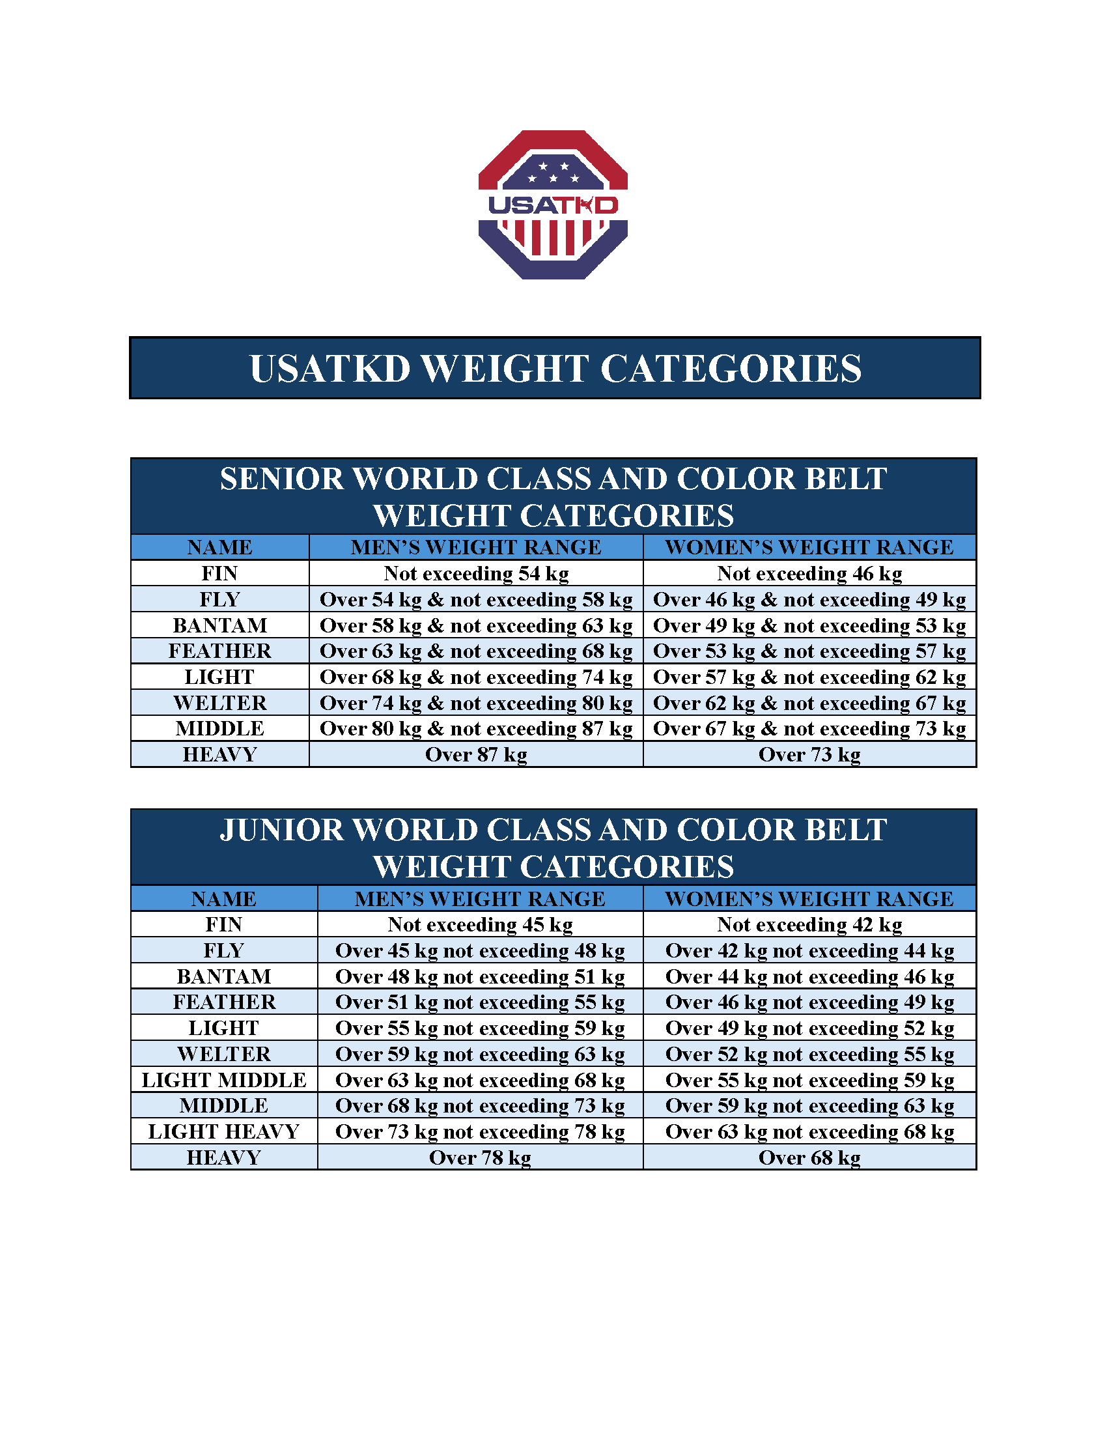

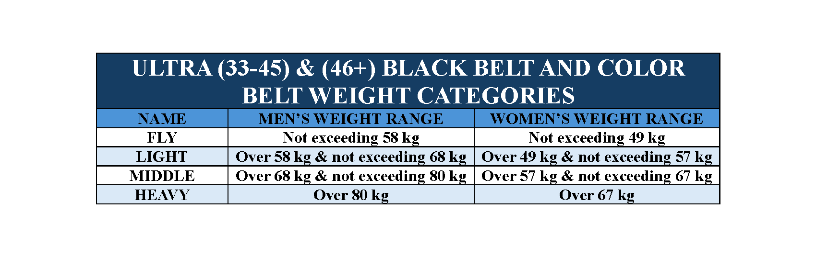

**JUNIOR SAFETY RULES**

Attacks to the head with light contact are allowed. The Referee will penalize the athlete for excessive contact. The referee can decide the winner of RSC (Referee Stop Contest) in case of a significant difference of competing ability between two athletes. OTA utilizes **USATKD’s KYORUGI COMPETITION RULES & INTERPRETATION Effective December 31st, 2023

**POOMSAE COMPETITION INFORMATION**

**RECOGNIZED SPORT POOMSAE**

**Qualifications of USATKD Poomsae Contestants**

* + Residency and citizenship: Residency and citizenship requirements vary among events. USATKD National Championships and Grand Slams require contestants to be citizens of the United States.
  + Registered USATKD athlete member
  + Black Belts: All black belt contestants must submit a copy of their Dan/Poom Certificate, current USATKD identification card, and birth certificate before the athlete can be confirmed. If any documents are missing, they will need to be submitted at the time of registration with the Tournament Organizing Committee unless otherwise directed.
  + Color belts: Contestant must be a solid color belt, with a USATKD recognized rank (1st & 2nd Geup Red Belt, 3rd & 4th Geup Blue Belt, 5th & 6th Geup Green Belts, 7th & 8th Geup Yellow Belts). Color belt contestants may only wear a yellow, green, blue or red belt, according to the contestant’s Geup rank.
  + All contestants participating in a tournament are required to observe the USATKD Code of Conduct and the rules of the tournament. Violators are subject to sanction by the USATKD.

**INDIVIDUAL POOMSAE**

* Consists of 1 competitor for the following age divisions: Cadet (12-14), Juniors (15-17), U30 (18-30), U40 (31-40), U50 (41-50), U60 (51-60), U65 (61-65) O65 (66+)

**PAIRS POOMSAE (CO-ED)**

* Consists of 1 Male & 1 Female competitors for the following age divisions: Cadet (12-14), Juniors (15-17), U30 Pairs (18-30) & O30 Pairs (31+) Pairs Poomsae.

**TEAM POOMSAE**

* Consists of 3 competitors of the same gender for the following age divisions: Cadet (12-14), Junior (15-17), U30 Team (18-30), O30 Team (31-50) and O50 (51+) Team Poomsae.

**TRADITIONAL POOMSAE**

* This division **does not qualify athletes for USAT nationals**
* **Dobok/Uniform:** Colored-uniformed will be allowed in this event
* **Color Belts:** You will choose ONE of the listed poomsae corresponding to the belt you registered

| **Division** | **Allowed Poomsae** |
| --- | --- |
| Yellow | Taeguek 1 OR 2 |
| Green | Taeguek 1, 2, 3, OR 4 |
| Blue | Taeguek 3, 4, 5, OR 6 |
| Red | Taeguek 4, 5, 6, 7, OR 8 |

* **Black Belts:** You can perform your current rank poomsae OR one rank below

| **1st Poom/Dan** | Taeguek 8 OR Koryo |
| --- | --- |
| **2nd Poom/Dan** | Koryo OR Keumgang |
| **3rd Poom/Dan** | Keumgang OR Taebaek |
| **4th Poom/Dan** | Taebaek OR Pyongwon |
| **5th Dan** | Pyongwon OR Shipjin |
| **6th Dan** | Shipjin OR Jitae |
| **7th Dan** | Jitae OR Chonkwon |
| **8th Dan** | Chonkwon OR Hansu |

For the complete Rule Set download from USA Taekwondo, which is located on their website at: https://[www.teamusa.org/usa-taekwondo/v2-events/competition-rules](http://www.teamusa.org/usa-taekwondo/v2-events/competition-rules)

**Official Uniform for Contestants**

* All contestants must wear a white Taekwondo V-neck USATKD approved uniform (dobok) or WT approved Poomsae competition uniform in good condition, and appropriate to the contestants’ division. Black Belts must wear black-collared white uniforms or WT approved Poomsae competition uniform. Color belts may not wear black-collared or poom collared uniforms.
  + Optional: Athletes may wear black pants.
* Only black belt athletes 14 and under may wear a poom belt. Also, if an athlete wears a poom collar uniform they must wear a poom belt.
* Patches, embroidery, logos, team names, country names, athlete names, and stripes are permitted on the uniform. Logos or names on the back of the uniform and patches on the chest area of the uniform are also allowed.
* Shoes may not be worn. No jewelry or ornaments may be worn. No hats or items may be worn on the head except for religious coverings or soft ties to contain the hair.
* NO TAPE WILL BE ALLOWED ON ANY PART OF THE UNIFORM. Text

  Description automatically generated with low confidence

**Personal Hygiene**

* All competitors must maintain the highest standard of personal hygiene, keep their nails cut short, and groom their hair neatly.
* Any violators of the Official Poomsae Uniforms as described above will be required to correct the violation within one minute or shall be subject to disqualification.

**Taping**

* There will be no ankle or wrist wrapping or bandage or any equivalent of protection on the hand and feet. Any taping for an injury requires medical approval.

**Medical Control**

* At Taekwondo events promoted or sanctioned by the USATKD, any use or administration of drugs or chemical substances described in the USOC anti-doping by-laws is prohibited.
* The USATKD may carry out any medical testing deemed necessary to ascertain if a contestant has committed a breach of this rule. Any winner who refuses to undergo this testing or who proves to have committed such a breach shall be removed from the final standings, and the record shall be transferred to the contestant next in line in the competition standings.
* The organizing committee shall be responsible for making arrangements to carry out medical testing.

**DEMONSTRATION TEAM INFORMATION**

**Overview & General Guidelines**

Demonstration Team Competition is a performance highlighting the many aspects of the art of Taekwondo, such as poomsae, breaking, acrobatic kicks, and self-defense techniques, with the addition of music and choreography.

* The performance must be confined to the 12m x 12m Contest Area. There will be a 0.1 Procedural Deduction each time a contestant crosses the boundary line with two feet during the performance. Any performance outside of the boundary line will not be scored.
* All contestants must wear appropriate sport attire, such as V-neck Taekwondo uniform of any color, WT Poomsae Competition Uniform or team track suit.
* The maximum set-up and clean-up time is 1 minute.
* The maximum time to complete the performance is 6 minutes.
* All music must be submitted for approval prior to the competition.
  + The tournament committee shall set the deadline for submissions.
  + The deadline shall be a minimum of 1 week before the start of the event.
* The machine to play music shall be provided by the Tournament Committee.
* There will be no chairs or tables, and no use of tumbling boards or any similar devices.
* Use of poles and similar devices to hold boards for high jumping breaks is permitted.
  + These must be approved in advance for safety.
* No Cinder Blocks or Bricks may be used for any purpose.
* Due to safety and liability issues, absolutely no weapons (i.e. swords, staves, fans, etc.), pyrotechnics, fireworks or flame breaks.
* Any Taekwondo striking or kicking technique may be used, apart from head strikes which are prohibited.
  + Performing a head strike will result in a 0.3 Procedural Deduction per attempt per board.
  + Performing a head strike will result in the Referee calling the medic for an examination of the athlete after the cleanup time is complete, or during the performance if there is a clear injury.
* All props used in the performance will be provided by the Demonstration Team, except for boards.
* Each demo team will be responsible for their boards (Board inspection will take place prior before the team steps on to the ring).
* Competitors are cautioned to stage the performance so that flying boards do not endanger officials, spectators or other competitors.
* There will be no limit on the number of Team members. Teams are allowed 1 alternate team member to replace an injured athlete.

For the complete Rule Set download from USA Taekwondo, which is located on their website at: https://[www.teamusa.org/usa-taekwondo/v2-events/competition-rules](http://www.teamusa.org/usa-taekwondo/v2-events/competition-rules)

**CREATIVE BREAKING COMPETITION INFORMATION**

**Overview & General Guidelines**

1. In Creative Breaking competition, participants use powerful, correctly executed Taekwondo hand and foot techniques to break pine boards. Competitors are expected to display technical skill and proper Taekwondo manners, as well as showmanship and creativity.

2. Competitors may choose the kind of techniques and number of boards to break, up to a maximum of 15 boards. Any Taekwondo striking or kicking technique may be used, apart from head strikes, which are a 0.3 procedural deduction each.

3. Competitors must provide their own board holder assistants. (Please note that board holder credentials are not a pass into the event; persons receiving this credential will need to pick it up in the designated holding area and return it to the holding area after competition).

4. Competitors and helpers will have three minutes to set up, perform the breaking routine and clean up all boards, broken boards and wood fragments. Exceeding the time limit will result in 0.3 procedural deduction in the final score for each 10 seconds, or fraction thereof, over the time. (Example: 12 seconds over = 0.6 procedural deduction.) If computer scoring is not used, a timer will be provided for each ring.

5. In the interest of safety, competitors may not use props such as chairs, trampolines, tables, etc. for aerial techniques. However, board holders may be used as “human launch pads.” No glitter, confetti, explosives or sound makers may be used. Blindfolds are permitted.

6. Multiple attempts of a single break are allowed, but each unbroken board will result in a 0.3 technical deduction.

7. A “Broken Board” is defined as one that is a) completely separated; or b) held together only by wood strands, such that if one side is held horizontal, the other side naturally drops perpendicular to the floor.

8. Boards that are brought into the ring but not attempted will result in a 0.3 technical deduction for each board. Note that missed boards are considered attempted, and will not result in any additional penalty, other than the deduction on the failed attempt described in Section 1.6, if a competitor chooses not to re-attempt the break.

9. The performance must be confined to the 8m x 8m competition area. A competitor who crosses the boundary line with two feet will receive a 0.3 procedural point deduction for each violation. Holders may cross the boundary line or stand outside the boundary line with no penalty.

10. Competitors will be cautioned to stage the performance so that flying boards do not endanger officials, spectators or other competitors.

11. Competitors may perform as many breaking techniques as they wish, as long as they do not exceed the three-minute time limit.

12. Boards must be purchased from OTA or the OTA-designated vendor at the competition venue. *Under no circumstance will competitors provide their own boards. Type and size of Boards will be set by the competition committee prior to the event.* Standard board sizes are:

* + - 6 - 9 years old: ¼ x 10 x 12-inch Pine Board
    - 10 - 14 years old: ½ x 10 x 12-inch Pine Board
    - 15 - 17 years old: 1 x 10 x 12-inch Pine Board
    - 18 + years old: 1 x 10 x 12-inch Pine Board

13. No spacers may be used, including fingers. Boards may be taped together for ease of holding in multiple board breaks.

14. Holders may not attempt to “help” the competitor by bending, moving, or pushing the boards; any attempt to do so will result in a 0.3 technical point deduction for each instance.

15. Boards may not be treated, manipulated or altered to increase the likelihood of breaking; any attempt to physically alter the boards will result in disqualification of the competitor.

16. No bricks, cinder blocks, or tiles may be brought into the Contest Area. Any mechanical holders used for multiple board breaks must not have sharp edges and must be approved for safety by a designated official at the ring prior to competing.

17. Competitors are expected to display self-control and good competition manners. A display of poor sportsmanship (profanity, etc.) may be penalized by either 0.1 or 0.3 in the Technical Execution score, depending upon severity. When a competitor commits excessive misconduct and does not follow the referee’s command, he/she may be disqualified.

For the complete Rule Set download from USA Taekwondo, which is located on their website at: https://[www.teamusa.org/usa-taekwondo/v2-events/competition-rules](http://www.teamusa.org/usa-taekwondo/v2-events/competition-rules)