**2025 USA Paratriathlon Nationals Qualifier**   
**Race Series Guide**

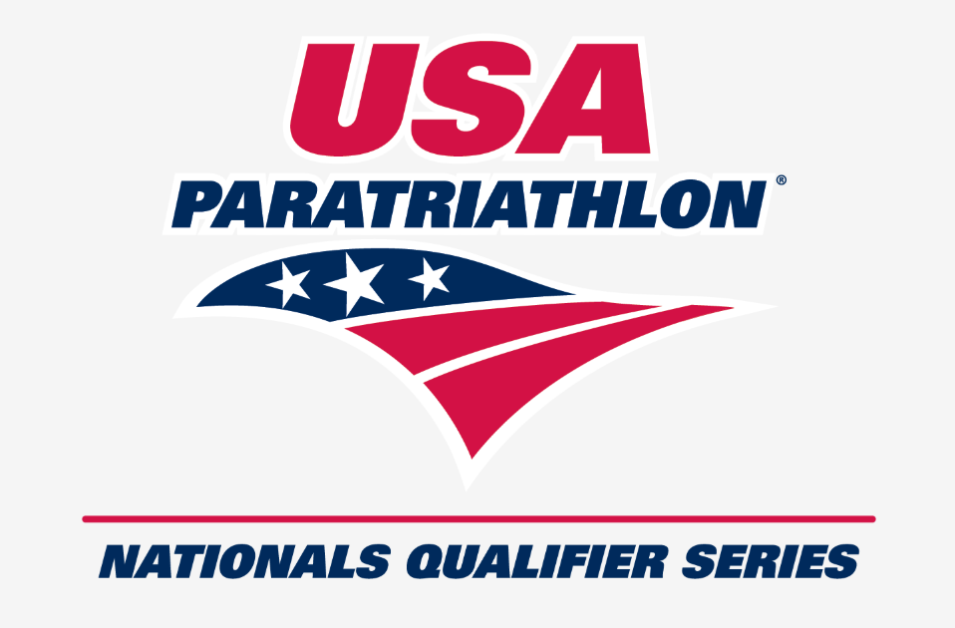

The USAT Paratriathlon Nationals Qualifier Race Series, formerly known are the Paratriathlon Development Series, is the premiere national-level racing circuit for up-and-coming paratriathletes in the United States. The aim of the series is to provide increased domestic competitive opportunities for the nation’s emerging paratriathletes. The Paratriathlon Nationals Qualifier Race Series provides paratriathletes and ATD1 athletes opportunities to race sprint distance races following USAT and World Triathlon paratriathlon competition rules. These races also offer a chance to qualify for the 2025 and 2026 USAT Paratriathlon National Championships with slightly more generous time standards than at other USAT-sanctioned races. Prior to each race, a USAT certified coach will host a clinic to help guide athletes through the course. Post-race, athletes accumulating points in a minimum of two series races and Nationals will receive series rankings. Top-ranked athletes will be awarded a sponsor-provided prize (details forthcoming) and recognized in our newsletter, on our website, and social media channels!

**2025 Race Series Events**

|  |  |  |
| --- | --- | --- |
| [**CLASH Endurance Miami**](https://clashendurance.com/pages/miami)  (Paratriathlon + ATD1 wave) | Homestead, FL | March 30, 2025 |
| [**St. Anthony’s Triathlon**](https://satriathlon.com/)  (Paratriathlon + ATD1 wave) | St. Petersburg, FL | April 27, 2025 |
| [**Lago Mar Triathlon**](https://www.trisignup.com/Race/TX/TexasCity/TejasLagoMarAquathon) (Paratriathlon + ATD1 wave) | Texas City, TX  (near Houston) | May 18, 2025 |
| [**Leon’s Triathlon hosted alongside USA Triathlon Military and First Responders National Championships**](https://leonstriathlon.com/) | Hammond, IN  (near Chicago) | June 1, 2025 |
| [**Treasure Valley Triathlon**](https://runsignup.com/Race/ID/Boise/TreasureValleyTriathlon) (Free Paratriathlon + ATD1 wave) | Boise, ID | June 7, 2025 |
| [**Pleasant Prairie Triathlon**](https://pleasantprairietri.com/)  (Paratriathlon + ATD1 wave) | Pleasant Prairie, WI | June 22, 2025 |
| **[Got the Nerve Triathlon](https://runsignup.com/gtn)** (Paratriathlon + ATD1 wave) | Ephrata, PA | June 22, 2025 |
| [**Long Beach Legacy Triathlon**](https://legacylongbeach.com/)  (Paratriathlon + ATD1 wave)  *The run course’s location on a public bike path may make it difficult to pass other athletes and limit high-speed acceleration, particularly for wheelchair runners | Long Beach, CA | July 20, 2025 |
| [**USA Paratriathlon National Championships hosted alongside USA Triathlon Sprint and Olympic-Distance National Championships**](https://www.usatriathlon.org/2025-sprint-and-olympic-nationals) | Milwaukee, WI | August 10, 2025 |

**Sport Class Classification**

Paratriathletes wishing to race in series races should have a USAT National Classification or a World Triathlon Classification of a “C” or “R” or “P” and be 16 years of age or older as of December 31, 2025.

If you have not yet been classified, you will need to have a good estimate of your future classification sport class so that you can register properly for the races. Please contact Chris Palmquist at [cspalmquist@gmail.com](mailto:cspalmquist@gmail.com) if you need some guidance on how you might estimate your sport class.

To request a classification appointment, you will need to qualify for and register for the USAT Paratriathlon National Championships in Milwaukee, WI on August 10th. Please send your medical diagnosis to [paratriathlon@usatriathlon.org](mailto:paratriathlon@usatriathlon.org) and Chris Palmquist at [cspalmquist@gmail.com](mailto:cspalmquist@gmail.com). Additional medical documentation needed for classification can be found here: <https://www.usatriathlon.org/adaptive-athletes/classification>

* A National Classification opportunity will be offered in conjunction with the USAT Paratriathlon National Championships in Milwaukee, WI on August 8-9, 2025.

**Paratriathlon Sport Classes**

All paratriathletes must compete within their USAT-approved sport class. There are nine sport classes in paratriathlon that compete in six medal events. PTWC1 and PTWC2 classes compete in the PTWC Medal Event. All the ambulant classes, PTS2-PTS5, compete in their own Medal Events. PTVI1, PTVI2 and PTVI3 compete into the PTVI Medal Event.

**PTWC1** - Most impaired wheelchair users. Athletes must use a recumbent handcycle on the bike course and a racing wheelchair on the run segment; Includes athletes with comparable activity limitation and an impairment of, but not limited to:  muscle power, limb deficiency, hypertonia, ataxia or athetosis.  
*Competes in PTWC Medal Event.*

**PTWC2** - Least impaired wheelchair users. Athletes must use a recumbent handcycle on the bike course and a racing wheelchair on the run segment; Includes athletes with comparable activity limitation and an impairment of, but not limited to:  muscle power, limb deficiency, hypertonia, ataxia or athetosis.  
*Competes in PTWC Medal Event.*

**PTS2** - Severe impairments. In both bike and run segments, amputee athletes may use approved prosthesis or other supportive devices. Includes athletes with comparable activity limitation and an impairment of, but not limited to, limb deficiency, hypertonia, ataxia and or athetosis, impaired muscle power or range of movement.  
*Competes in PTS2 Medal Event.*

**PTS3** - Significant impairments. In both bike and run segments, amputee athletes may use approved prosthesis or other supportive devices. Includes athletes with comparable activity limitation and an impairment of, but not limited to, limb deficiency, hypertonia, ataxia and or athetosis, impaired muscle power or range of movement.  
*Competes in PTS3 Medal Event.*

**PTS4** - Moderate impairments. In both bike and run segments, amputee athletes may use approved prosthesis or other supportive devices. Includes athletes with comparable activity limitation and an impairment of, but not limited to, limb deficiency, hypertonia, ataxia and or athetosis, impaired muscle power or range of movement.  
*Competes in PTS4 Medal Event.*

**PTS5** - Mild impairments. In both bike and run segments, amputee athletes may use approved prosthesis or other supportive devices. Includes athletes with comparable activity limitation and an impairment of, but not limited to, limb deficiency, hypertonia, ataxia and or athetosis, impaired muscle power or range of movement.  
*Competes in PTS5 Medal Event.*

**PTVI1** - Includes athletes who are totally blind, from no light perception in either eye, to some light perception. One guide is mandatory throughout the race. Must ride a tandem during the bike segment. A guide from the same nationality and gender is mandatory throughout the race. Must ride a tandem during the bike segment.  
*Competes in PTVI Medal Event.*

**PTVI2** - Includes athletes who are more severe partially sighted athletes. One guide is mandatory throughout the race. Must ride a tandem during the bike segment. A guide from the same nationality and gender is mandatory throughout the race. Must ride a tandem during the bike segment.  
*Competes in PTVI Medal Event.*

**PTVI3** - Includes athletes who are less severe partially sighted athletes. One guide is mandatory throughout the race. Must ride a tandem during the bike segment. A guide from the same nationality and gender is mandatory throughout the race. Must ride a tandem during the bike segment.  
*Competes in PTVI Medal Event.*

**ATD1 (Adaptive Triathlon Division 1)**

ATD1 (Adaptive Triathlon Division 1) athletes are paratriathletes who are not yet (or unable to be) classified. ATD1 athletes are welcome to race at the USAT Para Development Series events and at Paratriathlon National Championships in the ATD1 category (no qualification required). ATD1 athletes should register for the ATD1 category that best fits: ATD1 Wheelchair, ATD1 Ambulatory, or ATD1 VI.

**USAT Paratriathlon Nationals Qualification Standards for Para Nationals Qualifier Series Races**

Paratriathlon Nationals Qualification Standards are slightly more generous at Series races. See below for the time standards that you need to meet with any 2024 or 2025 USAT Para Nationals Qualifier Series Race to qualify for the 2025 USAT Paratriathlon National Championships in Milwaukee, WI on August 10th. Remember that you must be qualified for and registered for Para Nationals to request a National Classification Appointment.

|  |  |
| --- | --- |
| **Sport Class** | **2025 Paratriathlon Nationals Qualification at Para Nationals Qualifier Series Race** |
| Women PTWC | 1:34:31 |
| Women PTS2 | 1:51:08 |
| Women PTS3 | 1:35:34 |
| Women PTS4 | 1:48:09 |
| Women PTS5 | 1:33:55 |
| Women PTVI | 1:32:06 |
| Men PTWC | 1:19:19 |
| Men PTS2 | 1:37:40 |
| Men PTS3 | 1:35:34 |
| Men PTS4 | 1:23:54 |
| Men PTS5 | 1:23:12 |
| Men PTVI | 1:22:28 |

**Awards**

Awards or Recognition Certificates will be given at each series race and the USA Paratriathlon National Championships to the top three (3) athletes in each medal event, within each gender and will include VI guides.

Medal events are as follows for the eight (8) series races and USA Paratriathlon National Championships:

|  |  |
| --- | --- |
| **Medal Event: PTWC** | |
| **Women** | **Men** |
| 1st | 1st |
| 2nd | 2nd |
| 3rd | 3rd |

|  |  |  |  |  |  |  |  |
| --- | --- | --- | --- | --- | --- | --- | --- |
| **Medal Event: PTS2** | | **Medal Event: PTS3** | | **Medal Event: PTS4** | | **Medal Event: PTS5** | |
| **Women** | **Men** | **Women** | **Men** | **Women** | **Men** | **Women** | **Men** |
| 1st | 1st | 1st | 1st | 1st | 1st | 1st | 1st |
| 2nd | 2nd | 2nd | 2nd | 2nd | 2nd | 2nd | 2nd |
| 3rd | 3rd | 3rd | 3rd | 3rd | 3rd | 3rd | 3rd |

|  |  |
| --- | --- |
| **Medal Event: PTVI** | |
| **Women** | **Men** |
| 1st Athlete 1st GUIDE | 1st Athlete 1st GUIDE |
| 2nd Athlete 2nd GUIDE | 2nd Athlete 2nd GUIDE |
| 3rd Athlete 3rd GUIDE | 3rd Athlete 3rd GUIDE |

**To be eligible for awards athletes must:** race in the Paratriathlon division, be a U.S. citizen or U.S. National, hold a valid USAT annual USAT membership or elite paratriathlete membership and have a “C”, “R”, or “P” sport class status from USAT or World Triathlon. Athletes who hold USA Paratriathlon National Team status are eligible to compete at the USA Paratriathlon National Championships.

**USAT Membership**

All athletes competing in the series must hold a current annual USAT membership. Memberships can be purchased at [www.usatriathlon.org](http://www.usatriathlon.org).

**USA Paratriathlon Rules**

USAT Rule modifications for paratriathletes can be found here:   
<https://www.teamusa.org>

Any questions on these rules can be directed to Mark Turner, USAT Commissioner of Officials: [mark.turner@usatriathlon.org](mailto:mark.turner@usatriathlon.org)

General questions about the Series can be directed to Auburn Bosworth at auburn.bosworth@usatriathlon.org