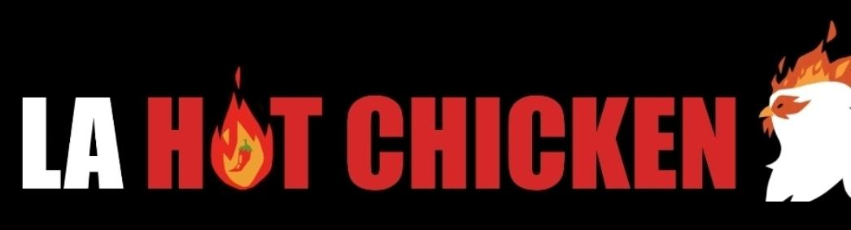
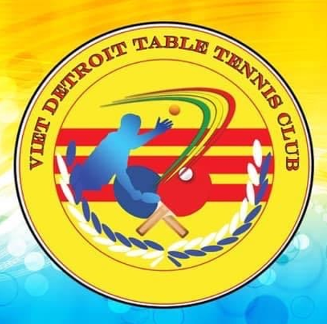
Livin Spaces, LLC
Paddle Palace and the Greater Michigan Table Tennis Org presents . . .
Motor City Spring Open
April 19-20, 2024 Bloomfield Hills, MI
A 4-Star USATT Sanctioned Tournament Awarding $2,850 in Prize Money
 | Event | Fee | Time | 1st Place | 2nd Place | 3rd Place | 4th Place | VENUE
 | FRIDAY |  |  |  |  |  |  | Cranbrook Kingswood Middle School for Girls
1. | Under 3800 Doubles | $25/pp | 6 pm | $150 | $100 |  |  | 39221 Woodward Ave., Bloomfield Hills, MI 48304
2. | Under 1500 | $30 | 6 pm | $50 | Medal |  |  | Gym, Wood Floors, 25 ft. ceiling (8 am open on Sat)
3. | Under 1200 | $30 | 6 pm | Medal | Medal |  |  | Court size exceeds minimum sanction requirements
 | SATURDAY
4. | Under 2200 | $40 | 9 am | $200 | $100 |  |  | EQUIPMENT
5. | Women’s Open | $40 | 9 am | $150 | $125 | $75 | $50 | 12 USATT approved Donic tables/nets, barriers
6. | Under 1600 | $35 | 9 am | $75 | Medal |  |  | White Nittaku Premium 3-Star balls
7. | Open Singles | $60 | 1 pm | $600 | $300 | $150 | $100
8. | O65 | $25 | 1 pm | Medal | Medal |  |  | TOURNAMENT STAFF
9. | U1800 | $35 | 1 pm | $100 | $50 |  |  | TD: Steve Gonzales CR: Michael Gill CU: Maruf Monwar
10. | U2000 | $40 | 5 pm | $150 | $100
11. | Hard Bat | $25 | 5 pm | $50 | $25 |  |  | ADVISORS
12. | Juniors U16 | $25 | 5 pm | $75 | $50 |  |  | Razmig B, Chad D, Tapa D, Mark N, Guilherme S, Maruf M
13. | U1400 | $25 | 5 pm | $25 | Medal
 |  |  |  |  |  |  |  | GMTTO.org

ELIGIBILITY: Events open to all USATT members. Please verify membership BEFORE tournament. Non-members may join by paying the membership fee or buy a tournament pass (qualifies as associate membership). See details below.
FORMAT: Round Robin events with 4 or more players per group with 2 advancing from each group into Single Elimination (SE). All matches are best 3 out of 5, except for Open Singles Finals, which will be 4 out of 7. We reserve the right to change formats as necessary.
RULES: All USATT regulations apply; only USATT approved equipment; USATT dress code will be enforced - no white shirts or shorts. Players cannot enter 2 events with the same starting time. Paddles must have black color on one side with either red, blue, green, pink or violet on opposite side. Hardbat rackets must be all wood. Matches will be 2 out of 3 with games played to 21. See rules on www.Hardbat.com
RATINGS: Ratings from March 15, 2024 will be used for eligibility. Updated ratings will be used for seeding. TD may modify, combine, cancel events and and/or limit total entrants. Unrated players may enter any event but cannot advance to SE from rated events except in Open Singles and Womens Open.
USATT MEMBERSHIPS: Memberships are available. Basic - $25, Pro-$75, Lifetime - $1,300. See www.teamusa.org/USA-Table-Tennis for more info.
SPONSORS: We thank our sponsors: LA Hot Chicken, Livin Spaces, LLC, Paddle Palace and Nittaku, Viet Detroit Table Tennis Club
RESTAURANTS /HOTEL: Restaurants in area. Recommended hotel is Quality Inn, 1461 N. Opdyke Rd., Auburn Hills, MI 48326 Ph. (248)-370-0044
PAYMENTS: Withdrawals by Monday, April 15, 2024 will receive a refund. No refunds after April 15. All payments must be received in full by midnight April 15. Unpaid entries will be removed after April 15. Late entries until April 17 with a $5 fee based on availability. Players earning $600 or more will be issued a Form 1099 and must provide required information. No walk-ins or payment accepted on day of tournament.
REGISTRATION: Register at www.omnipong.com using PayPal option. OR Check payable to Greater Michigan Table Tennis Organization. Mail entry and check to Steve Gonzales, 1747 Ashton Ln., Mason, MI 48854 (Postmarked by April 15). No Phone entries. Email inquiries to wreckdiver2006@gmail.com.
TOURNAMENT T-SHIRTS/FOOD: $15 cash preferred or Check made payable to Razmig Boghikian. Fresh prepared food available for purchase.
DIRECTIONS TO GYM: Specific directions with map with be emailed to participants.

NAME: ___________________________________  ADDRESS: ___________________________________  E-MAIL: ___________________________________  PHONE: ___________________________________  RATING: ___________________________________  USATT-MEMBERSHIP#: ___________________________________  EVENT FEES: $___________  USATT National Team Donation$___________  USATT MEMBERSHIP FEES: $___________  ADMINISTRATION FEE: $____7______  TOTAL: $___________ | Please enter me in the circled events. I agree to comply with all USATT regulations. I accept full responsibility for my participation and relieve the Greater Michigan Table Tennis Organization, Steve Gonzales, other advisors, sponsors and USATT of any liability resulting from injury to myself or damage to my property. Any image, photographic or otherwise, taken of tournament play or within the official venue is essentially the joint property of USATT, Greater Michigan Table Tennis Organization. Entrants agree to allow their voice and likeness in such images to be reproduced in connection with USATT, Greater Michigan Table Tennis Organization. All entries must be paid in full prior to participation.  CIRCLE ENTERED EVENTS 1 2 3 4 5 6 7 8 9 10 11 12 13  Signature: _____________________________________________  Date: _________________________

USATT TOURNAMENT PARTICIPANT WAIVER
IN CONSIDERATION of being permitted to participate in any way in USA Table Tennis sanctioned events, I and/or minor child, our personal representatives, assigns, heirs, and next of kin, I:
ACKNOWLEDGE, agree, and represent that I and/or minor-aged child understand the nature of Table Tennis Activities, including but not limited to risks involved in the sport itself together with all risks, known and unknown, associated with gatherings of people (“Activities”), including the exposure to COVID-19, coronavirus, or other infectious organisms or diseases; and that I and/or minor child are qualified, in good health, and in proper physical condition to participate in such Activities. I further agree that if at any time I believe conditions or equipment to be unsafe, I and/ or minor child will immediately discontinue further participation in the Activities.
FULLY UNDERSTAND that (a) TABLE TENNIS ACTIVITIES INVOLVE RISKS AND DANGERS OF SERIOUS BODILY INJURY, INCLUDING PERMANENT
DISABILITY, PARALYSIS, DISMEMBERMENT, AND DEATH ("RISKS"); (b) these Risks and dangers may be caused by me and/or minor child's own actions, or inaction, or the actions or inaction of others participating in the Activities, the condition in which the Activities takes place, or THE NEGLIGENCE OF THE "RELEASEES" NAMED BELOW; (c) there may be OTHER RISKS AND SEVERE SOCIAL AND ECONOMIC LOSSES either not known to me or not readily foreseeable at this time; and I FULLY ACCEPT AND ASSUME ALL SUCH RISKS AND ALL RESPONSIBILITY FOR LOSSES, COSTS, AND DAMAGES I
and/or minor child incur as a result of my participation in such Activities.
HEREBY ACCEPT AND ASSUME ALL SUCH RISKS, KNOWN AND UNKNOWN, AND ASSUME ALL RESPONSIBILITY FOR THE LOSSES, COSTS, AND/ OR DAMAGES FOLLOWING SUCH INJURY, DISABILITY, PARALYSIS, OR DEATH, EVEN IF CAUSED, IN WHOLE OR IN PART, BY THE NEGLIGENCE OF THE "RELEASEES" NAMED BELOW.
HEREBY RELEASE, DISCHARGE, AND COVENANT NOT TO SUE USA TABLE TENNIS, their respective administrators, directors, agents, officers, officials, volunteers, and employees, other participants, any sponsors, advertisers, and if applicable, owners and lessors of premises on which the Activities takes place, (each considered one of the "RELEASEES" herein) FROM ALL LIABILITY, CLAIMS, DEMANDS, LOSSES, OR DAMAGES ON MY ACCOUNT CAUSED OR ALLEGED TO BE CAUSED IN WHOLE OR IN PART BY THE NEGLIGENCE OF THE "RELEASEES" OR OTHERWISE, INCLUDING NEGLIGENT RESCUE OPERATIONS; AND I FURTHER AGREE that if, despite this RELEASE AND WAIVER OF LIABILITY, ASSUMPTION OF RISK, AND INDEMNITY
AGREEMENT I and/or my minor child, or anyone on my and/or my minor child's behalf, makes a claim against any of the Releases, I WILL INDEMNIFY, SAVE, AND HOLD HARMLESS EACH OF THE RELEASEES from any litigation expenses, attorney fees, loss, liability, damage, or cost which may incur as the result of such claim.
I HAVE READ THIS AGREEMENT, FULLY UNDERSTAND ITS TERMS, UNDERSTAND THAT I HAVE GIVEN UP SUBSTANTIAL RIGHTS BY SIGNING IT, AND HAVE SIGNED IT FREELY AND WITHOUT ANY INDUCEMENT OR ASSURANCE OF ANY NATURE AND INTEND IT TO BE A COMPLETE AND UNCONDITIONAL RELEASE OF ALL LIABILITY TO THE GREATEST EXTENT ALLOWED BY LAW AND AGREE THAT IF ANY PORTION OF THIS AGREEMENT IS HELD TO BE INVALID THE BALANCE, NOTWITHSTANDING, SHALL CONTINUE IN FULL FORCE AND EFFECT.
By registering for this table tennis tournament, all participants are subject to possible selection for drug testing as conducted by the US Anti-Doping Agency.
MEDICAL AND TRANSPORTATION RELEASE – I hereby give consent for the organizers of this table tennis tournament to provide me and/or my minor aged child with athletic trainer and emergency medical treatment. I swear and affirm that I am in good physical condition and I am not aware of any previous or existing diseases or injury that would result in my being injured. I further acknowledge that I have procured on my own and currently hold valid and adequate insurance for such loss, damage, or injury and if I do not have valid and adequate insurance, I accept full responsibility for the cost of the loss, damage, or injury that might occur as a result of my participation in this table tennis tournament. I give my consent to participate in any and all emergency transportation associated with activities during this table tennis tournament, in the event I become incapacitated or otherwise not conscious to give direct consent and I accept full responsibility for all costs associated with all emergency transportation as deemed necessary. Further, as the parent/guardian of a participating minor athlete, I hereby give my consent for complete medical treatment and emergency transportation services as deemed necessary beyond the on-site athletic trainer or emergency medical treatment provided.

MEDIA AND PHOTO RELEASE – Any image, photographic, or otherwise, taken of tournament play or within the official venue is essentially the property of USA Table Tennis regardless of the Approved status of the recording instrument or photographer. Entrants agree to allow their voice and likeness in such images to be reproduced in connection with USA Table Tennis by way of any medium. USA Table Tennis is not responsible for, nor can they control, the use of camera phones inside the venue. Participants are hereby notified of this policy.
SafeSport Compliance:
I understand USATT’s Safe Sport Policy including the organization’s Coaching Policy, which requires that all persons who are engaged in coaching activities at USATT Affiliated Member Clubs and/or USATT Sanctioned Tournaments, except parents or legal guardians coaching their own children, must be fully Safe Sport Compliant, which includes completing SafeSport Training offered by the US Center for SafeSport every year and undergoing a criminal background screen every two years.
I understand that, pursuant to USATT’s Minor Athlete Abuse Prevention Policy, all participants at USATT Sanctioned Tournaments who are over the age of 18 and have regular contact with or authority over minor athletes must complete annual SafeSport Training offered by the US Center for SafeSport.
More information on USATT’s Safe Sport Policy is available at: https://www.teamusa.org/usa-tabletennis/athlete-safety/safe-sport.
Signature of Participant Print Name: Date: ________________
Signature of Parent/ Legal Guardian Print Name: _______________________________ Date: _____________ (For Athlete of minor age 17 and under).
End. 20 12-15a

