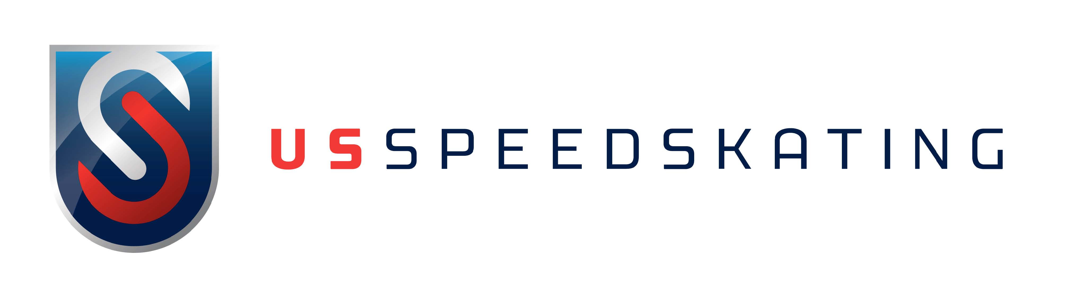

Date:

USS CODE OF CONDUCT NOTICE OF VIOLATION

TO:

Nature of Violation:

Decision:

Proposed Penalty:

Signature of USS Designee Date

If the penalty involves suspension or termination from U.S. Speedskating or any period of ineligibility, the athlete may dispute the proposed or imposed discipline described above according to the USS Grievance Procedures, detailed in section 14 of the US Speedskating Bylaws, except in the case of a positive doping test, in which case the USADA Protocol for Olympic Movement Testing and/or the ISU Doping Guidelines will apply. No athlete, coach, trainer, manager, administrator or official may be declared ineligible to participate without fair notice and opportunity for a hearing (unless that individual chooses to waive his/her right to a hearing). If you have any questions regarding this procedure, or the nature of the proposed or imposed discipline, please contact the US Speedskating Executive Director at 801-417-5360.

SERVICE

I hereby affirm that a copy of this Notice of Violation of the Code of Conduct was given to the Athlete/Member by me this day of , 20 .

Signature of Person Delivering Notice

