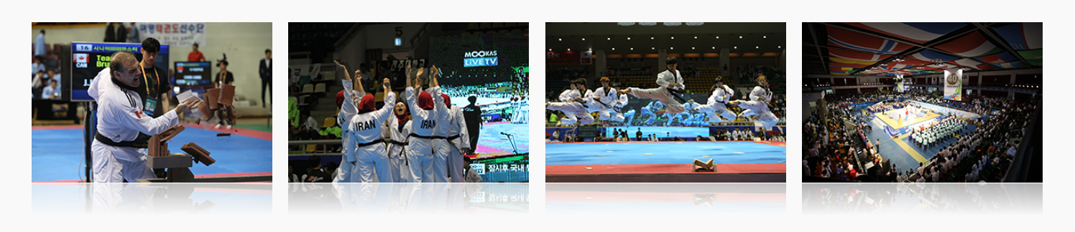
The Biggest Festival for Global Taekwondo Families : World Taekwondo Hanmadang

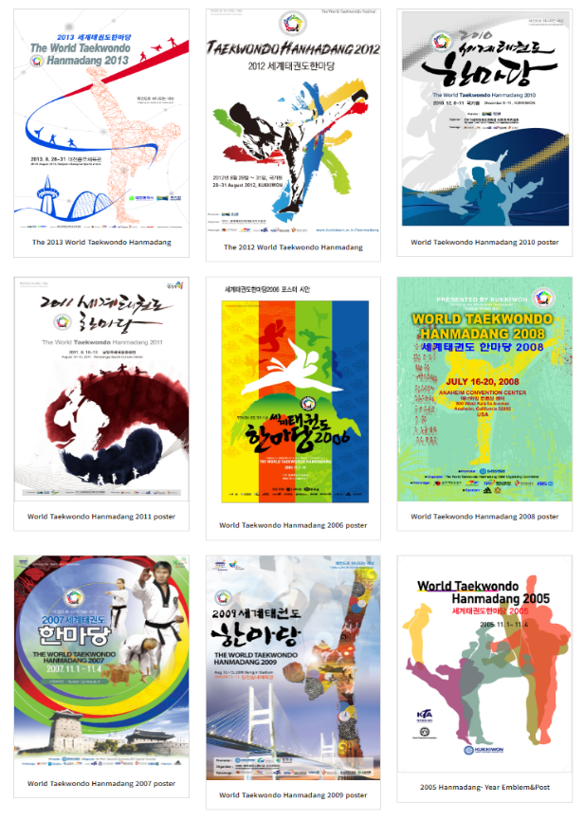
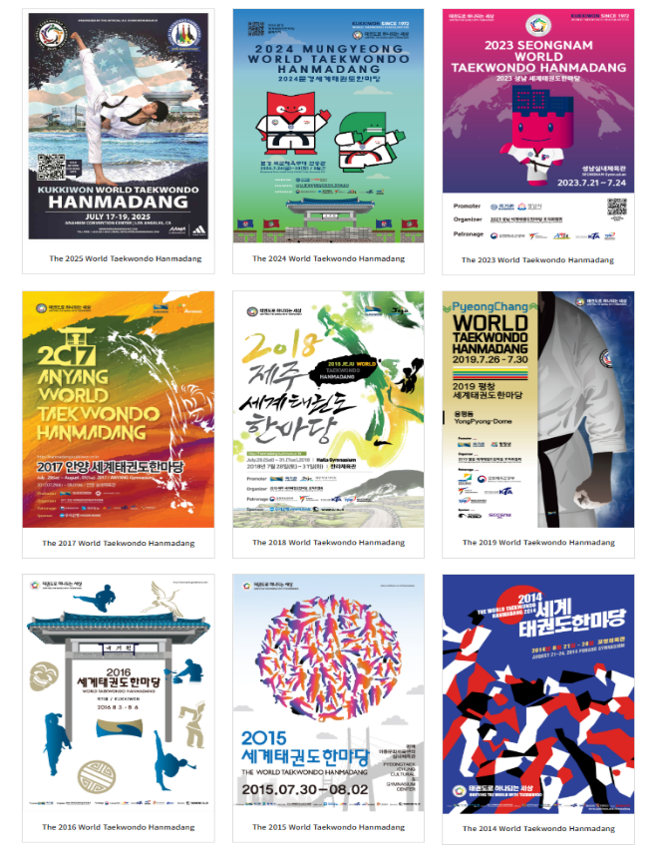
Kukkiwon holds World Taekwondo Hanmadang, the biggest festival for global Taekwondo families.
World Taekwondo Hanmadang (first called Taekwondo Hanmadang) was launched on December 9, 1992 under the banner of "Unifying the world with Taekwondo" The festival differentiates itself from other Taekwondo competitions by letting anyone with a Poom or a Dan certificate issued by Kukkiwon participate.

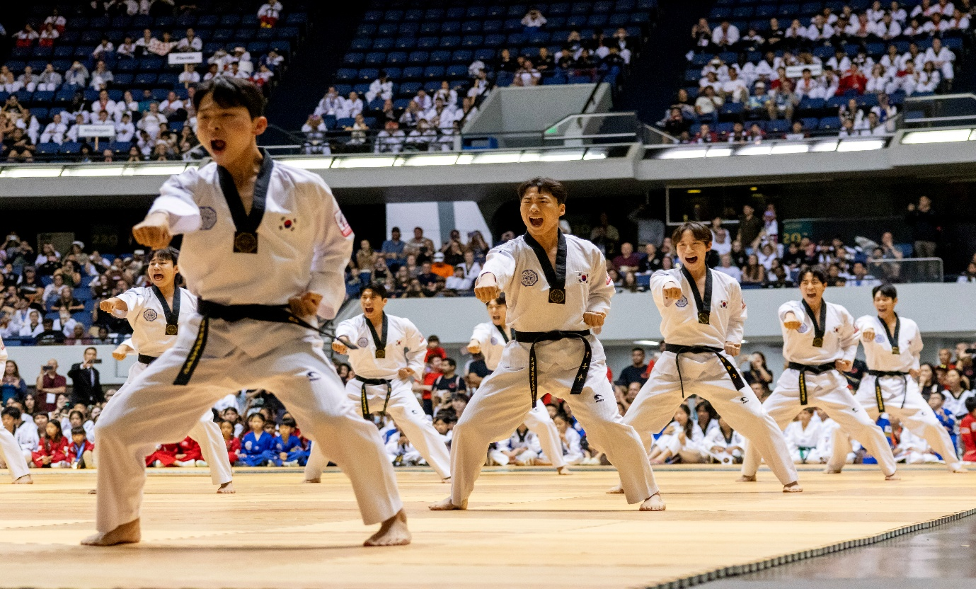
Organized by the Korea Taekwondo Association (KTA) in 1992, World Taekwondo Hanmadang was jointly organized by KTA and Kukkiwon in 1999. Since 2000, Kukkiwon has been the host of the festival.

With the participation of more than 5,000 practitioners from over 50 countries every year, World Taekwondo Hanmadang has become the best Taekwondo festival for demonstrating a variety of spectacular skills of Taekwondo including Poomsae, Gyeokpa, and self-defense except Gyeorugi, which is already vitalized as an Olympic item.
Not only that, World Taekwondo Hanmadang leads the commercialization of Taekwondo culture and tourism by enhancing the values of Taekwondo as a spiritual culture shared by the global population and promoting the excellence of the Taekwondo culture of the origin country.
