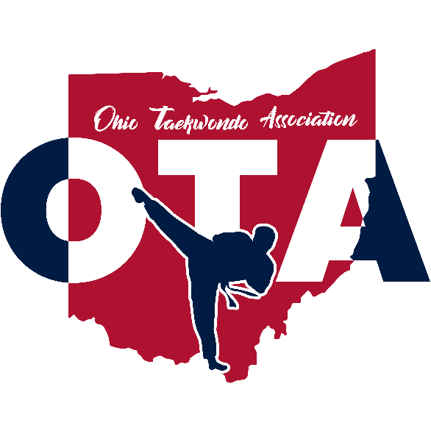 | 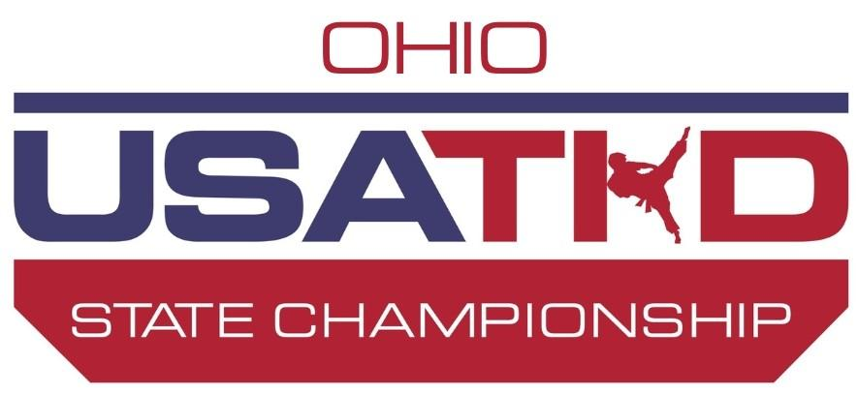
2026 USATKD Ohio State Championship
USA Taekwondo Sanctioned 12.0 Event

 Daedo Gen 3

Sunday, May 10th, 2026
Upper Arlington High School
1625 Zollinger Rd, Upper Arlington, OH 43221
Welcome to the State Championship!
WELCOME TO THE 2026 State Championship!
The State Championship will serve as a qualifying event for the 2026 U.S. National Taekwondo Championships, to be held in Charlotte, North Carolina.
Key Points:
- All athletes who earn a medal (Gold, Silver, Bronze) will be eligible for the U.S. National Taekwondo Championships.
*See Page 6 for World Class Qualification Requirements

HOST CITY/ACCOMMODATIONS
USATKD Ohio State Championship
Upper Arlington High School
1625 Zollinger Rd
Upper Arlington, Ohio 43221
Hotel Options
Home2 Suites Dublin-$149/Night
TownePlace Suites By Marriott Columbus Dublin- $139/Night
Please reference “Ohio Taekwondo Championships 2026” for these rates

PROMOTER – EVENT RANKING
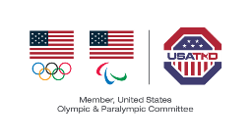
Promoter & Sanctioned By:
U.S.A. Taekwondo
Ohio Taekwondo Association

Ranking:
12.0
Ohio Taekwondo Association: https://www.ohiotaekwondo.org/
STATE POINTS OF CONTACT
OTA Event Email: events@OhioTaekwondo.org
For any and all USATKD Staff registration questions, email support@usatkd.zendesk.com

WEBSITE LINKS
- How-To-Register as an Athlete
- How-To-Register as a Coach
- Method of Competition & Competition Rules
- Team Trials Pathways and Procedures
- Dobok & Equipment Standards
- Sparring Weight Categories
- USATKD Kyorugi Head Contact Rules
- Poomsae Divisions
- Compulsory Poomsae
- Designated Poomsae
- Board Breaking Divisions
- Demo Team Division

SCHEDULE OF EVENTS
Date | Event | Time | Division
Wed  April 29 | Registration Deadline | 11:59 PM MT | All Divisions
May 3 | Designated Poomsae | 11:59 PM MT | Designated Poomsae Posted
Sat  May 9 | Athlete Weigh-in & Weight Changes  *All Athletes must weigh in by 7:00 PM | 4 PM – 7 PM EST | All sparring divisions  Location: Upper Arlington High School  Deadline: Weigh in by 7:00 PM EST
Sun  May 10 | Doors Open | 8:00 AM EST
Sun  May 10 | Check-in Opens | 8:00 AM EST | All Divisions
Sun  May 10 | Demo Check-in | 8:30 AM EST | All Demo team athletes and coaches check-in
Sun  May 10 | Referee Meeting | 8:30 AM EST | All referees
Sun  May 10 | Coaches Meeting | 8:45 AM EST | All coaches
Sun  May 10 | Check-in deadline | 9:15 AM EST | All athletes and coaches must check-in by 9:15 AM
Sun  May 10 | Tournament Begins | 9:00 AM EST | All Divisions on Sunday  Opening Ceremony  Demo Team  Sparring  Poomsae  Breaking

ATHLETE REGISTRATION
Registration for all athletes will be done through USATKD Sport80. All registrations must be completed by the registration deadline. There will not be any onsite registration for athletes or coaches.

2026 Ohio State Championship Registration Deadline: Wednesday, April 29th 2026, 11:59 PM, MST
THERE WILL BE NO LATE REGISTRATION.
USATKD HAS A NO REFUND POLICY.
All athletes must register and pay in full by the registration deadline. No exceptions will be made for not completing registration. If you are having trouble registering, please email support@usatkd.zendesk.com for assistance.

How-To-Register as an Athlete
Once on the USATKD Sport80 page:
- Click on “Events”, located on the left-hand side of the Home Page.
- Search for State Championship.
- Click on the “Enter Now” button for the State Championship registration.
- Click the +Enter button next to the athlete’s name.
- Follow the registration instructions within the site.

Tips For Successful Event Registration
Athletes must have their belt information in the belt section for their Sport80 profile. Missing belt information will prevent you from being able to select a division and register for any events.
*Black Belt Athletes: In addition to having a black belt listed in your profile, a photocopy of your black belt certificate must be uploaded into your Sport80 profile.
*Athletes aged 18 and older: Must complete the U.S. Center for SafeSport course each year.
- Log in to your USA Taekwondo Athlete profile on Sport80
- Click “View Profile”
- In the left navigation, click “Center for SafeSport Training”.
- In the top right, select the +Access Training button and follow the prompts to select and complete the SafeSport – Core Training Course.
- After completion, within 24 hours it will automatically validate that you completed the training on your Sport80 profile.
World Class Black Belt Athletes:
US Citizenship is NOT required to compete in the World Class Black Belt division at a State Championship.

Athlete Event Credentials:
Sparring athletes are checked in when they weigh in during their scheduled weigh-in period. Any athlete who does not weigh in will be marked as “Disqualified”.

ATHLETE REGISTRATION FEES
Event Entry Fee | Price Per Division
- $100 | $25

COACHING REQUIREMENTS AND REGISTRATION
Registration for all coaches will be done through USATKD Sport80. All registrations must be completed by the registration deadline. There will not be any onsite registration for coaches.
2026 State Championship Registration Deadline: Wednesday, April 29th 2026, 11:59 PM, MST
Profile Requirements to Register as a Coach for an Event:
- Upload a profile picture on your Sport80 profile.
- Have a current U.S.A. Taekwondo Membership on Sport80
- Have a current and valid Background Screen (valid through the final day of competition) (Ages 18+)
- Have a current and valid SafeSport Core Training (Valid through the final day of competition) (Ages 18+)
- Have either an Associate Coach or Level 1 Coach Course completion in the discipline you want to coach and have it uploaded and validated on your Sport80 profile.
  - To complete the course, CLICK HERE
- Please follow all steps on the following website to make sure your profile is complete; you will not be able to register until your profile is completed: How to Register as a Coach
Coaches must be an Associate Coach or Level 1 or higher to coach in the World Class Sparring & World Class Poomsae divisions at the National Championships, Final Championships, U.S. American Open, State Championships, and all USATKD Sanctioned Events. Your coaching certification must be in the discipline you are coaching, i.e. Kyorugi, Poomsae, or both.
SafeSport – Background Checks (Coaches 18 and over)
Coaches (Ages 18+) are required to complete and pass a background check (every two years) and complete the U.S. Center for SafeSport Training (Annually). The background check is conducted by a third-party system and can take anywhere from one week to one month to complete. Please initiate your background screening as soon as possible to ensure it is complete before the registration closes.
The SafeSport certification must be completed in your Sport80 Profile.
- Log in to your USA Taekwondo Coaches profile via Sport80
- Click “View Profile”
- In the left navigation, click “Center for SafeSport Training”
- In the top right, select the “+Access Training” button and follow the prompts to select and complete the SafeSport – Core Training Course
Credential: All coach credentials must have a photo. These photos are taken from your profile picture on Sport80. COACH CREDENTIALS ARE NON-TRANSFERABLE. USATKD HAS A NO REFUND POLICY

COACH REGISTRATION FEES
Entry Fee
$20

QUALIFICATION
Athletes must have a USATKD membership to participate in a State Championship tournament.
Age Qualification: USATKD uses the date December 31 of the given year to determine the competition age for all athletes. EX. A 14-year-old athlete turns 15 years old on September 27th, meaning they would compete as a 15-year-old athlete for all events during the calendar year.
Belt Qualification Rules: All athletes will be eligible to compete at the State Championship at the current belt in which they hold.
Weight Class Qualification Rules:
All athletes may compete in the current belt color in which they hold and weight category. Athletes may change weight classes prior to the registration deadline of Wednesday, April 29th 2026, 11:59 PM, MST. Any changes after the registration deadline must be made prior to stepping on the official scale to weigh-in and will be charged a $50 weight-change fee.
Weigh-in times will be scheduled beforehand (see the Schedule on Page 5). All participants must provide a valid ID to weigh-in. There is no exception to this policy. Valid ID can be any of the following: Government Issued ID, School ID, GAL, Military ID or Passport. If the athlete is a minor and does not have a Valid ID, then they are allowed to provide a copy of the athlete’s birth certificate.

WEIGH IN, WEIGHT CHANGES, & BELT CHANGES
Weight, Belt and Division Changes:

All Weight Changes Must Be Made Before Stepping on The Official Scale. NO EXCEPTIONS.
Athletes can change weight classes through the final registration deadline at no additional fee. If an athlete would like to change their weight class before the final registration deadline, they must email support@usatkd.zendesk.com. After the final registration deadline, all weight changes must be made prior to stepping on the official scale to weigh-in and will be charged a $50. Any weight changes after the registration deadline will incur a fee.

Weigh In Rules:
- A competitor’s weight shall be measured the day prior to their competition day. All competitors must weigh-in during the designated times on the schedule.
- A competitor’s weight may be measured twice. If a contestant does not qualify the first time, one more official weigh in attempt is granted within the scheduled time period. A scale, one that is calibrated the same as the official scale, will be provided in the weigh in area as a test scale so that athletes can check prior to stepping on the Official Scale.
- Before stepping on the Official Scale, athletes are required to show their valid ID and their virtual athlete credential.
- Any irregular action by the athlete or their coach during the weigh-in process may result in disqualification from the event.
- Weigh-in for adult athletes 18 years old and older, for both male and female, shall be taken in the official V-neck uniform, or, if a contestant wishes, weigh-in may be done in underpants for adult male athletes and underpants and bra for adult female athletes. Under no circumstances may an athlete weigh-in in the nude in the United States.
- Minor athletes who are 17 years old or younger must weigh-in wearing clothing or Dobok ONLY. Minor athletes will be given a 0.2kg allowance for clothing. One parent or guardian of the same sex will be allowed in the weigh-in room with their child.
- Phones are NOT ALLOWED in the weigh in area unless being used to show virtual credentials. Pictures and/or videos are absolutely not allowed to be taken while in the weigh in area.

METHOD OF COMPETITION & COMPETITION RULES
Athletes must wear the appropriate uniforms for sparring and/or poomsae. Click Here to view the uniform requirements: Dobok & Equipment Standards
The current competition rules for all divisions will be used. To view the current version, go to: https://www.usatkd.org/usatkd-competition-rules
Bracketing and Seeding: Seeding will be done for all sparring and poomsae divisions based off the most recently posted U.S. National Rankings.
Sparring – A single elimination format will be applied to all sparring divisions.
- Sparring Weight Categories
- USATKD Kyorugi Head Contact Rules
NOTE - All Sparring athletes are required to use Daedo GEN 3 e-footgear and GEN 3 PSS gloves
Poomsae – All poomsae divisions will be seeded for the first round according to the USATKD National Rankings

BOARD BREAKING & DEMO TEAM
Board Breaking:
Participants may only use boards purchased at the event from the event vendor.
Athletes 9 years old and younger will use ¼ inch boards, athletes ages 10-14 years old will use ½ inch boards, and athletes 15 years old and older will us 1-inch boards.
- Board Breaking Rules and Divisions
Board Breaking Holders: Athletes are responsible for providing their own board holders. Any board holder who is 18 + must complete the SafeSport Core Training Course through Sport80 prior to receiving their board holder credential. Athletes and/or their board holders can obtain a board holding credential at the Registration Desk on the day of competition for that division. This credential will only be valid for the day of the competition and must be returned to the Registration Desk after the division has been completed.
Demo Team:
Demo Team is open to all athletes who meet the age and belt requirements.
- Demo Team Rules & Division
GENERAL INFORMATION
Event Spectator Tickets: $20 – Available in advance via Zeffy at the following link: 2026 USAT Ohio State Taekwondo Championship or Cash the day of the event.
Medical
Sports Med Staff will be ringside and in the medical tent to provide injury and illness care for all participants. Please remember when taping ankles or instep pads, competitors must comply with the rules set forth by the WT and USATKD.
AWARDS
Sparring: Medals will be given out to the top 4 athletes, in the respective divisions and weight categories.

Poomsae: Medals will be given out to the top 4 individuals, pairs (co-ed), and teams in the respective divisions. For those World Class Poomsae Team divisions, where an alternate has registered, the athlete will receive a medal if they have participated in the event. USATKD defines participation as check-in, stepping on the mat, and competing in front of judges.

Creative Events (Board Breaking and Demonstration Team): Medals will be given out to the top 4 athletes for board breaking and the top 4 Demonstration Teams, in their respective divisions in Board Breaking and Demonstration Team.

INDIVIDUAL AWARDS
1ST PLACE | GOLD MEDAL
2ND PLACE | SILVER MEDAL
3RD PLACE | BRONZE MEDAL
3RD PLACE | BRONZE MEDAL

