QUICKSTART GUIDE:

CONCUSSION STORY WALL

(INTERACTIVE WEBSITE DATABASE)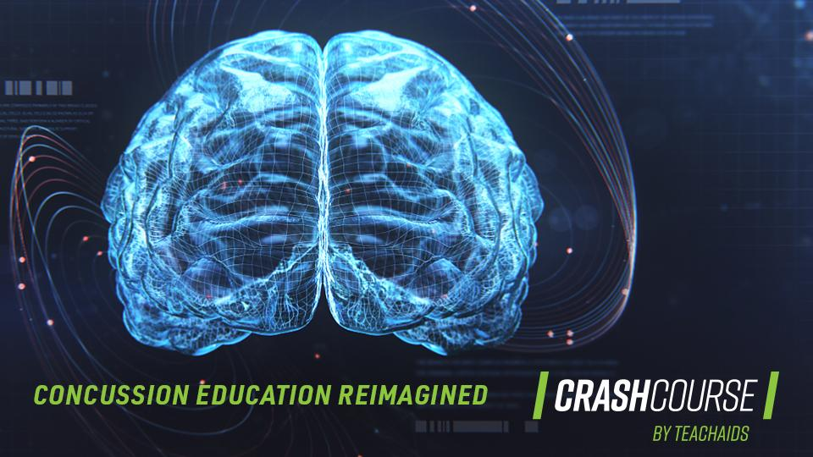

**Table of Contents**

ABOUT THE CRASHCOURSE PRODUCT SUITE 3

ABOUT THE GUIDE 4

Overview 4

Important: Pop-Up Warnings on Your Device 4

Included Media Assets 4

Introduction Boilerplate Text 5

Example Implementation 6

CONCUSSION STORY WALL IMPLEMENTATION 9

Product Overview 9

Example Implementation 10

Step 1: Introduce Product with Text/Graphics 12

Media Assets Required 12

Product Description Boilerplate Text 12

Step 2: Embed Product Resource Link 12

Concussion Story Wall Link 12

Best Practices 13

QUESTIONS? 13

# ABOUT THE CRASHCOURSE PRODUCT SUITE

After six years of research and thousands of hours of production and user-testing, TeachAids created the CrashCourse product suite. We quickly discovered that there are a number of basic myths and misconceptions surrounding concussions. To address these issues in the most impactful way, we enlisted the expertise of more than 100 medical and industry leaders along with the critical voices of people with lived experience in the development of our products.

CrashCourse’s award-winning programs have been adopted by the most influential organizations across the United States and the world. Our partnerships with the U.S. Olympic and Paralympic Committee’s National Governing Bodies, Stanford’s Lucile Packard Children’s Hospital, and the National Council of Youth Sports allow us to reach over 60 million youth in organized sports programs. In addition, our collaborations with the Brain Injury Association of America, National Association of State Head Injury Administrators, VA Palo Alto Health Care System, Stanford Program on International and Cross-Cultural Education, and other special programs position us to reach more than 100 million medical professionals, caregivers, parents, athletes, coaches, and veterans in countries like the United States, Canada, and Great Britain.

The CrashCourse product suite harnessed the power of scientific experts, sports organizations, leading advocacy groups, and thousands of volunteers to make better concussion education a reality. Our research-based, interactive products are available online (free of charge) as standard videos and in virtual reality to provide communities with the latest medical knowledge on the prevention and treatment of concussions.

Learn about CrashCourse here: [trailer](https://youtu.be/TBvrmzs-SOw) | [website](https://teachaids.org/for-concussions/crashcourse/) | [advisors](https://teachaids.org/about/team/?show_members_from=concussion) | [product suite](https://teachaids.org/for-concussions/products/)

### Proper Usage of These Products:

The TeachAids CrashCourse Concussion Suite includes three education products. All TeachAids products are offered under a [Creative Commons License](https://creativecommons.org/licenses/by-nc-nd/4.0/). Please read the license carefully. In essence, the products:

* Must be free
* Must be attributed to TeachAids
* May not be altered for distribution

Our products are available under our [Terms of Use](http://teachaids.org/terms-use/). If you wish to engage in a formal partnership (no cost) with TeachAids, contact [info@teachaids.org](mailto:info@teachaids.org) to learn more.

# ABOUT THE GUIDE

This guide provides instructions on how to implement our **Concussion Story Wall** interactive website database.

## Overview

This guide provides text and graphics for you to use to introduce the CrashCourse product suite on your website, app, etc. You may choose to include additional information about your organization and involvement with TeachAids. The files are linked throughout this guide, and you can also find them in folders in the ZIP file.

### Important: Pop-Up Warnings on Your Device

Relative hyperlinks, which will bring the user to specific locations within the Media Assets folder attached, may cause a “pop-up” warning message. If a warning appears, **click “yes”** to proceed to open the folder. If the link does not work, you can find the specific folder/file referenced by following the italicized file path below the relative hyperlink and its description. Example warning messages are below.

### Included Media Assets:

* [Graphics](Associated%20Media%20Assets/Step%202%20Assets%20(Graphics)/Graphics): This folder contains a variety of graphics provided for thumbnails and website text to select at your discretion.
  + *File path:* *Associated Media Assets/Step 2 Assets (Graphics)/Graphics*
* [Logos](Associated%20Media%20Assets/Step%202%20Assets%20(Graphics)/Logos): This folder contains a variety of CrashCourse and TeachAids logos to select at your discretion.
  + *File path: Associated Media Assets/Step 2 Assets (Graphics)/Logos*

### Introduction Boilerplate Text:

Adjust any of the following text as relevant. You are welcome to include more text from the TeachAids background section above or from our [CrashCourse by TeachAids website](https://teachaids.org/for-concussions/crashcourse/).

To help bring the latest concussion education to our community, [INSERT YOUR ORGANIZATION NAME] has joined [TeachAids](https://teachaids.org/for-concussions/crashcourse/), a nonprofit leader in global education innovation, in sharing CrashCourse. With research conducted out of Stanford and Harvard universities, TeachAids developed the [CrashCourse concussion education product suite](https://teachaids.org/for-concussions/products/) in collaboration with [world-class medical, sports, and education experts](https://teachaids.org/about/team/?show_members_from=concussion). We are proud to distribute TeachAids’ award-winning and interactive learning experiences.

The CrashCourse products are designed as comprehensive education and mental health resources for all who are affected by concussions. These products aim to raise awareness of the latest science around concussions, medically referred to as mild traumatic brain injuries, to shift the conversation away from fear and silence toward one of knowledge and empowerment.

TeachAids’ partnerships with the U.S. Olympic and Paralympic Committee’s National Governing Bodies and the National Council of Youth Sports allow the CrashCourse products to reach young people across organized sports. The products are also used by the Centers for Disease Control and Prevention (CDC), Brain Injury Association of America, National Association of State Head Injury Administrators, VA Palo Alto Health Care System, Stanford’s Lucile Packard Children’s Hospital and other special programs, making this concussion education available to more than 100 million caregivers, parents, athletes, coaches, and veterans in countries like the United States, Canada, and Great Britain.

## Example Implementation

For your reference, below are some examples of how the CrashCourse products have been integrated into the websites of multiple organizations.

**National Council of Youth Sports (**[**link**](https://www.ncys.org/education/education-crashcourse/)**)**

**Brain Injury Association of America (**[**link 1**](https://www.biausa.org/brain-injury/about-brain-injury/concussion-mtbi/crashcourse)**,** [**link 2**](https://www.biausa.org/brain-injury/community/concussionstorywall)**)**

**USA Football (**[**link**](https://footballdevelopment.com/courses-certifications/)**)**

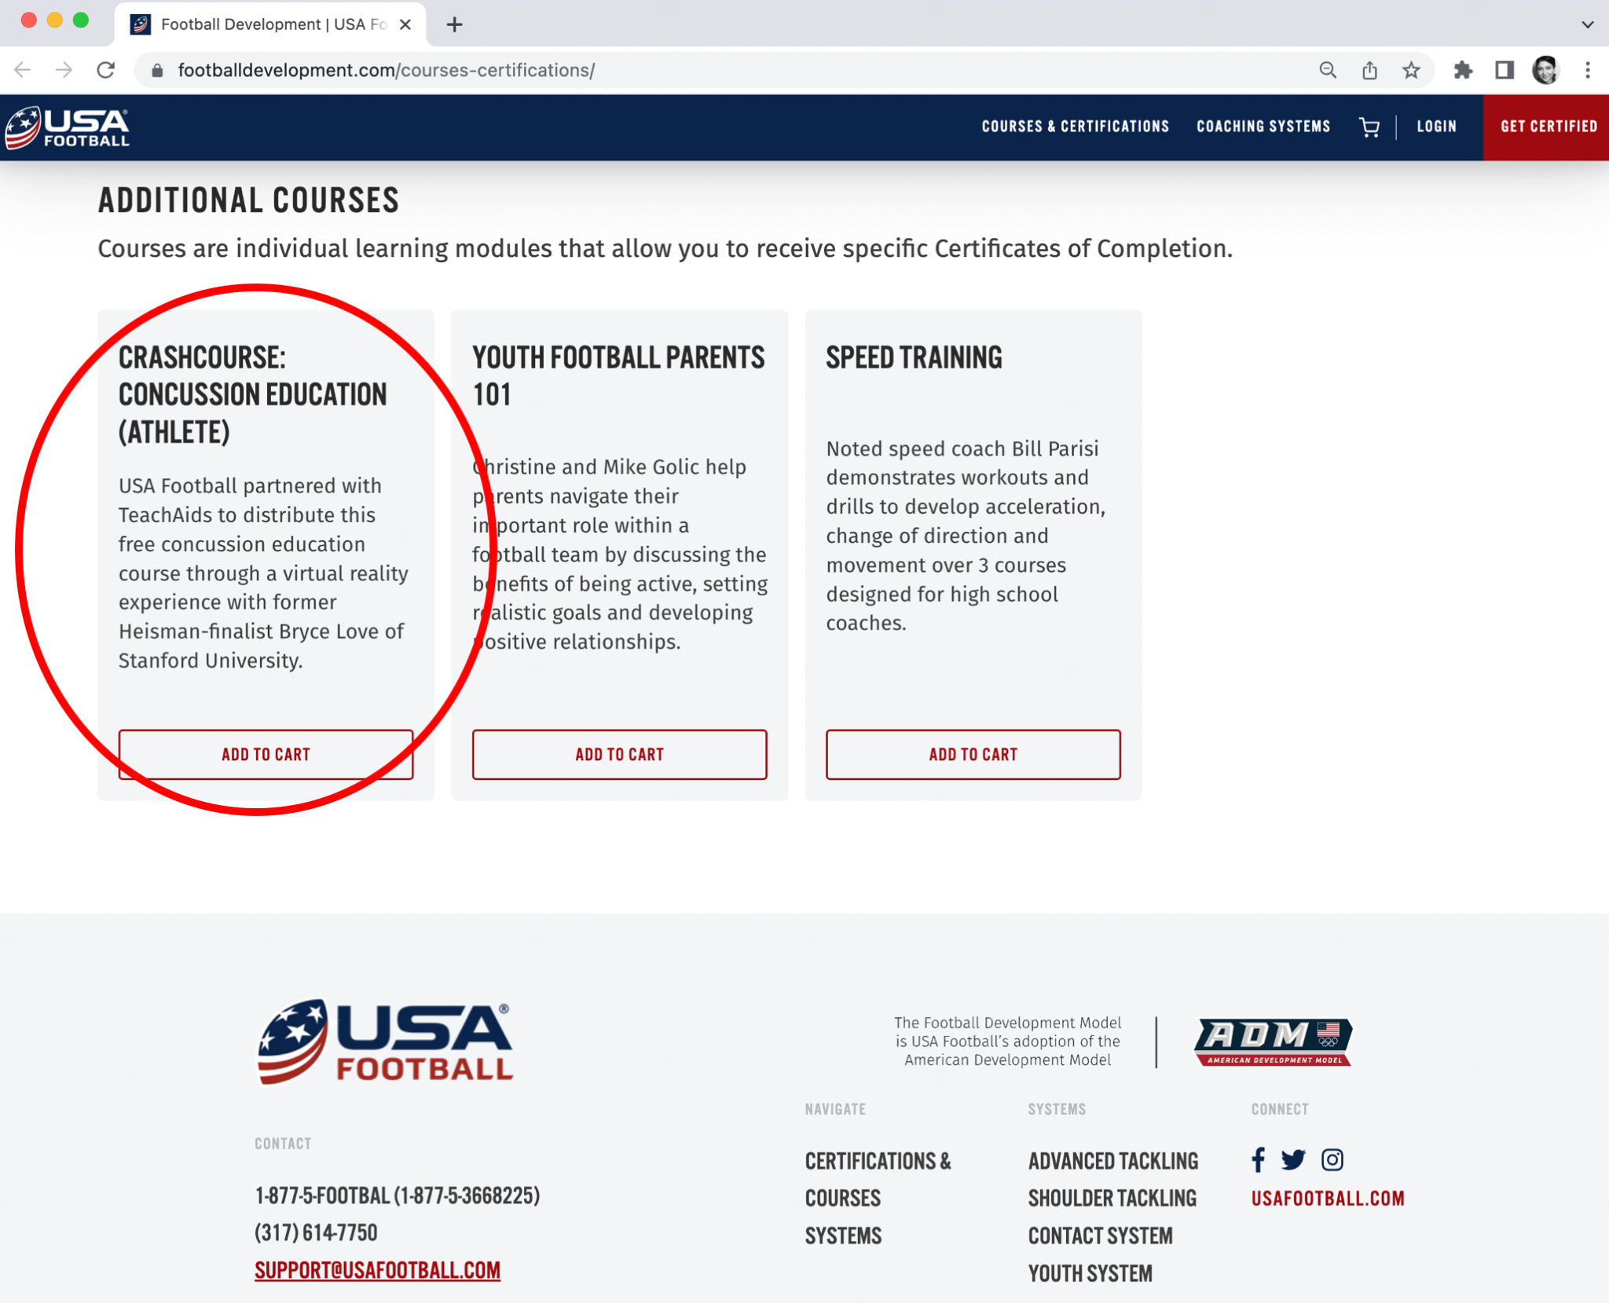

# CONCUSSION STORY WALL IMPLEMENTATION

## Product Overview

The CrashCourse Concussion Story Wall website is an interactive database featuring 4,000 video stories from individuals describing personal concussion experiences. It is intended as a comprehensive mental health resource for the many who are affected including athletes, parents, coaches, officials, teachers, caregivers, and military veterans. It also serves as a referral source for athletic trainers, rehab specialists, and physicians. Additionally, 14 leading medical experts offer video descriptions of concussion symptoms and how best to manage them. This is an invaluable resource to give users a well-rounded understanding of concussions and their effects on real people.

### Example Implementation:

Below are examples of how the CrashCourse Concussion Story Wall has been integrated into different websites.

**Brain Injury Association of America (**[**link**](https://www.biausa.org/brain-injury/community/concussionstorywall)**)**

**National Council of Youth Sports (**[**link**](https://www.ncys.org/education/education-crashcourse/)**)**

## Step 1: Introduce Product with Text/Graphics

Use the provided text and graphics to introduce the CrashCourse Concussion Story Wall on your website.

### Media Assets Required:

* [Graphics](Associated%20Media%20Assets/Step%202%20Assets%20(Graphics)/Graphics): This folder contains a variety of graphics provided for thumbnails and website promotion to select at your discretion. (Note: We have provided variations of each thumbnail option. For consistency, we recommend using the same “play button” color option for each CrashCourse product on your website.)
  + *File path: Associated Media Assets/Step 2 Assets (Graphics)/Graphics*

### Product Description Boilerplate Text:

Adjust any of the following text as relevant. You are welcome to include more text from our [Concussion Story Wall website](https://concussionstorywall.org/).

This Concussion Story Wall product is an interactive database of more than 4,000 video stories relating to how an injury occurred, the symptoms experienced, and personal insights from individuals who have sustained a concussion. It includes [a panel of the world’s leading medical experts](https://concussionstorywall.org) addressing specific aspects of concussions. This product is intended as a comprehensive mental health resource for the many who are impacted – including athletes, parents, coaches, officials, teachers and military veterans. A key goal is combating stigma and communicating best health practices. The Concussion Story Wall serves as a referral source for athletic trainers, rehab specialists, physicians and concussion clinics.

## 

## Step 2: Embed Product Resource Link

Simply link the Concussion Story Wall’s external website onto your own website along with the product description text above. We recommend placing this link on both the selected graphic and in the product description.

### Concussion Story Wall Link

<https://concussionstorywall.org/>

## Best Practices

To optimize the user experience, please ensure the following:

* Test your implementation across all devices (e.g., iPad, iPhone, PC) and browsers (e.g., Safari, Chrome, Explorer) to ensure the Concussion Story Wall appears correctly across all platforms.

# 

# QUESTIONS?

For CrashCourse Product Suite implementation questions,

please contact [info@teachaids.org](mailto:info@teachaids.org).