New National Referee FAQ’s

- What should I do before the tournament?
  - First, be sure to read the informational email the national office sends out the week of the event. If you don’t receive this, contact referees@usafencing.org.
  - Save the phone numbers of the assigners from the email into your phone so you can call them if you have a bout committee appeal.
  - Be sure to attend the pre-NAC Zoom call for referees (now called “Monthly Referee Zoom Call”), information about which is also provided via email from the national office. This meeting will include need-to-know updates about the NAC and discussions on rules interpretation.
  - If there are travel delays, please contact referees@usafencing.org as well as the referee coordinator for the tournament whose contact information will be listed in the informational email.
- What should I expect my day to look like?
  - Check your report time every day at www.usafencing.org/officials. The times are posted the night before.
  - Breakfast will be provided at the hotel, sometimes with a voucher and sometimes without, so check the national office’s email or the front desk of the hotel.
  - When you arrive at your first national event of a season, be sure to pick up your referee credentials at USA Fencing’s check-in desk.
  - Check the informational email for any morning meetings and be sure you attend on time - there’s always one on the first day of a national event, usually at 7:45 am, and for summer nationals there’s a second meeting halfway through the 10 days.
  - Make sure to scan the barcode on your badge when reporting to the venue and when departing to clock in and out. You can scan your credentials at the main registration desk or Satellite BC. This is not included in any evaluation and is just to collect overall statistics of how long referees’ days typically are. Many referees do this after the morning meeting, but it’s a more accurate representation of your working time if you can do it in advance of the meeting.

  - Grab a clipboard, pencil, and weights/shims if necessary before they’re all gone. These are usually near the IT tables next to bout committee.
  - When your event starts (e.g., 8 am) head on over to bout committee in front of the printed sign with your event name and listen for your name to be called as pool sheets are handed out. You might be with a partner, especially if this is your first national event. If you get the sheet first, be sure to find your partner. Ask someone for help if you don’t know them. If you can’t find them, ask bout committee to page them to your strip and get started. If your name was never called, ask your assigner for assistance finding which pool you’re assigned to.
  - After your pool is finished, return it to bout committee (at the same sign labeled with your event) and then go help other people finish their pools if they’re by themselves and need help double-stripping for speed.
  - After pools, check with your bout committee official to see if your name has been added to a pod. Often, the pod assignments will be posted at the bout committee station where you picked up/turned in your pool sheet. If not, check with the assigner to see if they need you anymore. If you get a “handshake” being released, check in with the referee coordinator to get your next assignment.
  - If you do have a pod assignment in your original event, go work DEs until you are released by your pod captain. Do not leave your pod area without telling your pod captain, even if it’s to go to the bathroom or grab coffee. When you have been released, check with your assigner to see if you will be used in the video rounds or if you will be going to a different event. If you are released by your assigner, check with the ref coordinator for any other assignments for the day. It’s very important that you follow this “hierarchy of handshakes.”
  - When you’ve finally been released by the referee coordinator you can go scan your badge to check out and you’re done for the day! Note that sometimes at the end of a long day the referee coordinator has already left, and in that case, your event assigner is your final handshake
  - Some notes on food - you’ll be sent to lunch sometime between 11-3, varying by the tournament. Sometimes this is between pools and DEs, or during DEs,

or sometimes even between events. If you’re sent to lunch during DEs by your pod captain, clarify if you should come back or not before you leave the pod.
  - Sometimes they’ll need you to return after eating lunch to help finish the remaining bouts. If they do not need you to return, figure out your next assignment before going to lunch. If your pod needs you to return, then limit your lunch to about 20 minutes before heading back to the pod.
  - As for dinner, if you work past a certain time (typically 6:30pm or 7:00pm, depending on the tournament), you will receive a food voucher from your assigner to use at vendors within the convention center. If the concession stands are closed, and you are unable to redeem your vouchers, you can expense your dinner (up to $20; alcohol not included) when you submit all your receipts at the conclusion of the tournament.
  - Diagram of your day: 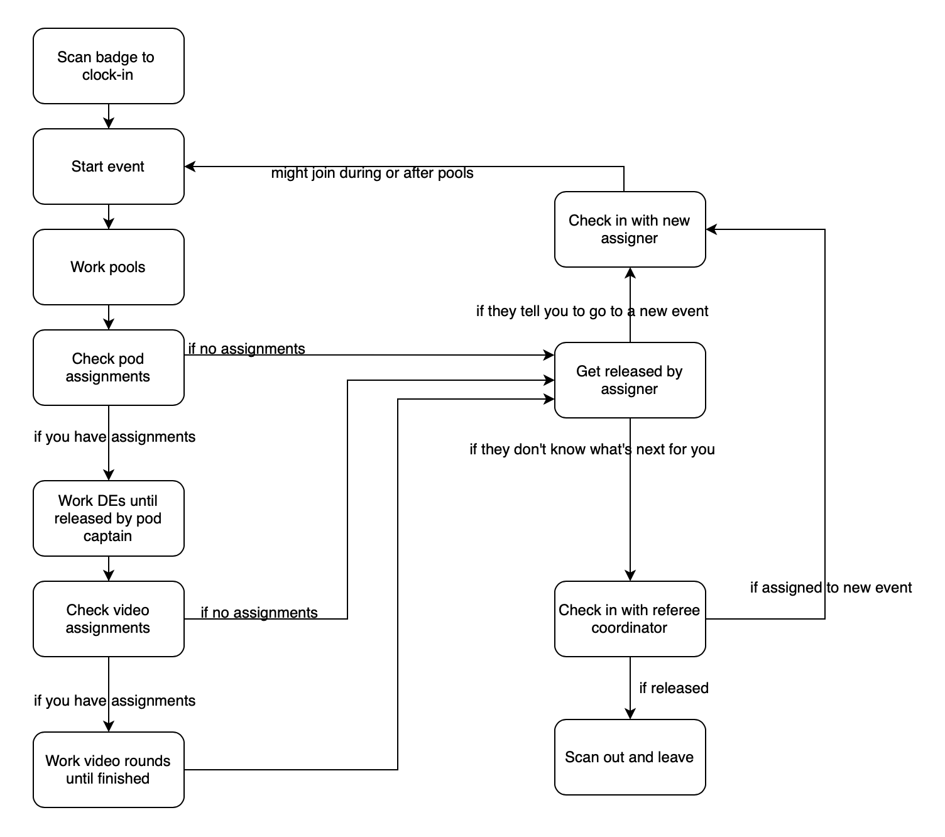

Hierarchy of handshakes:
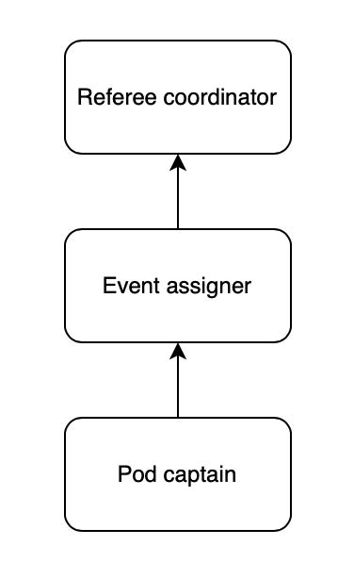

- What if I have a conflict of interest, either real or perceived (e.g., club, division, friends, family, ex-partner)?
  - If you feel like your calls could be biased towards or against a fencer, coach, or club, OR you believe that it might even appear that way, let your assigner or pod captain know. Note that at national events, conflicts also include any fencer who shares your division, which is handled automatically in pools but needs to be manually checked in DEs.
  - If the conflict is on a pool sheet, tell your assigner and they’ll swap you to a different pool. If the conflict is in a DE, tell your pod captain and they’ll give your bout to a different referee. If you’re continuing on to the video round, check the fencers listed and let your assigner know as necessary.
- How do we let assigners know our preferred weapon for multi-weapon refs?
  - At the beginning of the weekend, or even in advance via email, reach out to the referee coordinator. You might not get assigned to your preferred weapon all the time depending on the needs of the tournament, but this will allow the coordinator to try and find a spot for you where you’d like to work.

- A fellow referee is filming me with a tablet - what’s up with that?
  - The Referees’ Commission runs an assessment program to help develop referees. The person filming you is a high-level referee who is there to record your bout and discuss it with you later to help you improve. You will also receive a copy of the video at some point in time from the national office. This is not an exam, it’s purely to help you develop your skill set!
- How do we call for medical or armory?
  - Medical and armory calls are handled through a texting system. You should stay at your strip and text (312)757-7223 for medical and (754)227-6679 for armory, including your strip number. Save these numbers in your phone for easy access. Do not try and call these phone numbers - they will not work. If you do not get an automated text back saying “Got it” within a minute, send another text. This is because sometimes convention centers have poor signal. and the message might not go through. You can also send another text if you do not get confirmation that someone is on their way within 5 minutes.
  - For an armory call, in addition to the strip number be sure to include the symptoms of the issue so they know what equipment to bring.
  - Once you text medical or armory, make sure to keep the fencers on strip. It is helpful to keep them near the en garde lines to keep an eye on both of them simultaneously. This is not time for coaching or a water break. If it’s a medical break where it is taking a while for someone to arrive, the fencers can place chairs next to the strip (not on the metal piste) and sit.
  - During a medical call, once the trainer has arrived, they will assess the situation. Ask them to tell you if and when the injury has been confirmed and then start your 5-minute timer. Note that parents and coaches will often try and come into the pod during this process but they should not enter the area.
- I got assigned to video rounds, what should I expect?
  - Go head over to satellite bout committee and the mini ref corral nearby. Your assigner will come over and give out bout slips one round at a time. Your fellow referees can provide further instruction on each role - reffing “up front,” video referee, or “boom (controlling the camera)
  - When you’re done with all your assignments, be sure to get a handshake from your assigner and continue with the usual process before continuing to another event or leaving for the day.

- What if I’d like to coach or cheer on friends or students while I’m at the tournament?
  - No coaching, cheering, or outward displays of support of a competitor are allowed by referees until they have been officially released by the referee coordinator for the day, or must be done before “clocking in” at the beginning of the day if you’re planning on coaching in the morning then refereeing in the afternoon.
  - If you are coaching or supporting someone off the clock, you must remove your blazer and your referee credential to make it clear that you are not an active official.
Travel and Pay
- How do I get paid?
  - Sign up for direct deposit in advance of the tournament using the Direct Deposit Form available on this page
  - If you have not completed your direct deposit form, visit the check-in desk at the NAC for a direct deposit form or with questions on how you will be paid.
- Per Diem Advancement
  - USA Fencing will issue full per diem payments to officials, beginning on the first day of competition, excluding Summer Nationals. This policy applies exclusively to those enrolled in direct deposit. To set up direct deposit, please follow the instructions provided above. Note that your direct deposit form must be completed and sent into the national office at least one week before the competition begins.
  - If you are paid by check, your per diem will be included with your honorarium and sent after the event concludes.
  - The amount per diem to be paid will be based upon the officials’ contracted work and travel schedule. Officials will be paid the per diem amount of $50 per day worked, along with a maximum of two travel days.
- How do I book my flights? What if I’m driving?
  - If you are a full-time referee (see definition in the Full-Time Expense Form here), USA Fencing will reimburse you for your flights and mileage. For flights, make sure you have a profile with Cain Travel – If you do not have a Cain profile, please reach out to referees@usafencing.org to get an account set up. Then you can book your flights once you have been officially hired for a

tournament. If you are driving, please reach out to national events ahead of time notifying them of your travel days and that you will be driving.
  - Details on mileage reimbursement are outlined in the Full-Time Expense Form here. You must complete that form or the equivalent Part-Time Expense Form within 30 days of the end of a tournament to be reimbursed.
- Where will I stay?
  - If you are a full-time referee (see definition in the Full-Time Expense Form here), USA Fencing will provide a hotel room shared with another official. You will receive an email confirmation of your hotel location and roommate about a week before the tournament.
  - Be sure to complete your referee profile on the member portal with roommate preferences and whether you’d like a single room. You can also email specific roommate requests in advance of the tournament to t.gonzales@usafencing.org
  - If you are a part-time referee, you will be responsible for your own lodging.
- How do I get reimbursed for extra expenses?
  - USA Fencing will reimburse full-time referees for transportation to and from the airport and your home or the hotel, parking fees at the airport, bag fees, etc. only as enumerated in the Full-Time Expense Form here. You must submit your expenses for reimbursement within 30 days of the end of a tournament to be reimbursed. Starting with January NAC 2025, all officials will be required to use Emburse Certify for expense reimbursement submissions. You should have received a welcome email directly from Emburse at the beginning of the 24-25 season with directions to getting your account set up, if you have not received this email, please reach out to t.gonzales@usafencing.org. You can find guides of how to submit your expense found here on the website underneath “Officials Documentation and Forms”.

