**INFORMATION PACKET**

Dear Taekwondo Athletes, Coaches, Officials and Supporters:

The Arizona State Taekwondo Association would like to personally invite you to the 2025 USAT Arizona State Taekwondo Championships and National Qualifier on April 12, 2025, at Washington High School.

The Arizona State Taekwondo Association (AZTA) is the USA Taekwondo approved organization for the state of Arizona. Our non-profit organization is committed to enabling athletes to achieve sustained competitive excellence, while promoting the growth of Sport Taekwondo throughout Arizona. Our events will help fund the Arizona State Taekwondo Team, workshops, seminars, and other educational events. We welcome your participation and encourage you to share in our successes. We wish that our success can be success for your athletes as well!

All state championships will be 12.0 events. Beginning in 2025 **all Athletes that**

**finish in the Top 4 (Gold, Silver, Bronze, Bronze) at a State Championship will automatically qualify for the 2025 U.S. National Taekwondo Championships.** Athletes may only attend 1 State Championship of their choosing. If an athlete does not win a gold, silver, bronze, or bronze medal at a state championship the athlete can qualify for the U.S. National Taekwondo Championships through the American Open tournament series. Athletes must be a U.S. Citizen to participate in the world class divisions at the **U.S. National Taekwondo Championships**. Citizenship or residency documents are **not required** to participate in **state championships** or other state

sanctioned tournaments or more information on the national points and ranking system process, please check out the USA Taekwondo website.

.

For those of you who are already familiar with us, you know our dedication to supporting athletes and developing Sport Taekwondo here in Arizona. This can only be continued if we encourage sound fundamentals, build relationships, and remain true to our martial art values. We invite you to come and experience our event and see what we have been working so hard to grow. With your help and support for the Arizona State Taekwondo Association we can continue our efforts to bring in fun, exciting and competitive events to our region.

We welcome you to our event and encourage you join in the future of Arizona State Taekwondo. We wish you and your athletes the best of luck!

Sincerely,

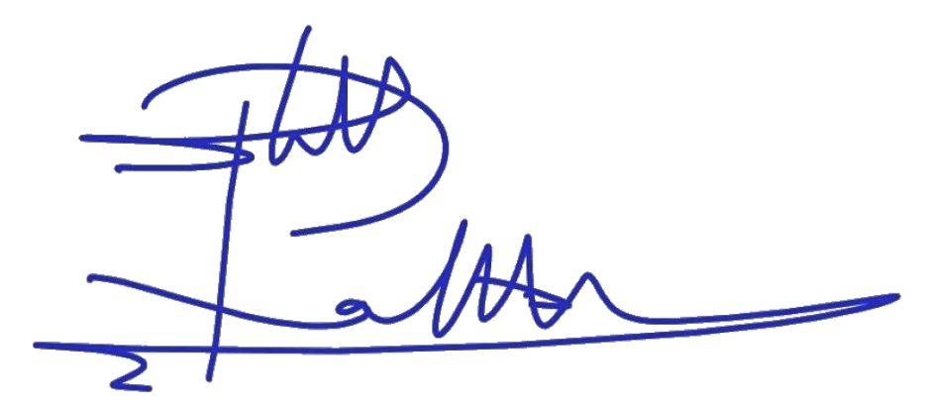

Grand Master Rubben Lolly

President of Arizona State Taekwondo Association

**SANCTIONED BY**

USATKD

1 Olympic Paza

Colorado Spring, CO 80909

Ranking: US 12.0

**Attention all USAT Certified Referees and prospective Referees:**

The Arizona State Taekwondo Association is promoting the growth of all aspects of Sport Taekwondo competition and invites you to participate in the upcoming 2025 Arizona State Taekwondo Championships.

Certified Referees who attend the State Championship will receive the following benefits:

**I/R Level:** $150 Stipend, 2-nights hotel stay and up to $250 reimbursement for travel

**USAT Level A, B:** $100 stipend 2-nights hotel stay and up to $100 reimbursement for travel

**USAT C or D Level:** $75 Stipend, - nights hotel stay and up to $100 reimbursement for travel

Hotel stay and travel reimbursement is provided for out of state referees only

All Referees will be provided food and drinks the day of the competition.

Proof of expenses will be verified for travel reimbursements

We will be following all current USAT Rules and Guidelines, using Daedo True Score Scoring Systems and having five rings (3 rings - 8X8 Black Belt, 2 rings – 7X7 Color Belt) and approved Poomsae software. The ring staffing format will include and subject to change as needed:

1 - Technical Assistant

4 - Certified Referees/ Judges

1 - Computer Operator

3 - 4 Ring Runners

We truly look forward to your participation. We realize that the best way to improve the value of our events is to run them in a timely fashion with highly capable and experienced referees. We will do our absolute best to minimize downtime, keep the competitors flowing to the rings, and ensure that the day starts and ends on time.

If you are available to be an official for our event, please register online through Sport 80 by March 12, 2025.

Our sincerest thanks for your participation in advance!

The Arizona State Taekwondo Association

***REGISTRATION INFORMATION***

* ***ONLINE ONLY at*** [*https://usataekwondo.sport80.com/*](https://usataekwondo.sport80.com/)
* ***All Coaches, Referees, and competitors must be current members of USA Taekwondo, pass background check and Safe Sport to be eligible.***
* ***All referees must register by March 12, 2025.***
* ***Event Date: April 12, 2025***
* ***Entry Fees******:***
  + ***Athletes Early Registration: $125, and $25 for Each Event***

* + ***Coaches: $65***

***Early Registration ends on March 13, 2025.***

***Registration fees after March 13:***

* ***Entry fee is $150, and $35 for Each Event***
* ***Coaches: $65***

**Final Registration; April 2, 2025**

**There will be absolutely no registration after April 2, per USAT**

**NO REFUNDS WILL BE GIVEN FOR ANY REASON, ABSOLUTELY NO EXCEPTIONS.**

**USA Taekwondo membership is required before registration.**

**If you need assistance registering for the event, please view a short** [**video**](https://vimeopro.com/user44435707/usatkd-member-tutorials/video/431742671) **that has been provided**

***SPECTATOR ADMISSION: $20.00, under 5 years old are FREE***

***TIMES: Check in 8:00 am, competition begins promptly at 9:00 am. Please be on time to avoid missing your event***

***WHERE: Washington High School***

***2217 W. Glendale Ave. Phoenix, AZ 85053***

***AWARDS: 1st, 2nd and two 3rd places will be awarded.***

**GOVERNANCE**

Each State Championship or approved sanctioned tournament must use and follow the

USATKD rules and regulations. For current sparring and poomsae rules please refer to the following link*,* [*http://www.teamusa.org/USA-Taekwondo/Events/Competition-Rules.aspx*](http://www.teamusa.org/USA-Taekwondo/Events/Competition-Rules.aspx)*.*

Seeding for events will be based on the current National Rankings posted on the USATKD website:[*https://www.usatkd.org/v2-national-teams/tusah-us-national-rankings*](https://www.usatkd.org/v2-national-teams/tusah-us-national-rankings)to seed each **sparring** **and poomsae** division.

**MEMBERSHIP REQUIREMENTS**

Athletes must have an active USATKD membership to compete in a State Championship or Other Sanctioned Event. The membership must be active through the conclusion of the tournament. They must also have a belt listed in their USATKD profile. Please see the How To Register section of the USATKD website (<https://www.usatkd.org/athlete-how-to-register-for-an-event> ) for step by step instructions.

All coaches and referees are required to hold the appropriate and current USATKD membership prior to the start of the competition. Please see the How To Register section of the USATKD website (<https://www.usatkd.org/coach-how-to-register-for-an-event>) for step by step instructions. **If any coaches or referees participate without a current USATKD membership,  
then the liability insurance will be invalid, and the State Association shall assume all responsibility for any injury or liabilities accrued at the event.**

All coaches, referees, and club owner/instructors 18 and older are required to complete and pass the USATKD background check and complete the SafeSport training before registering for USATKD state sanctioned events. Athletes 18 and older must complete the SafeSport training before registering for USATKD state sanctioned events.

The background check must be completed **every two years**. The SafeSport Refresher or Core Training must be completed **every year**. The background check and SafeSport must be active through the  
conclusion of the event

**WEIGH-INS/CHECK IN**

***All competitors must check-in Friday night April 11, 2025.***

***NO EXCEPTIONS WILL BE MADE TO THIS RULE.***

***Date and time: April 11, 2025, 5:30pm to 9pm***

***Venue:* Washington High School, *Main Gym***

***2217 W. Glendale Ave. Phoenix, AZ 85053***

All sparring Black Belts & Color Belts **MUST** weigh in on April 11, 2025

1. A competitor’s weight shall be measured the day prior to his or her competition day. **All competitors must weigh-in during the designated times on the schedule.**

2. A competitor’s weight may be measured twice. If a contestant does not qualify the first time, one more official weigh-in is granted within the time limit. If a competitor weighs the second time and does not make weight, they will be disqualified from the competition. For your convenience, so as not to be disqualified during official weigh-in, a scale, the same as the official one, will be provided at the venue as a test scale.

3. **During the weigh-in, the contestant is required to show his/her current photo ID, USA Taekwondo identification card or birth certificate.**

4. Any irregular action by the competitor or coach during the weigh-in may result in disqualification from event participation.

5. Weigh in, for both males and females shall be taken in the official V-neck uniform, or, if a contestant wishes, weigh-in may be done in underpants for male and underpants and bra for female contestants. ***Under NO circumstances may an athlete weigh-in in the nude in the United States.***

**WEIGHT and BELT CHANGE**

A competitor will be allowed to change weight if they choose to do so before their second official weigh in or belt colors onsite. **This will result in additional $50, fee no exceptions.**

**The Venue**

**Washington High School**

**ADDRESS:** 2217 W Glendale Ave, Phoenix, AZ 85021

**DIRECTION:**

<https://www.google.com/maps/dir/33.3479936,-111.8437376/washington+high+school+phoenix+az/@33.4427224,-112.1166044,11z/data=!3m1!4b1!4m9!4m8!1m1!4e1!1m5!1m1!1s0x872b6cdb23e6623d:0x4b09e2d9258876d2!2m2!1d-112.1060778!2d33.5368068>

**From the South: I-17 North. Exit on Glendale Ave. Turn Right (east) on Glendale Ave to 23rd Ave. Turn Right (South) on 23rd Ave and left into the parking garage.**

**From the North: I-17 South. Exit on Glendale Ave. Turn Left (East) on Glendale Ave to 23rd Ave. Turn Right (South) on 23rd Ave and left into the parking garage.**

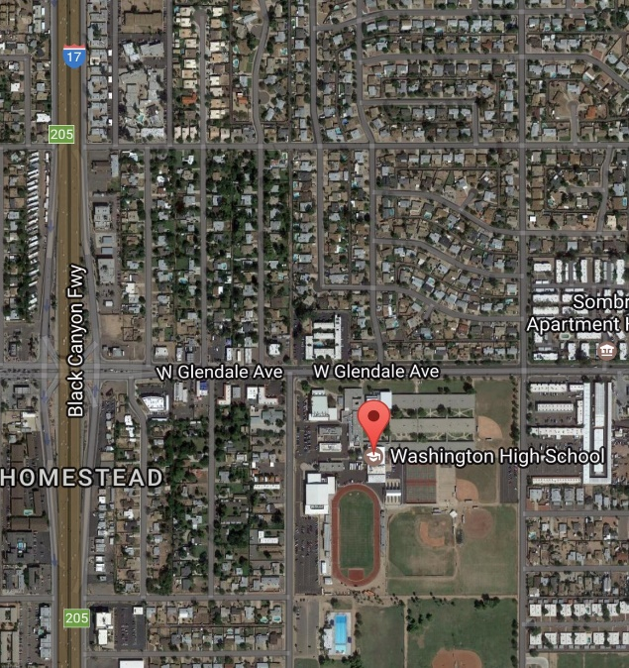

EVENT HOTEL

**DoubleTree by Hilton Phoenix North**

**10220 N. Metro Parkway East, Phoenix, AZ  85051 Hotel: 602-997-5900**

**Booking Link:** [https://www.hilton.com/en/book/reservation/deeplink/?ctyhocn=PHXNTDT&groupCode=CDTAZT&arrivaldate=2023-02-03&departuredate=2023-02-05&cid=OM,WW,HILTONLINK,EN,DirectLink&fromId=HILTONLINKDIRECT](https://nam02.safelinks.protection.outlook.com/?url=https%3A%2F%2Fwww.hilton.com%2Fen%2Fbook%2Freservation%2Fdeeplink%2F%3Fctyhocn%3DPHXNTDT%26groupCode%3DCDTAZT%26arrivaldate%3D2023-02-03%26departuredate%3D2023-02-05%26cid%3DOM%2CWW%2CHILTONLINK%2CEN%2CDirectLink%26fromId%3DHILTONLINKDIRECT&data=05%7C01%7CAmy.Johnson%40hilton.com%7C9ccdccaa35ba45a2d02608daede1f52d%7C660292d2cfd54a3db7a7e8f7ee458a0a%7C0%7C0%7C638083851977610776%7CUnknown%7CTWFpbGZsb3d8eyJWIjoiMC4wLjAwMDAiLCJQIjoiV2luMzIiLCJBTiI6Ik1haWwiLCJXVCI6Mn0%3D%7C3000%7C%7C%7C&sdata=ZO1X3Vp3udWTPssYQrRKlmMTXhTwW9e931fYEhmr5cI%3D&reserved=0)

**REGISTRATION DEADLINES & FEES**

All registration must take place on the USA Taekwondo [Sport80](https://usataekwondo.sport80.com/) platform. Please have your USA Taekwondo membership number accessible to register.

All athletes and coaches must register and pay in full by the early registration dates to receive the early registration fee. If payment is not received by early registration deadline you will be required to pay the final registration fee.

Athletes will need to check their belt information in the belt section. Athletes will want to make sure a belt color is added in your Sport80 profile. Not having belt information will prevent you from being able to select any events for the Grand Prix Series. Black belt athletes will need to upload a copy of their black belt certificate in [Sport80](https://auth.sport80.com/saml/login?SAMLRequest=jZFNTwIxEIbv%2FIqmd3a7X3w0yxKUgyQYCawevJjZboXG3RY7XfTnW0AiiYnx1rx9Z95nZvLpZ9uQg7SojJ7QKGB0WvTyWed2ei3fO4mOeIfGCe2s5gZQIdfQSuRO8M3sfsnjgPG9Nc4I01CymE%2FoiwAYJCIdJmkaD%2BLXcSKyLB2OajmqasaSygvjyv9JoOTpku37%2BHLETi40OtDOSyyO%2Bizts6iMBjwb8iR7pmTuoZQGd6raObdHHobgiQPcG%2BtGLBCmDRHaJmzMVmlKVt94N0rXSm%2F%2FnqU6m5DfleWqv3rYlJTMEKU9Bt4ajV0r7UbagxLycb38QegQHMi3D6Nr8xsFBNIiPz75aUh73is%2FKn8DwSWcFv%2BLaqWD2hvy8CquyMPrqxa9Lw%3D%3D&SigAlg=http%3A%2F%2Fwww.w3.org%2F2001%2F04%2Fxmldsig-more%23rsa-sha512&Signature=QghFWPXF6eSNqYL1uOnb%2FbtwGANy156CRSMU78k5ZWWbhPhY8AV02JF0gdooo9V4LCxwBKmyMuzuaXU2oCrm%2FT83JARatmMQBFP%2B%2Bh9nLmpLpVx7P80fmp9ZIwd%2FNKjFoUtqAm9Wr9kzUGsRChuyggZL2yy1DuDekz5IRHQYPs9ORT6%2BxLLPbdAfmI%2Bum28KUxQ5yE8kTTnC0BrPNlGTQkRnYbw1K0F11zdromZXLHCi5bRR1zyUW0Xyq%2BetJ3CAyEWaw8i78ePs%2Fyh9fzvSlrb4gubuVT%2FtsGjgRtcBtfqBWS2WMutgdLFoEdej1dytZTAP%2BeD67b5DuGKbnI7Grg%3D%3D).

USA Taekwondo has a NO REFUND policy. **NO REFUNDS** will be given for any reason.

|  |
| --- |
| **COACHES** |

|  |  |  |  |  |
| --- | --- | --- | --- | --- |
| CIDP LEVEL | Early Registration Fee | Early Registration  Deadline | Final Registration Fee | Final Registration Deadline |
| Associate Coach or Level 1 | $65.00 | March 23, 2025 | $65.00 | April 2, 2025 |

All coaches ARE REQUIRED to hold at minimum an Associate Coach (AC) Certification within the USA Taekwondo CIDP program, be a current member, completed the Center for SafeSport training (every year), and taken and cleared the USATKD background check (every 2 years). Coaches may obtain the AC certification by passing the Associate Coach Quiz. The AC Coach Quiz should be completed at least 5 business days prior to the State Championship registration deadline to allow for grading. Coaches will also be required to view the Center for SafeSport Training Video. The SafeSport video and background check must be completed before a coach can take the AC Quiz and register for an event. All documents regarding the State Championship or an approved State Tournament must inform coaches that each coach is required to be a member of USATKD, take and clear the USATKD background check every two years, complete the SafeSport video training every year, and have, at minimum, an AC certification to participate in the event. When discussing how to obtain a USATKD CIDP AC certification, please use the following link. <http://www.teamusa.org/usa-taekwondo/v2-coaching/coach-education-program>

The background check and SafeSport training can be accessed through your [Sport80](https://usataekwondo.sport80.com/) member portal.

**USATKD 2025 Updates**

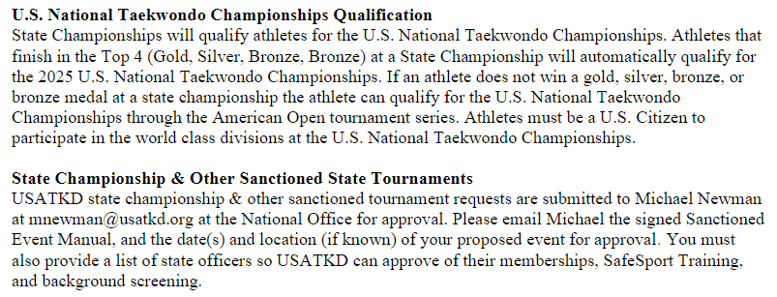



**SAFESPORT AND MAAP**

**Below are links to SafeSport requirements for this tournament**

**1. U.S. Center for SafeSport Code** <https://uscenterforsafesport.org/response-and-resolution/safesport-code/>

**2. MAAPP Policy:** <https://maapp.uscenterforsafesport.org/>

**3. USA Taekwondo SafeSport Webpage:** <https://www.teamusa.org/usa-taekwondo/v2-safe-sport>

**4. Quality Control System Document:** <https://www.teamusa.org/usa-taekwondo/v2-safe-sport>

**5. Response & Resolution information – In the Strategy Document:** <https://www.teamusa.org/usa-taekwondo/v2-safe-sport>

**6. How to Report a Concern & Reporting Process:** <https://uscenterforsafesport.org/report-a-concern/>

**7. Emotional & Physical Conduct Reporting Email Link:** <https://www.teamusa.org/usa-taekwondo/v2-safe-sport>

**8. Minor Training:** <https://www.teamusa.org/usa-taekwondo/v2-safe-sport/free-minor-athlete-training>

**9. Parent Training & Education Catalog:** <https://uscenterforsafesport.org/training-and-education/safesport-courses-for-all/>

**The U.S. Center for SafeSport training must be completed every year.**

**Athletes aged 18 and older are required to complete the U.S. Center for SafeSport training. The SafeSport training must be valid through the conclusion of the tournament.**

**Volunteers at the tournament that are 18 and older will be required to complete the U.S. Center for SafeSport training.**

**The SafeSport training will need to be completed before they can register for a tournament. All SafeSport training should be done through the Sport80 profile**

**All medical staff are required to take the U.S. Center for SafeSport training and complete a background check. The only exception to this is if you contract an ambulance service to work your tournament. The Paramedics assigned by the service are not required to complete a background check or watch the U.S. Center for SafeSport videos. However, if you contract Paramedics that are not part of a contracted ambulance service for the event, these Paramedics must complete the background check and watch the U.S. Center for SafeSport training videos. Medical staff can create a free volunteer profile in Sport80 to complete the SafeSport training and background check.**

**WEIGH-INS & BRACKETING**

|  |
| --- |
| **SPARRING** |

**Note:** (Explanation #1) Not exceeding: The weight limit is defined by the criterion of one decimal place away from the stated limit. For example: not exceeding 50kg is established as until 50.0kg with 50.1kg being over the limit and resulting in disqualification. (Explanation #2) Over weight: Over 50.00 kg marks occur at the 50.1kg reading and 50.0kg and below is regarded as insufficient, resulting in disqualification.

* A competitor’s weight shall be measured the day prior to their competition day. All competitors must weigh-in during the designated times on the schedule.
* A competitor’s weight may be measured twice. If a contestant does not qualify the first time, one more official weigh-in is granted within the time limit. So as not to be disqualified during official weigh-in, a scale, the same as the official one, shall be provided at the convention center as a test scale.
* During the weigh-in, the contestant is required to show his/her current photo ID, USATKD identification card or birth certificate.
* Any irregular action by the competitor or coach during the weigh-in may result in disqualification from event participation.
* Weigh in, for both males and females shall be taken in the official V-neck uniform, or, if a contestant wishes, weigh-in may be done in underpants for male and underpants and bra for female contestants. **Under NO circumstances may an athlete weigh-in in the nude in the United States.**
* **A**thletes 17 and younger must weigh-in wearing clothing or dobork ONLY. Athletes will be given 0.2kg cushion for clothing. 1 Parent/Guardian of the same sex will be allowed in the weigh-in room with their child. Pictures are not allowed in the weigh-in rooms.

**Ultra Divisions (33+ year olds) – All Belt Colors (Yellow, Green, Blue, Red & Black) (33-4 and 46+)**

|  |  |  |
| --- | --- | --- |
| **Classification** | **Male Divisions**  **Weight Category (kg)** | **Female Divisions**  **Weight Category (kg)** |
| Fly | Not exceeding 58kg | Not exceeding 49kg |
| Light | Over 58kg & Not exceeding 68kg | Over 49kg & Not exceeding 57kg |
| Middle | Over 68kg & Not exceeding 80kg | Over 57kg & Not exceeding 67kg |
| Heavy | Over 80kg | Over 67kg |

**Senior Divisions (17-32 year olds) – All Belt Colors (Yellow, Green, Blue, Red & Black)**

|  |  |  |
| --- | --- | --- |
| **Classification** | **Male Divisions**  **Weight Category (kg)** | **Female Divisions**  **Weight Category (kg)** |
| Fin | Not exceeding 54kg | Not exceeding 46kg |
| Fly | Over 54kg & Not exceeding 58kg | Over 46kg & Not exceeding 49kg |
| Bantam | Over 58kg & Not exceeding 63kg | Over 49kg & Not exceeding 53kg |
| Feather | Over 63kg & Not exceeding 68kg | Over 53kg & Not exceeding 57kg |
| Light | Over 68kg & Not exceeding 74kg | Over 57kg & Not exceeding 62kg |
| Welter | Over 74kg & Not exceeding 80kg | Over 62kg & Not exceeding 67kg |
| Middle | Over 80kg & Not exceeding 87kg | Over 67kg & Not exceeding 73kg |
| Heavy | Over 87kg | Over 73kg |

**Junior Divisions (15-17 year olds) – All Belt Colors (Yellow, Green, Blue, Red & Black)**

|  |  |  |
| --- | --- | --- |
| **Classification** | **Male Divisions**  **Weight Category (KG)** | **Female Divisions**  **Weight Category (KG** |
| Fin | Not exceeding 45kg | Not exceeding 42kg |
| Fly | Over 45kg & Not exceeding 48kg | Over 42kg & Not exceeding 44kg |
| Bantam | Over 48kg & Not exceeding 51kg | Over 44kg & Not exceeding 46kg |
| Feather | Over 51kg & Not exceeding 55kg | Over 46kg & Not exceeding 49kg |
| Light | Over 55kg & Not exceeding 59kg | Over 49kg & Not exceeding 52kg |
| Welter | Over 59kg & Not exceeding 63kg | Over 52kg & Not exceeding 55kg |
| Light Middle | Over 63kg & Not exceeding 68kg | Over 55kg & Not exceeding 59kg |
| Middle | Over 68kg & Not exceeding 73kg | Over 59kg & Not exceeding 63kg |
| Light Heavy | Over 73kg & Not exceeding 78kg | Over 63kg & Not exceeding 68kg |
| Heavy | Over 78kg | Over 68kg |

**Cadet Divisions (12-14 year old) – All Belt Colors (Yellow, Green, Blue, Red & Black)**

|  |  |  |
| --- | --- | --- |
| **Classification** | **Male Divisions**  **Weight Category (kg)** | **Female Divisions**  **Weight Category (kg)** |
| Fin | Not exceeding 33kg | Not exceeding 29kg |
| Fly | Over 33kg & Not exceeding 37kg | Over 29kg & Not exceeding 33kg |
| Bantam | Over 37kg & Not exceeding 41kg | Over 33kg & Not exceeding 37kg |
| Feather | Over 41kg & Not exceeding 45kg | Over 37kg & Not exceeding 41kg |
| Light | Over 45kg & Not exceeding 49kg | Over 41kg & Not exceeding 44kg |
| Welter | Over 49kg & Not exceeding 53kg | Over 44kg & Not exceeding 47kg |
| Lt. Middle | Over 53kg & Not exceeding 57kg | Over 47kg & Not exceeding 51kg |
| Middle | Over 57kg & Not exceeding 61kg | Over 51kg & Not exceeding 55kg |
| Lt. Heavy | Over 61kg & Not exceeding 65kg | Over 55kg & Not exceeding 59kg |
| Heavy | Over 65kg | Over 59kg |

**Youth Divisions (10-11 year old) – All Belt Colors (Yellow, Green, Blue, Red & Black)**

|  |  |  |
| --- | --- | --- |
| **Classification** | **Male Divisions**  **Weight Category (kg)** | **Female Divisions**  **Weight Category (kg)** |
| Fin | Not exceeding 30kg | Not exceeding 30kg |
| Light | Over 30kg & Not exceeding 35kg | Over 30kg & Not exceeding 35kg |
| Middle | Over 35kg & Not exceeding 40kg | Over 35kg & Not exceeding 40kg |
| Heavy | Over 40kg | Over 40kg |

**Tiger Divisions (8-9 year olds) – All Belt Colors (Yellow, Green, Blue, Red & Black)**

|  |  |  |
| --- | --- | --- |
| **Classification** | **Male Divisions**  **Weight Category (kg)** | **Female Divisions**  **Weight Category (kg)** |
| Fin | Not exceeding 21kg | Not exceeding 21kg |
| Light | Over 21kg & Not exceeding 25kg | Over 21kg & Not exceeding 25kg |
| Middle | Over 25kg & Not exceeding 30kg | Over 25kg & Not exceeding 30kg |
| Heavy | Over 30kg | Over 30kg |

**Dragons Divisions (6-7 year olds) – All Belt Colors (Yellow, Green, Blue, Red & Black)**

|  |  |  |
| --- | --- | --- |
| **Classification** | **Male Divisions**  **Weight Category (kg)** | **Female Divisions**  **Weight Category (kg)** |
| Fin | Not exceeding 19kg | Not exceeding 19kg |
| Light | Over 19kg & Not exceeding 23kg | Over 19kg & Not exceeding 23kg |
| Middle | Over 23kg & Not exceeding 27kg | Over 23kg & Not exceeding 27kg |
| Heavy | Over 27kg | Over 27kg |

**Junior Safety Rules:** Attacks to the head are prohibited. The Referee will penalize the athlete for this case. The referee can decide the winner of RSC (Referee Stop Contest) in case of significant difference of competing ability between two athletes.

|  |
| --- |
| **POOMSAE** |

This tournament will use Poomsae competition rules per USAT guidelines as outlined in the link below <https://www.teamusa.org/usa-taekwondo/v2-events/competition-rules>.

**INDIVIDUAL POOMSAE**

|  |  |  |  |  |
| --- | --- | --- | --- | --- |
| **AGE CLASSES** | **AGE DIVISIONS** | **BELT COLOR** | **RANK** | **COMPETITION TYPE** |
| DRAGONS | 6-7 YEARS OLD | **YELLOW, GREEN, BLUE & RED** | N/A | SINGLE ELIMINATION |
| DRAGONS | 6-7 YEARS OLD | **BLACK** | 1ST – 9TH | SINGLE ELIMINATION |
| TIGER | 8-9 YEARS OLD | **YELLOW, GREEN, BLUE & RED** | N/A | MODIFIED WT FORMAT |
| TIGER | 8-9 YEARS OLD | **BLACK** | 1ST – 9TH | MODIFIED WT FORMAT |
| YOUTH | 10-11 YEARS OLD | **YELLOW, GREEN, BLUE & RED** | N/A | MODIFIED WT FORMAT |
| YOUTH | 10-11 YEARS OLD | **BLACK** | 1ST – 9TH | MODIFIED WT FORMAT |
| CADET | 12-14 YEARS OLD | **YELLOW, GREEN, BLUE & RED** | N/A | MODIFIED WT FORMAT |
| CADET | 12-14 YEARS OLD | **BLACK** | 1ST – 9TH | WT FORMAT |
| JUNIOR | 15-17 YEARS OLD | YELLOW**, GREEN, BLUE & RED** | N/A | MODIFIED WT FORMAT |
| JUNIOR | 15-17 YEARS OLD | **BLACK** | 1ST – 9TH | WT FORMAT |
| UNDER 30 | 18-30 YEARS OLD | YELLOW**, GREEN, BLUE & RED** | N/A | MODIFIED WT FORMAT |
| UNDER 40 | 31-40 YEARS OLD | YELLOW**, GREEN, BLUE & RED** | N/A | MODIFIED WT FORMAT |
| UNDER 50 | 41-50 YEARS OLD | YELLOW**, GREEN, BLUE & RED** | N/A | MODIFIED WT FORMAT |
| UNDER 60 | 51-60 YEARS OLD | YELLOW**, GREEN, BLUE & RED** | N/A | MODIFIED WT FORMAT |
| UNDER 65 | 61-65 YEARS OLD | YELLOW**, GREEN, BLUE & RED** | N/A | MODIFIED WT FORMAT |
| OVER 65 | 66 & OLDER | YELLOW**, GREEN, BLUE & RED** | N/A | MODIFIED WT FORMAT |
| UNDER 30 | 18-30 YEARS OLD | **BLACK** | 1ST – 9TH | WT FORMAT |
| UNDER 40 | 31-40 YEARS OLD | **BLACK** | 1ST – 9TH | WT FORMAT |
| UNDER 50 | 41-50 YEARS OLD | **BLACK** | 1ST – 9TH | WT FORMAT |
| UNDER 60 | 51-60 YEARS OLD | **BLACK** | 1ST – 9TH | WT FORMAT |
| UNDER 65 | 61-65 YEARS OLD | **BLACK** | 1ST – 9TH | WT FORMAT |
| OVER 65 | 66 & OLDER | **BLACK** | 1ST – 9TH | WT FORMAT |

**PAIRS POOMSAE (CO-ED) – 1 MALE & 1 FEMALE**

**Dragon(6-7), Tiger (8-9), Youth(10-11), Cadet (12-14), Juniors (15-17), 1st Pairs (18-30) & 2nd Pairs (31+) Pairs Poomsae**

|  |  |  |  |  |
| --- | --- | --- | --- | --- |
| **Division** | **Belt** | **Rank** | **Gender** | **Format** |
| Dragon (6-7) | Black | 1st – 9th | Co-Ed | Modified WT Format |
| Tiger (8-9) | Black | 1st – 9th | Co-Ed | Modified WT Format |
| Youth (10-11) | Black | 1st – 9th | Co-Ed | Modified WT Format |
| Cadet (12-14) | Black | 1st – 9th | Co-Ed | Modified WT Format |
| Juniors (15-17) | Black | 1st – 9th | Co-Ed | Modified WT Format |
| Under 30 | Black | 1st – 9th | Co-Ed | WT Format |
| Under 50 | Black | 1st – 9th | Co-Ed | WT Format |
| Under 60 | Black | 1st – 9th | Co-Ed | WT Format |
| Over 60 | Black | 1st – 9th | Co-Ed | WT Format |

*State Championships can choose to do Dragon, Tiger and Youth Team Poomsae, but those divisions will not be available at the USATKD Grand Prix Regionals or National Championships. *

**State Championships can choose to do color belt Team Poomsae, but those divisions will not be available at the

USATKD Grand Prix Regionals or National Championships. **

**TEAM POOMSAE – 3 COMPETITORS OF THE SAME GENDER**

**Dragon (6-7), Tiger (8-9), Youth (10-11), Cadet (12-14), Junior (15-17) 1st Team (18-30) & 2nd Team (31+) Team Poomsae**

|  |  |  |  |
| --- | --- | --- | --- |
| **Division** | **Belt** | **Rank** | **Gender** |
| Dragon (6-7)* | Black | 1st – 9th | Female |
| Dragon (6-7)* | Black | 1st – 9th | Male |
| Tiger (8-9)* | Black | 1st – 9th | Female |
| Tiger (8-9)* | Black | 1st – 9th | Male |
| Youth (10-11)* | Black | 1st – 9th | Female |
| Youth (10-11)* | Black | 1st – 9th | Male |
| Cadet (12-14) | Black | 1st – 9th | Female |
| Cadet (12-14) | Black | 1st – 9th | Male |
| Juniors (15-17) | Black | 1st – 9th | Female |
| Juniors (15-17) | Black | 1st – 9th | Male |
| Under 30 | Black | 1st – 9th | Female |
| Under 30 | Black | 1st – 9th | Male |
| Under 40 | Black | 1st – 9th | Female |
| Under 40 | Black | 1st – 9th | Male |
| Under 50 | Black | 1st – 9th | Female |
| Under 50 | Black | 1st – 9th | Male |
| Under 60 | Black | 1st – 9th | Female |
| Under 60 | Black | 1st – 9th | Male |
| Over 60 | Black | 1st – 9th | Female |
| Over 60 | Black | 1st – 9th | Male |

*State Championships can choose to do Dragon, Tiger and Youth Team Poomsae, but those divisions will not be available at the USATKD Grand Prix Regionals or National Championships. *

**State Championships can choose to do color belt Team Poomsae, but those divisions will not be available at the

USATKD Grand Prix Regionals or National Championships. **

|  |
| --- |
| **BOARD BREAKING** |

|  |  |  |  |  |
| --- | --- | --- | --- | --- |
| **AGE CLASSES** | **AGE DIVISIONS** | **BELT COLOR** | **SET-UP TIME LIMITS** | **ROUTINE TIME LIMITS** |
| DRAGONS | 6-7 YEARS OLD | YELLOW**/GREEN, BLUE/RED** & **BLACK** | 1 MINUTE | 1 MINUTE |
| TIGER | 8-9 YEARS OLD | YELLOW **/GREEN, BLUE/RED** & **BLACK** | 1 MINUTE | 1 MINUTE |
| YOUTH | 10-11 YEARS OLD | YELLOW **/GREEN, BLUE/RED** & **BLACK** | 1 MINUTE | 1 MINUTE |
| CADET | 12-14 YEARS OLD | YELLOW **/GREEN, BLUE/RED** & **BLACK** | 1 MINUTE | 1 MINUTE |
| JUNIOR | 15-17 YEARS OLD | YELLOW **/GREEN, BLUE/RED** & **BLACK** | 1 MINUTE | 1 MINUTE |
| SENIOR | 18-32 YEARS OLD | YELLOW **/GREEN, BLUE/RED** & **BLACK** | 1 MINUTE | 1 MINUTE |
| ULTRA | 33+ YEARS OLD | YELLOW **/GREEN, BLUE/RED** & **BLACK** | 1 MINUTE | 1 MINUTE |

**REGISTRATION CHECKLIST**

Completing all items on this list will help ensure a speedy check-in and weigh-in process 2022 Arizona State Championships

* Register for the State Championships through the [USATKD Sport80](https://usataekwondo.sport80.com/) online registration system.
* Complete registration payment online. To receive the early registration price, you must pay by the early deadline. If payment is not received by this deadline the system will automatically update to the late fee.
* Upload your proof of Citizenship and/or black belt certification, if required, to your [Sport80](https://usataekwondo.sport80.com/) profile.
* Upload a picture (headshot only in BMP, GIF, JPEG, PNG, TIFF and file must be under 4MB) to your membership profile. Please do not mail or email a photo.
* If you need assistance registering for the event, please view a short [video](https://vimeopro.com/user44435707/usatkd-member-tutorials/video/431742671) that has been provided.

**REQUIREMENTS**

All participants must be current and active USA Taekwondo members at the time of the tournament. All athletes must also have a belt listed in their USATKD profile. Please see the how to Register section of the USATKD website (<https://www.usatkd.org/coach-how-to-register-for-an-event>) for step by step instructions.

All coaches, referees, club owner/instructors 18 and older are required to and MUST complete and pass USA Taekwondo background check and complete the SafeSport training before registering for USATKD state sanctioned events. Please see the USA Taekwondo website for more details.

* Athletes **DO NOT** need to provide proof of citizenship or residency for any division at State Championships.
* However, Athletes **MUST** be a U.S. Citizen to participate in the World Class divisions at the U.S. National Taekwondo Championship

**AWARDS**

**SPARRING**

Medals and certificates will be given out to the top 4 athletes, in the respective divisions and weight categories.

|  |  |  |
| --- | --- | --- |
| **Individual Awards** | | |
| 1st Place |  | Gold medal |
| 2nd Place |  | Silver medal |
| 3rd Place |  | Bronze medal |
| 3rd Place |  | Bronze medal |

**POOMSAE**

Medals and certificates will be given to the top 4 individuals, pairs (co-ed) and teams in the respective divisions.

|  |  |  |
| --- | --- | --- |
| **Individual/Pairs/Team Awards** | | |
| 1st Place |  | Gold medal |
| 2nd Place |  | Silver medal |
| 3rd Place |  | Bronze medal |
| 3rd Place |  | Bronze medal |

**OTHER INFORMATION**

* There is absolutely no registration after April 2, 2025, nor on-site registration. No exceptions.
* Athletes do not need to provide proof of citizenship or residency for any division at State Championships

**PROOF OF BLACK BELT REQUIREMENT**

* If an athlete doesn’t have a black belt certification uploaded to their profile or provide a copy of certification at the time of registration, the State Association will be able to utilize the black belt verification form. The form will include contact information so that USA Taekwondo can track that each person provides a copy of their black belt certification by the National Championships. If a copy is not provided at the National Championships, then the athlete’s coach and/or instructor will be required to apply for a USA Taekwondo Dan black belt certificate at the time of registration. For more information on the USA Taekwondo Dan certification program follow this link: <http://www.teamusa.org/USA-Taekwondo/Resources/Dan-Certification-Program>

**PREREQUISITES**

**USA Taekwondo Competition Rules & Jr. Safety Rules**

For more information, please visit USA Taekwondo Competition Rules Page:

<https://www.teamusa.org/usa-taekwondo/v2-events/competition-rules>

**EQUIPMENT:** The Arizona State Taekwondo Association will be using Daedo True Score PSS at this event for all sparring events and we will be supplying the electronic body protectors. All athletes ***are required to have your own Daedo sensor socks***. These can be purchased online at [https://www.tkdscore.com](https://www.tkdscore.com/) or from your school.

All athletes will be responsible for supplying their own headgear, gloves, foot pads, arm and shin guards, mouth guards and all necessary taping. Electronic headgear will be provided for all black belt divisions.

Gear requirements are found in the competition rules packet link above.

**WEIGHT DIVISIONS & COMPETITION FORMAT**

The Arizona State Taekwondo Association will be using the Age/Weight Divisions found in the USAT Competition Rules (provided above). The competition format is listed below:

**SPARRING**

All Color Belt and 9 & under Black Belt divisions will spar best two of three one-minute rounds with a 30 second rest periods in single elimination brackets including finals rounds.

All 10 & over Black Belts will spar best two of three one-minute thirty seconds rounds with a 60 second rest including the final round. Only Senior World Class Divisions will compete best two of three 2 minutes rounds with 60 seconds break in the final round. These times are subject to change at the tournament and will be confirmed at during the coaches meeting.

**POOMSAE**

All Color Belt and Black Belt 11 & Under forms divisions will use the cut off system

All Black Belt 12 & Over divisions will follow USAT sport poomsae rules. We will use the cut off format.

**For more information regarding USAT competition rules please follow the link**

<https://www.usatkd.org/usatkd-competition-rules>

2025 ARIZONA STATE TAEKWONDO CHAMPIONSHIP

**DESIGNATED POOMSAE**

Please refer to the USAT competition website at <https://www.usatkd.org/usatkd-competition-rules> for more details at

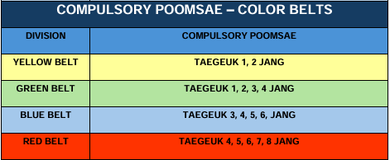

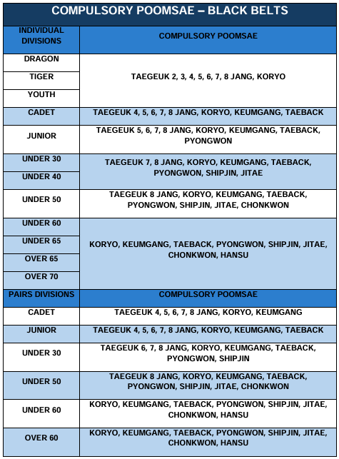

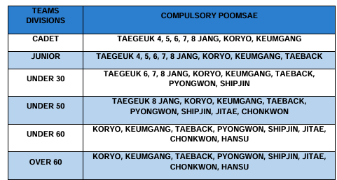

** Black Belt Cadet/Junior/Senior/Master (Individual/Pairs/Team) **

8 or less competitors begin in Final Round

9 – 19 competitors begin in Semi-Final Round

20 or more competitors begin in Preliminary Round

**BOARD BREAKING RULES**

Color Belts & Black Belts do their own routine.

* Yellow & Green Belts = **10 boards**.
* Blue & Red Belts = **10 boards**.
* Black Belts = **10 boards**.
* There is ***One Chance*** for each breaking.
* Board set up and finish time is ***One Minute*** with judges.
* Never use a chair, person or any other equipment to set up.

**All Competitors MUST purchase the boards at the door ($4 per Board)**

**TENTATIVE SCHEDULE OF EVENTS**

**Friday,** **April 11, 2025**

* All athletes must check in
* All Sparring athletes must Weigh-In No exceptions (Black Belts & Color Belts) **at** 2217 W Glendale Ave, Phoenix, AZ 85021
* ***April 11, 2025, 5:30pm to 9pm***
* ***All belt colors must be accurate and current on Sport 80 to avoid belt change charge fee of $50***

**Saturday, April 12, 2025**

* Doors open 8:00am
* **Referee meeting promptly at 8:15am at Washington High School**
* **Coaches meeting promptly at 8:30am** **at Washington High School**
* Competition Begins promptly at 9:00am

***Tentative Competition Schedule (competition may be ahead of or behind schedule)***

* 6-9 years old Poomsae Divisions forms Report at 9:00am
* 10-11 & 12-13 years oldPoomsae Divisions Report at 9:30 am
* 14 & OverPoomsae Divisions Report at 10:30am
* **All World Class Black Belt Divisions Sparring & Poomsae**

**Report at 8:30am**

**Opening Ceremony & Lunch Break** (competition may or may not continue) 12:00pm – 12:30pm

* 6 to 9 years old all divisions for sparring Report at 12:00pm
* 10-11 years old all division sparring Report at 12:45 pm
* 12-13 years old color belts sparring Report at 1:30pm
* 14 & Over color belts sparring Report at 2:30pm

**Closing Remarks/Competition Ends** 6:00pm

*This schedule is tentative and subject to change.