ARKANSAS STATE CLOSED CHAMPIONSHIPS
Date: OCTOBER 26, 2024

Sanctioned by: USATT 1-Star Tournament | Venue: DAILEY FITNESS CENTER
Hosted by: LRTTC, AITTA, & ATTA | 300 S Monroe
Sponsored by: AITTA | Little Rock, Arkansas, 72205

 | SANCTIONED EVENTS | TYPE | START | 1ST | 2ND | 3RD
1 | OPEN ABCD ROUND ROBIN | RR | 11:30A
 | OPEN SINGLES | RR | 3:50P | $150+T | $75+T
 | A SINGLES | RR | 3:50P | $20+T | T
 | B SINGLES | RR | 3:50P | $15+T | T
 | C SINGLES | RR | 3:50P | $10+T | T
2 | U2000 SINGLES | RR | 9:20A | T | T
3 | U1600 SINGLES | RR | 9:20A | T | T
4 | U1200 SINGLES | RR | 9:20A | T | T
5 | U900 SINGLES | RR | 9:20A | T | T
6 | WOMENS SINGLES | RR | 1:55P | $10+T | M | M
7 | JUNIOR BOYS SINGLES | RR | 8:00A | T | M | M
8 | JUNIOR GIRLS SINGLES | RR | 8:00A | T | M | M
9 | OVER 40 SINGLES | RR | 8:00A | T | T
10 | OVER 60 SINGLES | RR | 8:00A | T | T
 | NON SANCTIONED EVENTS
11 | OPEN DOUBLES | RR | 2:10P | T | T
12 | U3400 DOUBLES | RR | 2:10P | T | T
Tournament Director Eugene Atha
Tournament Referee: Eugene Atha
Tournament Umpire: David Willard
ELIGIBILITY:
All players must be a resident of Arkansas and a member of the USATT (except for non-sanctioned events listed above). Military personnel stationed in Arkansas and full time students attending school in the state are eligible.

TOURNAMENT RULES:
- OPEN A-B-C-D ROUND ROBIN: Limited to the first 34 entries; open to all players. Groups of 3-5 players; all players advance to second round robin. Top 2 seeds will be placed in second round. Winners advance to Open Singles; second place to A Singles, etc. Format after the second round robin determined by number of entries.
- ALL OTHER ROUND ROBIN EVENTS: Each group will consist of at least 3 players, maybe more. The second round format (if required) will be determined by the number of entries and number of tables available.
- OPEN & U3400 DOUBLES: Players have until 1pm to find a partner. Maximum of 6 teams in Open doubles; maximum of 9 teams in U3400 doubles. Both events round robin groups of three – second round format determined by number of entries.
- EQUIPMENT: Stiga/Donic tables; Stiga and Tibhar nets; Nittaku poly white 3 star premium 40 mm balls; wood flooring.
- RATING EVENTS: limited to the first 6 entries – might be expanded if tables & time permit
- JUNIOR/WOMENS/AGE SINGLES: Limited to the first 6 entries; field may be expanded if time permits. Juniors must be 17 or younger on 10-26-24.
- All USATT rules apply. Rackets must meet USATT regulations.
- Events with less than 3 entries may be cancelled or combined with the next higher rated event.
- All matches are best 3 out of 5 games - games to 11.
- Unrated players must have the approval of the tournament director before entering rated events.
- All players must report to the control desk 20 minutes prior to the start time of their first event.
- No lunch provided so plan accordingly. Forfeits will be called if players have left the tournament site without permission of the Tournament Director or Control Desk.
- No refunds the day of the tournament, except in doubles if a partner cannot be found.
- The rating posted on the USATT website as of the entry deadline will be a participant’s rating.
- A player may not enter 2 or more events that start at the same time.
- Matches must be played for prize money to be awarded. Splitting of prize money is not allowed.

Entry Form
Mail entries to: ARKANSAS CLOSED, c/o Eugene Atha, 1608 Club Lane East, Sherwood, AR 72120.
(Make checks out to Eugene Atha)
Phone entries: Call Eugene Atha (501) 835-5291 or leave a message.
Email Entries: email to: eatha@swbell.net.

NAME: ____________________________________________ PHONE: _____ - _____-_______
STREET: __________________________ CITY: _____________ STATE: AR ZIP: _______-______
EMAIL ADDRESS: ______________________________________ BIRTHDATE: _____/_____/_____
USATT Membership Expires: ____/____ RATING: ______________
DOUBLES PARTNER: _______________________________________
ENTRY DEADLINE: October 23,2024 1PM
See fees below - check events entered

✓ |  | Event | PAY BY  10/21/24 | PAY BY  10/23/24 | PAY ON  10/26/24
 | 1. | OPEN ROUND ROBIN | $30.00 | $35.00 | $45.00
 | 2. | U2000 SINGLES | $10.00 | $15.00 | $25.00
 | 3. | U1600 SINGLES | $10.00 | $15.00 | $25.00
 | 4. | U1200 SINGLES | $10.00 | $15.00 | $25.00
 | 5. | U900 SINGLES | $10.00 | $15.00 | $25.00
 | 6. | WOMENS | $10.00 | $15.00 | $25.00
 | 7. | JUNIOR BOYS | $10.00 | $15.00 | $25.00
 | 8. | JUNIOR GIRLS | $10.00 | $15.00 | $25.00
 | 9. | OVER 40 SINGLES | $10.00 | $15.00 | $25.00
 | 10. | OVER 60 SINGLES | $10.00 | $15.00 | $25.00
 | 11. | OPEN/U3400 DOUBLES | $12.00 | $17.00 | $25.00
 |  | SUBTOTAL ENTRY
 |  | FACILITY FEE | $8.00 | $8.00 | $8.00
 |  | MEMBERSHIP/PLAYING PERMIT
 |  | DONATION TO NATIONAL TEAM
 |  | LATE ENTRY FEE |  |  | $5.00
 |  | SUBTOTAL FEES
 |  | TOTAL ENTRY + FEES
Payment must be received by 10-21-24 to receive discount.

Non-USATT members may enter sanctioned events by purchasing a USATT membership or playing permit.
Membership fees are: 1 Year Basic $25 Pro $75 Lifetime $1300
Playing permit $50 Adult; $20 Juniors

Please enter me in the above events. I agree to comply with all USATT Regulations.

WAIVER: I accept full responsibility for my participation and relieve the sponsors, the AITTA, the USATT, the LRTTC and the venue/facility of any liability resulting from injury to myself or damage to my property.

SIGNATURE__________________________________________________________ (Guardian if minor)

DATE ___________________________

Prize money for Open Singles 1st place provided by the Little Rock Table Tennis Club.

Nittaku balls provided by Paddle Palace in association with the USATT.



Directions

From I-630W: Take Exit 4 and go right on Fair Park Boulevard. At the intersection of Fair Park Boulevard and Zoo Drive, turn right onto Zoo Drive.

From Asher Ave./Hwy 5: Turn North onto Fair Park Boulevard. At the intersection of Fair Park Boulevard and Zoo Drive, turn right onto Zoo Drive.

Parking: As you drive down Zoo Drive, the Dailey Fitness Center will be on the left just past the Zoo entrance.

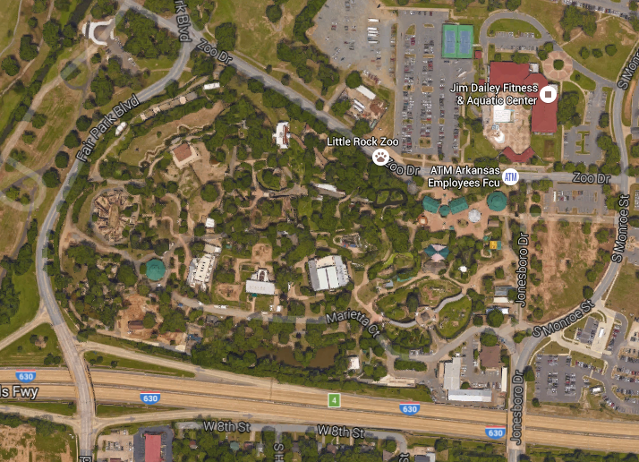

PRACTICE SITES

LITTLE ROCK TABLE TENNIS CLUB
300 S MONROE LITTLE ROCK AR 72205
SATURDAY 10A-1P

Sponsored by office of Joseph Giles
501 Millwood Circle Suite H Maumelle AR 72113
501 753-6388

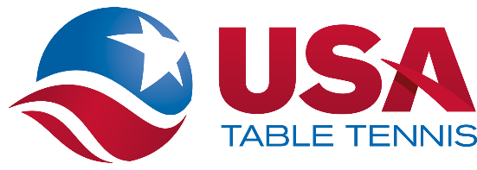

USATT SAFE SPORT PROTOCOL
ENTRY BLANK TEMPLATE FOR USATT SANCTIONED TOURNAMENTS

I understand USATT’s Safe Sport Policy including the organization’s Coaching Policy, which requires that all persons who are engaged in coaching activities at USATT Affiliated Member Clubs and/or USATT Sanctioned Tournaments, except parents or legal guardians coaching their own children, must be fully Safe Sport Compliant, which includes completing SafeSport Training offered by the US Center for SafeSport every year and undergoing a criminal background screen every two years.

I understand that, pursuant to USATT’s Minor Athlete Abuse Prevention Policy, all participants at USATT Sanctioned Tournaments who are over the age of 18 and have regular contact with or authority over minor athletes must complete annual SafeSport Training offered by the US Center for SafeSport.

More information on USATT’s Safe Sport Policy is available at: https://www.teamusa.org/usa-table- tennis/athlete-safety/safe-sport.

Local Amenities

Hotels

Days Inn on Fair Park Blvd.
Clarion on University Ave.

Restaurants

Fair Park & Markham Subway, Chi’s Chinese Cuisine, Jimmy’s Serious Sandwiches
Fair Park Blvd.: U.S. Pizza, Riviera Maya
12th Street: Pepe's Mexican Restaurant, Church's Chicken, Rally's, Subway
Grady's Pizza and Subs
Asher Ave.: China Plus Buffet, Taco Bell, Captain D's, KFC
University Ave.: Zack's Place, Catfish City and BBQ Grill, Senior Tequila, Papa John's, Pizza Hut, Popeye's, Go Go China, Subway, Little Caesar's, Denny's, Wendy's, Long John Silver's, McDonald's

Groceries

Walgreens at the corner of University Ave. and Asher Ave.

Kroger on Asher Ave.

Banks

Regions on Asher Ave.
Bank of America and Arvest on University Ave.

