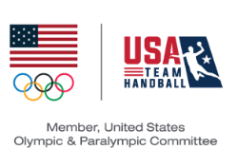

2025 USATH NRC Nominee Commitment Form
(The information provided on this form will be included with balloting materials.)

Name:

Address:

City:___________________________ State:_________Zip:

USATH Referee Certification Level: ___________________________

USATH Member Number:____________________ Birthdate: _____________

Phone: E-Mail: ______________

Attestation: I have reviewed the qualifications, charges, and responsibilities of the position that I am seeking as outlined in the USATH Bylaws, SafeSport policy, and NRC Constitution Bylaws and affirm that I am qualified to serve and committed to fulfill the responsibilities of the position that I seek.

Signature of Candidate Date

Please provide a response to each of the following questions: (USATH now uses a digital platform to announce nominees and their responses, thereby no longer necessitating a limit on length of response to these questions)

- Why are you interested in being an NRC Representative?

- What skills, experience, and/or perspective would you bring to the NRC position?

- How do you think the NRC can better serve officials?

- Please expound on your experience as a referee, as well as particular perspectives or ideas you believe are critical to the optimal performance of the NRC.

- Is there anything else about yourself that you would like to add?

Materials must be received (NOT postmarked) by February 19, 2024.

Return this Nomination Form to:

USATH – Elections
michael.king@usateamhandball.org, matthew.collins@usateamhandball.org

