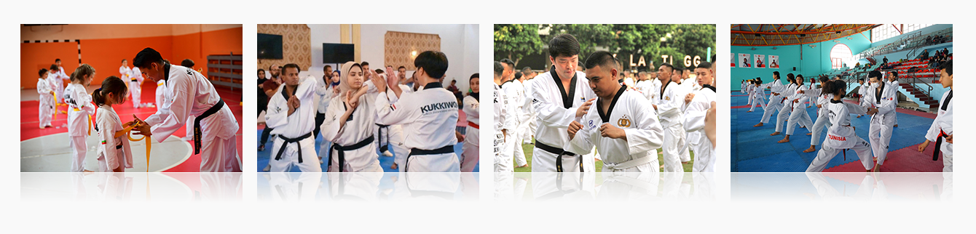
Taekwondo Master Overseas Dispatch Business

Since 2009, Kukkiwon has carried out the "Taekwondo Master Overseas Dispatch Business" to dispatch Taekwondo masters to different countries around the world in line with the request for standardization of Taekwondo, which had rapidly developed from a traditional martial art to a global sport, and the significance of close communication and collaboration between countries.

Starting with the dispatch of 11 masters, 53 Taekwondo masters have been dispatched to a total 53 countries: 19 in Asia, 13 in Europe, 12 in America, 7 in Africa, and 2 in Oceania.
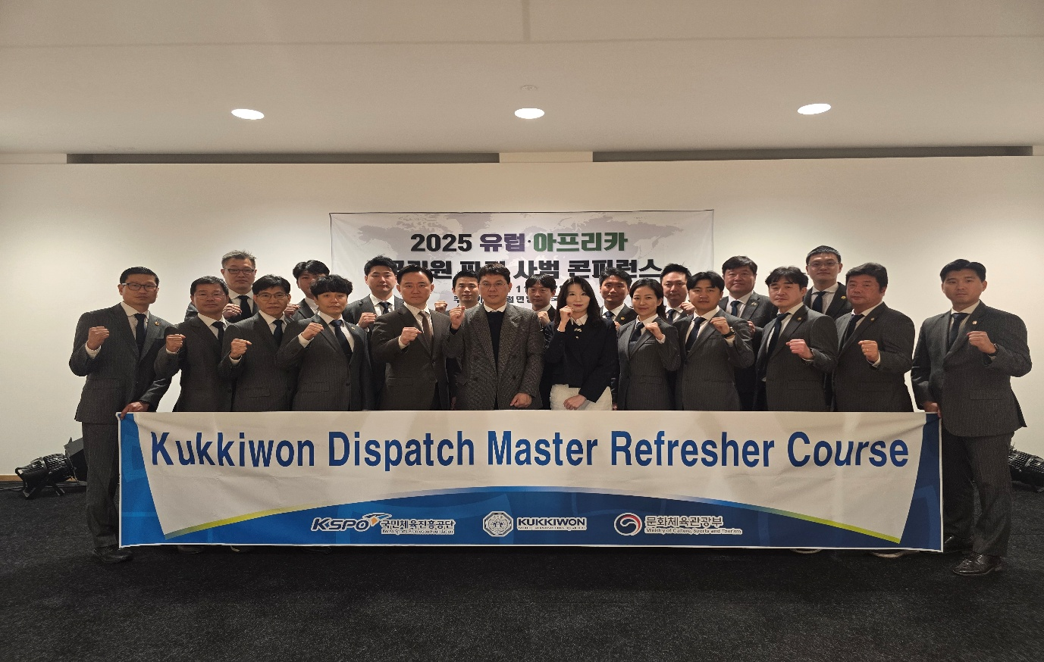

Taekwondo masters with the best proficiency and personality as selected through strict screening are engaging in activities for expanding the foundation of Taekwondo by passing on the Taekwondo spirit, philosophy, knowledge, skills, and experience.

Upon dispatch, they mainly coach the coach of the national team, policemen, and national youth team to contribute to the development of Taekwondo. They also contribute to maintaining Taekwondo as an official Olympic sport by holding seminars and competitions.

In the future, Kukkiwon will increase the number of countries for the dispatch of masters and continue cooperating with the governments of the countries where masters have been dispatched as well as providing refresher training to enhance the talents of the masters. It will promote friendly relations between countries and serve as a bridge for cultural exchange.
