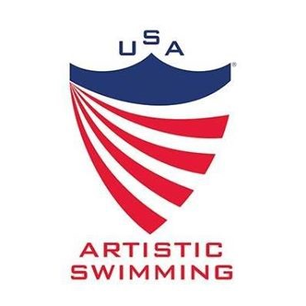
Officials Committee
August 2026
The Official’s Committee has worked hard along with the help of Betty Hazle to update Appendix G to include a section on Difficulty Technical Controllers and Synchronization Technical Controllers. We have realized a need has occurred to have a third level of DTC. While there is no further testing required, a Level 2 DTC will be required to work at a Zone Meet before taking on the task of evaluating athletes as a Level 3 DTC at a national meet. The Zone Officials Chair (or representative) will notify the Officials Chair when a DTC/STC has successfully completed this requirement. They can then be used at a national meet. There will be a similar requirement for DTC 1 moving to DTC 2. AQUA & PAQ DTC’s are automatically Level 4 DTC. Please refer to Appendix G for the details. This was approved by the BOD last winter.

There was a $15 charge for the training and testing of DTC/STC and Judge Levels 1F, 1, 2F/2. Judges 1F, 1, 2F/2 still need to do a webinar or in-person training before practice judging in their Association. All online courses and tests were available online on the USAAS Academy. Judge training for Levels 3 and 4 were on USAAS Academy, but testing will continue to be paper tests.

This will be the year of Judge Updates! It is a mandatory process for all levels of judges. We are waiting (not so patiently) for the new figures/elements/rules to be released by AQUA so we can begin to prepare the materials for our updates. We are working on the details of the mandatory National Judges Update and all of the judge updates to follow and hope to have that information out ASAP.

Our most exciting information – we have two new Level 4 (National Judges)!!! Congratulations to Ginny Whisenhunt (SZ) and Jennifer Wilzynski (EZ) for successfully completing their training!! We look forward to seeing you on the judging stand this year. We also have another Level 4 judge candidate, Anil Jina, who will be finishing up practice judging/mentoring this season. We encourage all judges to move up a level this year!

I would like to thank all of the judges and technical controllers who worked at our national meets this year and all levels of judges and TC’s that worked at every meet throughout the country. The sport appreciates your knowledge and dedication! We continue to strive to improve with this new system and I appreciate everyone’s patience and cooperation as we continue to receive new updates and changes to the process. Shari Darst has been working hard to update information constantly on the USAAS Academy as AQUA gives us updated information.

Thank you to my committee members Eugenia Gillan, Shannon Korpela, Darcee Redding & Ginny Jasontek and to our staff member, Shari Darst, for all their work as we try to update these materials. Additionally, thank you to Betty Hazle for her contributions and wordsmithing.

Respectfully submitted,
Linda Loehndorf
Officials Committee Chair

