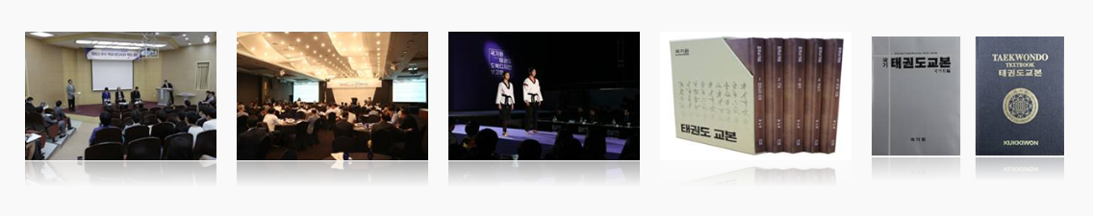
Laying the Academic Foundation of Taekwondo: "Taekwondo Research"

On April 3, 2006, Kukkiwon opened the Taekwondo Research Institute in order to start systematic research and present the vision for the development of Taekwondo. The institute has played a pivotal role in the academic research of Taekwondo by establishing the history of Taekwondo and leading R&D.
Since its foundation, the institute has published about 80 books and reports including the glossary and the Taekwondo textbook as the basis of Taekwondo research, education, promotion test, and competitions and distributed translated versions in different languages across the world.
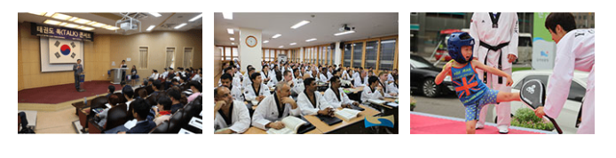
On June 30, 2010 in particular, it launched Taekwondo Journal of Kukkiwon. The journal became a candidate registered journal of the National Research Foundation of Korea on July 3, 2015, and it was finally selected as a registered journal on August 28, 2017, which means it is the representative journal in the Taekwondo circle.
It has also prepared a venue for sharing and disseminating knowledge and discussion among Taekwondo researchers and leaders in various forms, including academic seminars, research presentations, and monthly academic forums, more than 10 times so far.
As of July 2, 2022, the IF (impact factor) public announcement by KCI (Korea Citation Index) indicates that Taekwondo Journal of Kukkiwon is ranked first among 155 academic journals in the field of art and sport study and 38th among 2,678 academic journals in all academic fields; thus raising the academic value of Taekwondo.
The Taekwondo Research Institute will continue functioning as the center for systematic and scientific academic research on Taekwondo with the goal of proposing the directions and vision for the future of Taekwondo and enhancing its status.
