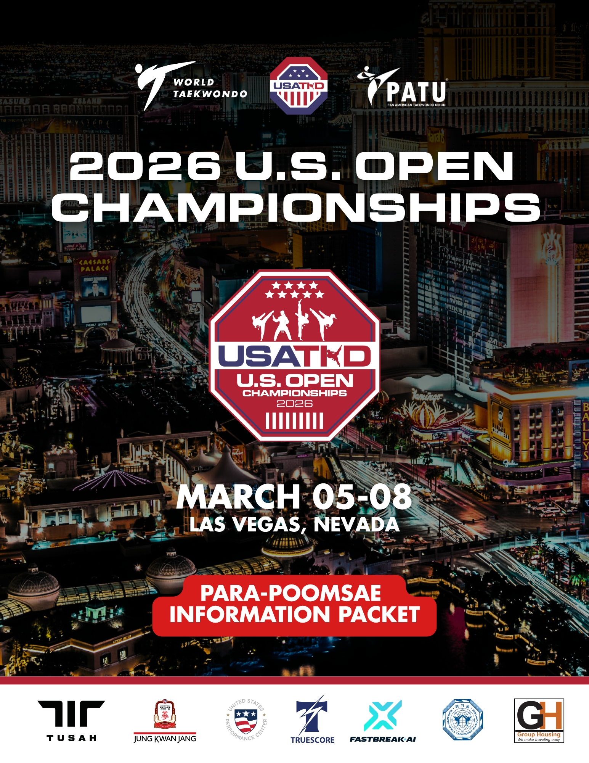
2026 US Open Poomsae Information Packet

PROMOTER

Pan American Taekwondo Union
General Guadalupe Victoria 214, Zona Centro, 20000 | Aguascalientes, Mexico
events@panamericantaekwondounion.org

World Taekwondo
10th Floor, Booyoung Taepyung Building 55, Sejong-daero, Jung-gu, Seoul Republic of Korea 04513

Seniors: G2 Junior: N/A Cadets: N/A

USA Taekwondo
1015 Garden of the Gods Road Suite 110
Colorado Springs, CO 80907
719-374-5736 Phone
USATKD
One Olympic Plaza
Colorado Springs, Colorado 80909
1-719-866-2423
SANCTIONED BY
World Taekwondo
10th Floor, Booyoung Taepyung Building 55, Sejong-daero, Jung-gu, Seoul Republic of Korea 04513

Pan American Taekwondo Union
General Guadalupe Victoria 214, Zona Centro, 20000 | Aguascalientes, Mexico
events@panamericantaekwondounion.org
ORGANIZER
USATKD
One Olympic Plaza
Colorado Springs, Colorado 80909
1-719-866-2423

Christine Simmons, Managing Director
cssimmons@usatkd.org

Eric Wininger, Director of National Teams
ewininger@usatkd.org

Katie Cleveland, Associate Director of Events
kcleveland@usatkd.org

Michael Newman, Events Assistant Manager
mnewman@usatkd.org

VENUE
Westgate Resort and Casino Las Vegas Paradise Event Center
3000 Paradise Road
Las Vegas, Nevada 89109
Hotel accommodation
ACCOMMODATION
All accredited club/teams participating at the event are strongly recommended to book their hotel accommodation via the Organizing Committee in the Official Hotels through Group Housing.

REGISTRATION & ACCREDITATION
March 4-8, 2026
Westgate Las Vegas Resort & Casino Paradise Event Center
3000 Paradise Road
Las Vegas, Nevada 89109
DRAW SHEETS & DESIGNATED POOMSAE
Poomsae draws and brackets will be published after the Technical Meeting on the USATKD website and Facebook page. Designated Poomsae will be released during the poomsae head of team meeting.

2026 U.S. OPEN TAEKWONDO CHAMPIONSHIP | USA Taekwondo
SEEDING
World Taekwondo Poomsae World Ranking Bylaw will be enforced. Seeding will be done for Recognized Under 30, Recognized Under 40, and 17 and Over Freestyle divisions. All other poomsae divisions will not be seeded.
HEAD OF TEAM MEETING

The head of team meeting will be … TBD
COMPETITION RULES
World Taekwondo Poomsae Rules will be followed.

To view para poomsae rules, please see the World Taekwondo website: CLICK HERE
CONTEST TIME
Recognized Poomsae
Individual competitions between 20 to 120 seconds for each Poomsae.

The WT Technical Delegate has the authority to adjust the contest time as seen fit.
ATHLETE ELIGIBILITY REQUIREMENTS
- Holder of a valid WT Global Athlete License.
- Member of the team/club of a pertinent Member National Association, recognized by the Pan American Taekwondo Union or World Taekwondo.
- Holder of 1st Dan/Poom, and above (WT regulations) for Cadet athletes and above.

Contestants may compete in a maximum of two events per WT Competition Rules (in recognized poomsae and/or freestyle poomsae). If an athlete is registered in more than two events, the athlete will randomly be removed from the needed events until meeting the two limit criteria.

NO ONSITE REGISTRATION WILL BE ACCEPTED FOR ATHLETES

- Minimum age of 18 years.
COACH ELIGIBILITY REQUIREMENTS
- Holder of a valid WT Global Official License.
- Coach is not allowed to wear a Dobok while coaching.

Coaches are required to have at minimum a World Taekwondo Level I Poomsae Coach certification. Any member that cannot provide proof of a WT coach certification will not be allowed to coach at this tournament.

NO ONSITE REGISTRATION WILL BE ACCEPTED FOR COACHES

USA Coaches

USA Coaches are required to complete and pass a background check (every two years), complete the U.S. Center for SafeSport training (every year).

The SafeSport and background check can be completed from your Sport80 profile.
First Time SafeSport - https://sport80.zendesk.com/hc/en-us/articles/360054619112-How-do-I-take-SafeSport-core-training-

SafeSport Refreshers - https://sport80.zendesk.com/hc/en-us/articles/360054619252-How-do-I-take-a-SafeSport-refresher-course-
These will update on Sport80 automatically every 24 hours if you follow the link through your Sport80 profile.
POOMSAE DIVISIONS
Sport Class | Male | Female
P11, P12 | Senior I (18-30)  Senior II (31 & Older) | Senior I (18-30)  Senior II (31 & Older)
P21, P22, P23 | Senior I (18-30)  Senior II (31 & Older) | Senior I (18-30)  Senior II (31 & Older)
P31, P32, P33, P34, P35 | Senior I (18-30)  Senior II (31 & Older) | Senior I (18-30)  Senior II (31 & Older)
P51, P52, P53 | Senior I (18-30)  Senior II (31 & Older) | Senior I (18-30)  Senior II (31 & Older)
COMPULSORY POOMSAE

Compulsory Poomsae determined based on Article 9 of WT Para Poomsae Rules.

For all Sport Classes there is a free choice to athletes to choose one Poomsae from Group 1 and one Poomsae from Group 2 for each round.
REGISTRATION & FEES

Team and athlete entries will only be accepted through the WT GMS online registration system Simply Compete.
Registration of athletes is only possible with a valid WT Global License (GAL issued by assigned GMS club, Edition and MNA Administrators only).

https://worldtkd.simplycompete.com/

ATHLETES
EARLY BIRD DEADLINE | ONE DIVISION
January 28, 2026 | $155
REGULAR DEADLINE | ONE DIVISION
February 18, 2026 | $180
COACHES
DEADLINE | FEE
February 18, 2026 | $100

PAYMENT ENTRY
All entry fees will be paid in advance to USATKD through Simply Compete registration system. PAYMENT FOR REGISTRATION WILL NOT BE ACCEPTED ON SITE. If a wire transfer needs to be done directly to USA Taekwondo due to national policies of MNA, please refer to the following info:

Beneficiary: USA Taekwondo
Name of the bank: Wells Fargo
Account Number: 1690251853
Routing Number: 102000076
BIC/SWIFT: WFBIUS6S
Bank address: 90 S Cascade Ave. Colorado Springs, CO 80903

SUBMIT A COPY OF YOUR PAYMENT TO: kcleveland@usatkd.org.

Athletes and coaches must pay IN FULL by the final registration deadline to compete.

USATKD has a NO REFUND policy.
CREDENTIALS
All athletes will receive a physical credential onsite at the event. Please come to the registration desk to pick up during the designated registration desk times.

All coaches will receive a physical credential onsite at the event. Please come to the registration desk for credential pickup during the designated registration desk times.
The visa invitation letter for each registered individual will be automatically generated from WT GMS platform if the visa is requested during the registration for the event. All members who need an entry visa to the USA must be registered for the event in GMS. You must then use this letter to apply for your or your team member’s visa.
VISA REQUEST
If you need assistance with a Visa letter you can email mnewman@usatkd.org.
SPORT EQUIPMENT
Mats
WT Recognized mats will be used at the event.

Dobok
Athletes can only use WT recognized products while participating at the event. See a list of recognized products at: http://www.worldtaekwondo.org/wtpartners-wt/recognize.html

Approved Poomsae Competition Uniforms

Children Division (6-11): Color code as Cadets is highly encouraged, but participants may compete in fully white V neck dobok.

Division (Ages 12-14): White top with red and black collar, plus blue pants for males; the same top, but with red pants, for females.

Junior and Senior Division (Ages 15-50): White top with dark blue pants for males; white top with light blue pants for females.

Master Division (Ages 51 and up): Yellow top and dark blue pants for both males and females.
AWARDS
INDIVIDUAL AWARDS
1st Place | Gold Medal
2nd Place | Silver Medal
3rd Place | Bronze Medal
3rd Place | Bronze Medal

Team awards will be given out to the top three (3) teams in each of the Men’s and Women’s Poomsae per medalist.

Special awards
Best Male and Best Female athlete in the Senior Poomsae Division
Best Male and Female Poomsae International Referees
Best Male and Female Poomsae Team Coach.

Awards would be given out after the conclusion of the poomsae event.

Applicable medical rules
ANTI-DOPING
The WT Medical Code, WT mouthguard, bracing, taping, padding, and piercing rules are applicable, which all MNA participating in this event must comply.

Applicable doping rules
The WT Anti-Doping Rules and the WADA Anti-Doping Code are applicable. Compulsory random doping tests will be conducted among all athletes. World Taekwondo and/or WADA may carry out random out-of-competition testing prior to the event.

Therapeutic Use Exemption
Athletes who take any substance or medicine listed in the “Prohibited List” of the WT Anti-Doping Rules and WADA Anti-Doping Code for therapeutic purposes are requested to submit TUE applications via ADAMS, together with the required medical information. Otherwise, please download the TUE Application Form (found on https://ita.sport/TUE), and once duly completed and signed, send it together with the required medical file to tue@ita.sport. Report TUE applications also to the WT Sport Department via antidoping@worldtaekwondo.org by no later than 2 January 2026.

ADAMS login
For ADAMS login, please contact National Anti-Doping Organization (NADO) in your country or tue@ita.sport with copy to antidoping@worldtaekwondo.org

For more details, please visit:
http://www.wada-ama.org/en/ADAMS/
http://www.worldtaekwondo.org/anti_doping-wt/therapeutic.html
MEDICAL
Athletic Trainers & Taping of Athletes
Sports Med Staff will be ringside and in the medical tent to provide injury and illness care for all participants. Please remember when taping ankles or instep pads, competitors must comply with the rules set forth by World Taekwondo and USATKD.
MEDIA

Registered media and press officials or official photographers are entitled to receive a media credential. For more information, please contact the USATKD at media@usatkd.org.

Admission to the US Open is by credential or ticket only. Event tickets can be ordered directly online through Easy Event Tickets. No onsite ticket sales will be available for purchase. Online ticket sales will be available through the conclusion of the event.
SPECTATORS TICKETS
CLICK HERE TO BUY TICKETS
TICKETS (Early Bird Deadline 2/18/2025)
TICKET TYPE | EARLY BIRD PRICE | REGULAR PRICE
ADULT SINGLE DAY | $20.00 | $25.00
ADULT ALL WEEKEND (4-DAY) PASS | $72.00 | $77.00
CHILD SINGLE DAY | $15.00 | $20.00
CHILD ALL WEEKEND (4-DAY) PASS | $52.00 | $57.00
SENIOR (65 & OLDER) SINGLE DAY | $17.00 | $22.00
SENIOR (65 & OLDER) WEEKEND (4-DAY) PASS | $60.00 | $65.00

Wristbands will be given in exchange for your tickets at the tournament. Wristbands must be worn at all times and are good for the time allotted on your ticket (Single Day = only for the appropriate day purchased).

Delta Air Lines is pleased to offer special discounts for USA Taekwondo
You may also call Conferences and Events® at 1.800.328.1111* Monday–Friday, 8:00 a.m. – 6:30 p.m. (EST) and refer to Meeting Event Code NY49H
*Please note there is not a service fee for reservations booked and ticketed via our reservation 1-800 number.


SAFESPORT & MAAP
If you need crisis intervention, referrals, or emotional support at any time, contact the 24-hour SafeSport Helpline at 866-200-0796.
If you are facing a life-threatening emergency, contact 911. Please use this link to report a Safe Sport incident - safesport-i.sight.com/portal.
How to report a Safe Sport concern -
Please call 833 5US Safe
safesport-i.sight.com/portal

USA Taekwondo, SafeSport and the MAAPP Policy
Safe Sport is an initiative that is mandatory for all USOPC National Governing Bodies to develop and to implement. USA Taekwondo has done so, and it is now a requirement that people in supervisory positions with our Taekwondo athletes must undergo and successfully complete a background check. Of course, the emphasis here is on the safety of our athletes and the strong motivation to keep them safe from all kinds of abuse, including harassment, bullying and improper touching. We will also be providing training for our membership regarding Safe Sport and its implementation.
We are partnering with the USOPC to bring this training to our membership. Athlete safety concerns our entire membership, and SafeSport is a great initiative that has been instituted by the U.S. Olympic & Paralympic Committee to help to protect all of our athletes.
The Minor Athlete Abuse Prevention Policies (MAAPP) limits one-on-one adult/minor interactions and sets standards for training and sport settings that prevent abuse and misconduct. Sport organizations invested in keeping young athletes free of abuse are strongly encouraged to adopt the MAAPP—now required throughout the U.S. Olympic and Paralympic Movement.
Click here to view USATKD’s SafeSport Details including Reporting and MAAPP

Click here to view the US Center for SafeSport

SCHEDULE
DATE | TIME | EVENT | LOCATION
March 4, 2026 | 13:00 – 17:00 | Accreditation Pick Up  (Poomsae Athletes and Coaches) | Paradise Event Center
March 4, 2026 | 10:00 – 17:00 | Para Athlete Classification | Paradise Event Center
March 4, 2026 | 13:00 – 17:00 | Training | Paradise Event Center
March 5, 2026 | 7:30 – 17:00 | Accreditation Pick Up  (Kyorugi Athletes and Coaches) | Paradise Event Center
March 5, 2026 | 7:30 – 17:00 | Spectator Wrist Band Pick Up + Member Services Desk | Paradise Event Center
March 5, 2026 | 8:30 – 17:00 | Poomsae Competition | Paradise Event Center
March 5, 2026 | 8:30 – 17:00 | Para Poomsae Competition | Paradise Event Center
March 5, 2026 | 9:00 – 17:00 | Training | Paradise Event Center
March 5, 2026 | 10:00-12:00 | Junior + Para Kyorugi Weigh In | Paradise Event Center
March 6, 2026 | 7:30 – 17:00 | Accreditation Pick Up  (Kyorugi Athletes and Coaches) | Paradise Event Center
March 6, 2026 | 7:30 – 17:00 | Spectator Wrist Band Pick Up + Member Services Desk | Paradise Event Center
March 6, 2026 | 8:30 – 17:00 | Junior Kyorugi Competition | Paradise Event Center
March 6, 2026 | 8:30 – 17:00 | Para Kyorugi Competition | Paradise Event Center
March 6, 2026 | 9:00 – 17:00 | Training | Paradise Event Center
March 6, 2026 | 10:00 – 12:00 | Cadet Weigh In | Paradise Event Center
March 6, 2026 | 12:00 – 14:00 | Ultra, Youth, Tiger, Dragon Weigh In | Paradise Event Center
March 7, 2026 | 7:30 – 17:00 | Accreditation Pick Up  (Kyorugi Athletes and Coaches) | Paradise Event Center
March 7, 2026 | 7:30 – 17:00 | Spectator Wrist Band Pick Up + Member Services Desk | Paradise Event Center
March 7, 2026 | 8:30 – 17:00 | Cadet, Youth, Tiger, Dragon, Ultra Kyorugi Competition | Paradise Event Center
March 7, 2026 | 9:00 – 17:00 | Training | Paradise Event Center
March 7, 2026 | 10:00 – 12:00 | Senior Weigh In | Paradise Event Center
March 8, 2026 | 5:30 | Senior Random Weigh In List Posted | Paradise Event Center
March 8, 2026 | 6:30 | Senior Random Weigh In | Paradise Event Center
March 8, 2026 | 6:30 – 17:00 | Accreditation Pick Up  (Kyorugi Athletes and Coaches) | Paradise Event Center
March 8, 2026 | 7:30 – 17:00 | Senior Kyorugi Competition | Paradise Event Center

MEDIA RELEASE
By registering for this event, I hereby agree to be filmed, videotaped and photographed, and to have my name, image, picture, likeness, voice and biographical information otherwise recorded, in any media, by USA Taekwondo (USATKD) and its official photographers, film crews and video crews, and by any other entity authorized by USA Taekwondo (the “Footage”).

I hereby grant the USA Taekwondo and its assigns the irrevocable, perpetual, fully paid-up, worldwide right and license to use, and to authorize third parties to use, in all media, the Footage for: (1) news and information purposes, (2) promotion of me and the specific competition(s) in which I compete, (3) promotion of the USA Taekwondo Teams, and (4) promotion of USA Taekwondo (including, but not limited to in videos, blogs, episodes, shows or other promotions distributed digitally through a USA Taekwondo YouTube Channel) without the need to seek any further consent from me.

I acknowledge and agree that the programming in which the Footage is used, and the media through which the Footage is distributed, may contain advertising and sponsorships; provided that, in no event may USA Taekwondo use or authorize the commercial use of the Footage in any manner that would imply my endorsement of any company, product, or service, without my written permission. My permission will not be unreasonably withheld, delayed or conditioned provided that the proposed commercial association does not create sponsor conflicts for me.

USA Taekwondo may edit my appearance as it sees fit. USA Taekwondo shall have all right, title and interest in any and all results and proceeds from usage of the Footage. USA Taekwondo is not obliged to make any use of my performance or exercise any of the rights granted by this Release.

