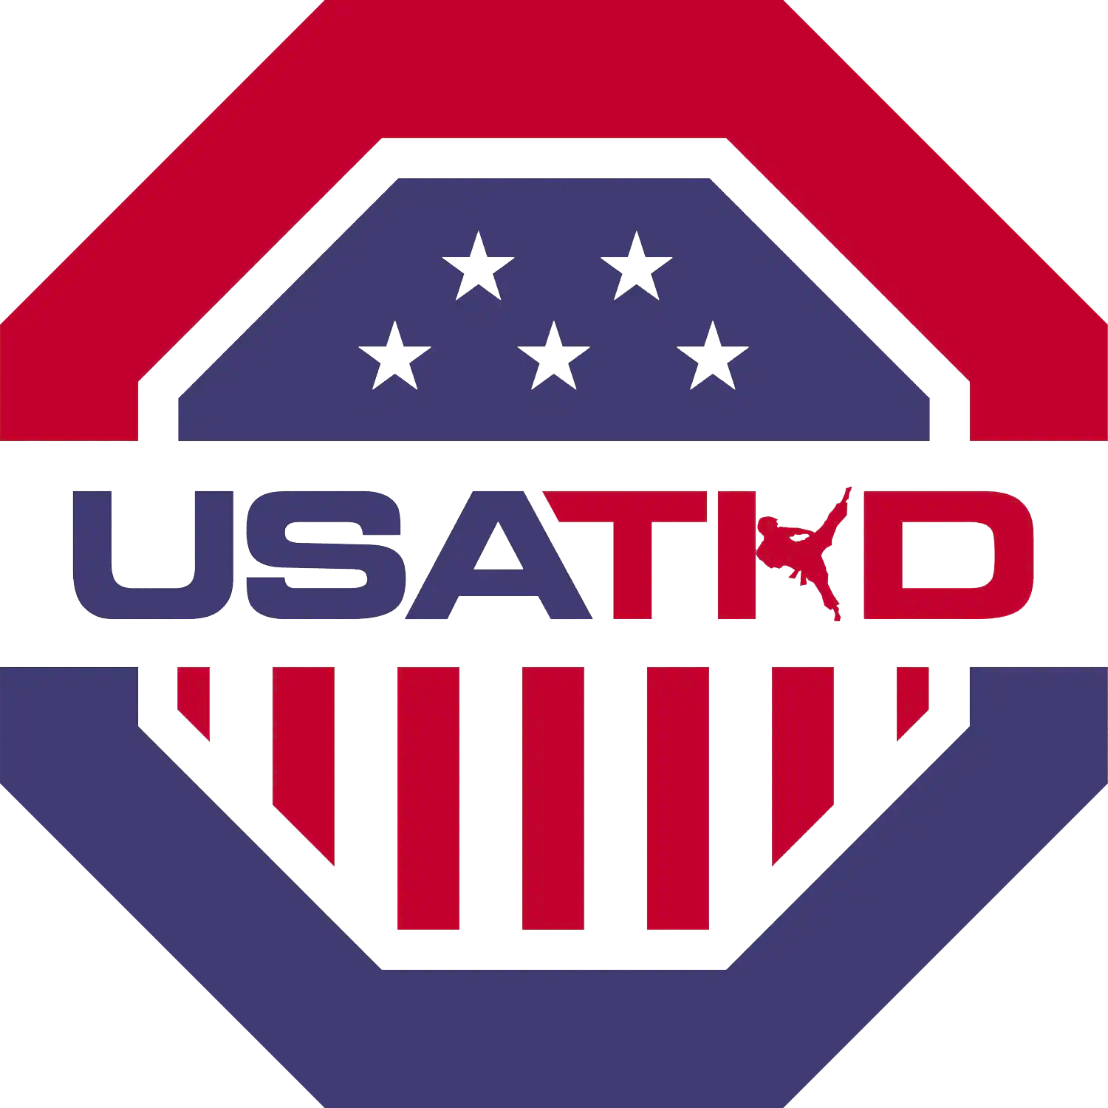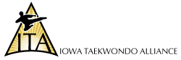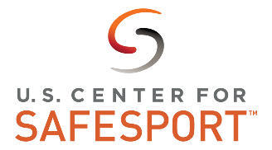

2026 USAT Iowa State Championships
Tournament Packet
This packet intends to help all school owners, coaches, and parents and welcome you to the 2026 USAT 12.0 Iowa State National Qualifier. It contains all the event information, registration details, and planning needed for your athlete for competition.

Event Name: 2026 USAT Iowa State Championships
Date: Saturday, April 4th, 2026: 9:00am Start Time
Location: Cedar Rapids Armory: 1500 Wright Brothers Blvd W
Event Status: USAT 12.0 Event (Those of you planning to attend the 2026 USAT Nationals in Charolette, NC must medal at this event.)

**All athletes, coaches, referees, and volunteers must have a current active USAT membership. USAT membership WILL NOT be included with your registration fee, and your membership must be obtained prior to competition. Anyone aged 18 and older must have completed a current SafeSport course and background screening before registering for this event. You may complete this section once you become a USAT member. Those who do not have this finished cannot compete, coach, ref, or volunteer on the competition floor. **
Thank you for understanding. These are REQUIREMENTS for our state championships. With your USAT membership, members are insured under USAT for any injuries or accidents that may occur during the event.
Event Details for the
Iowa State Championships

Link to sign-up as a USAT member: https://usataekwondo.sport80.com/public/wizard/e/510

Events Offered (Links to view all rules for each event): https://usatkd.org/usatkd-competition-rules
-Traditional Poomsae (Palgwe and Taegeuk)
-Sport Poomsae (Individual, Pairs (One Male, One Female), Teams (Three Male, Three Female))
-WT Olympic Kyrougi (Use of Gen 2 will be in use at our state qualifier)
**NOTE: THOSE GOING TO NATIONALS MUST HAVE GEN 3 EQUIPMENT READY BEFORE COMPETING. GEN 2 EQUIPMENT WILL NOT BE USED. PLEASE ADVISE**

Entry Fees: $80 Regular Registration + $20 per event and a $5 CC Processing Fee

Important Dates:
March 25th: Final registration closes at 11:59pm
March 27th: Designated Sport Poomsae Forms will be released (All World Class Divisions will have their forms selected on the mat.)
April 3rd: Weigh-Ins 5:00pm to 8:00pm **Athletes sparring MUST weigh-in the day before competition**
April 4th: USAT Iowa State Championships (9:00am start time)

Tournament Day Information

Rules & Competition Standards: This is a national qualifying event. All divisions will follow current USAT Taekwondo rules and regulations. Certified referees and judges will be used to ensure fairness and safety for all players. This, along with creating a professional environment and experience for all in attendance, will be our main priority at this event.

Coach & Athlete Expectations: All coaches MUST be USAT members and are responsible for athlete conduct and equipment compliance. Sportsmanship and professionalism are expected from all the participants, coaches, and spectators and will follow all SafeSport guidelines to all in attendance.

Venue Information: Cedar Rapids Armory is a facility capable of accommodating two full-sized rings and a warm-up area, along with seating for spectators. There will be a concession stand at the venue, but outside food IS permitted.

**PLEASE KEEP THE VENUE FREE FROM TRASH. NO FAST FOOD INSIDE THE COMPETITION AREA**

Doors will be open at 8:00am

Spectator Fees
Ages five and under: Free
Ages 6 to 64: $5 Spectator Fee
Ages 65 and Older: Free

Nearby Hotel Recommendations:
The following hotels are located within 10–15 minutes of the Cedar Rapids Armory and are used by most teams and families attending events in the area:

1.) Country Inn & Suites by Radisson (9100 Atlantic Dr SW, Cedar Rapids Airport, IA 52404)
2.) Comfort Inn & Suites (2025 Werner Ave NE, Cedar Rapids CID Easter Iowa Airport, IA 52404)
3.) AmericInn by Wyndham (4747 1st Ave SE, Cedar Rapids Airport, IA 52404)
4.) Avid Hotel (645 America Dr SW, Cedar Rapids South, IA 52404)

Communication & Updates:
Official updates and advertising will be posted through the Iowa Taekwondo Alliance Facebook Page. All are encouraged to follow our page to monitor for updates leading to the big event. Like and follow our page using the link below:
https://www.facebook.com/iowatkdalliance

Contact Information
Tournament Director: Ryan Bishop
Email: rbishop@bishopselitemartialarts.com
Phone: (515) 525-6670

Thank you all for making an investment in your athlete, school, and most importantly, the growth of Taekwondo in state of Iowa. After a six-year hiatus, we truly look forward to giving you all the best experience possible at this tournament. Please do not hesitate to reach out with any questions, comments, or concerns.

-Ryan Bishop, ITA President
-Katy Sebers, Executive Tournament Director

