

Name:

Preferred Pronouns:

|  |  |
| --- | --- |
| What is this document? | We want make sure filming/ working in the office is an enjoyable experience for you.  The purpose of this document is for you to outline any adjustments you may need.  Please tell us what we can do to help to you feel comfortable.  This form is confidential. It means we won’t share this information with anyone outside of this production.  Nothing that you write on this form will affect our decisions about whether or not to include you in the show.  You don’t have to answer all the questions if you don’t want to. |



How can we contact you?

We need to be able to contact you when we are filming with you.

How do you prefer to be contacted?

|  |  |
| --- | --- |
| Do you like to be contacted  by phone call? | Yes/No |
| Do you like to be contacted by text? | Yes/No |
| Do you like you be contacted by email? | Yes/No |
| Would you like to be contacted in  another way i.e. WhatsApp? |  |
| What methods of communication do you feel most comfortable with? |  |
| How do you feel about how we have contacted you so far? |  |



Filming with you

|  |  |
| --- | --- |
| Are you happy meeting new people?  Is there anything we can do to make meeting the crew easier for you? |  |
| Is there anything we can do to make  you feel more comfortable? For example, supplying photos and names of the crew in advance. |  |
| Is there anything you would like us not  to do while filming with you? |  |

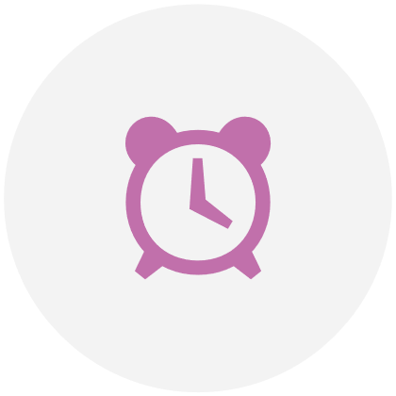

Your Routine

Filming might require us to disrupt your daily routine.

|  |  |
| --- | --- |
| How comfortable are you with changes to your routine? |  |
| How much notice would you need if changes to your routine are needed for filming? |  |
| Sometimes things can change at short notice when filming. How much notice do you need if a plan that has been arranged with you needs to change? |  |
| Where possible, we will provide breaks during filming. How would you like to spend your breaks? |  |
| Do you have any specific routines that you need to follow? |  |



Your Routine

Continued

|  |  |
| --- | --- |
| Do you eat meals at set times? |  |
| How flexible can you be with when you eat? |  |
| Would you prefer to bring your own food when we are filming? |  |
| Do you have any dietary requirements or allergies? |  |
| Are there any foods you particularly like or dislike? |  |
| Are you comfortable eating in restaurants? |  |



Your personal space

We may need to attach a small microphone to your clothes whilst filming.

We may also need to film with you out and about in your local area.

|  |  |
| --- | --- |
| Are you comfortable with members of the crew touching you, for example, to attach a microphone? |  |
| How comfortable are you with busy and crowded spaces? |  |
| How comfortable are you with brightly  lit spaces? Could you please tell us  how lights affect you? |  |
| How comfortable are you with noisy spaces or occasional loud noises? |  |
| Do you have any other sensory processing issues or triggers? For example, specific smells and heat. |  |



Travel for filming

On occasions, we may need you to travel to where we’re filming.

|  |  |
| --- | --- |
| Is there somebody that can help you prepare to travel? |  |
| How do you like to travel?  For example, train, car or bus? |  |
| Are you happy to travel on your own? |  |
| Are you happy to travel on  public transport? |  |
| Do you prefer to arrive early for meetings and train departures? If yes, how much extra time should we allow? |  |



Overnighting during filming

We may ask you to stay overnight in a hotel if we’re filming a long way from where   
you live, especially if we’re filming early in the morning or late in the evening.

|  |  |
| --- | --- |
| Are you happy to stay in a hotel? |  |
| Would you prefer if a friend or relative stayed with you at the hotel during filming? |  |
| Do you have routines or schedules  you would like to stick to whilst away from home? |  |



Finally

Some other things you may like to share.

|  |  |
| --- | --- |
| If you experience meltdowns or shutdowns, are there any signs that we should look out for? |  |
| Are there are any topics we absolutely should not talk about in front of you? |  |
| Is there anything not covered in this document that causes you distress that you would like us to know about? |  |
| How do you like to be supported in moments of distress? |  |
| What else can we do to help you enjoy your time filming with us? |  |



Finally

Continued.

|  |  |
| --- | --- |
| Has there been anything on this production that has concerned you  so far? |  |
| Has the Covid-19 pandemic affected you in any way? If so, can you elaborate? i.e. you avoid travelling by public transport, you suffer from ‘Long Covid’. |  |
| Let us know if there is someone, other than yourself, that you would like us to talk to if you have any issues during the production. This could be a partner, parent, friend or support worker. |  |

|  |
| --- |
| This section provides you with the opportunity to share any additional information with us that has not been covered in the above sections.  For example:  Any special interests you need to follow such as TV programmes.  Any sensory requirements that have not been mentioned already.  Anything else that might cause you distress or anxiety.  Any spiritual and cultural requirements. |
|  |
| This document was last updated on: DD/MM/YYYY |