|  |  |
| --- | --- |
| What is this document? | Now filming is complete, this document informs you of what to expect from  now on. Although filming has finished, your safety and mental wellbeing is still important to us.  There are a number of ways you may be affected by your involvement in  the show.  This document is designed to give you some practical tips and advice. |

|  |  |
| --- | --- |
| What to expect before  show transmission? | After editing, it may be some months when this show finally transmits on television. But as soon as we have  a date **[PROD POC]** will let you know in advance. Sometimes this will be a month before transmission but can be as little as 2 weeks.  The show will go out on **[CHANNEL HERE]** and will also be available on NOW TV. |

|  |  |
| --- | --- |
| Press Photos | Before transmission, we will be promoting the series. There will be some press and marketing activity to spread awareness of this show. This could happen on radio, newspapers and social media.  This could involve photos of you, but don’t worry, **[PROJECT POC]** will send you the photos featuring you to check and choose in advance so there will be no surprises. Newspapers and other press might be interested in being in touch with you. We will deal with all requests for you. You don’t have to communicate with anyone if you’d prefer not to. |

|  |  |
| --- | --- |
| Social Media | When the show broadcasts, there is a good chance you will get attention on social media.  People you don’t know may approach you, or people may be mentioning you on X, TikTok, Facebook posts, Instagram etc. There may be people who want to say unpleasant and sometimes nasty things about you or  to you, which you may find upsetting. |

|  |  |
| --- | --- |
| Should I read comments  on social media? | Do your best not to look up comments about the show on social media. If you do see an unpleasant comment, do your best to ignore it.  This can be really difficult, but don’t engage in an argument – most people who post unpleasant things online only do it to try to get an angry or upset response, so do not give them the satisfaction of knowing it upset you. |

|  |  |
| --- | --- |
| What happens if I see  an unpleasant comment  on my social media? | Block the user.  Report them to the social  media platform.  Let **[PROD POC]** know. Screenshot the comment and note the date and time. |

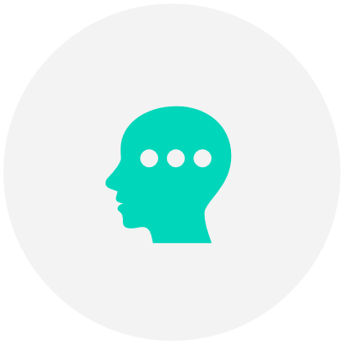  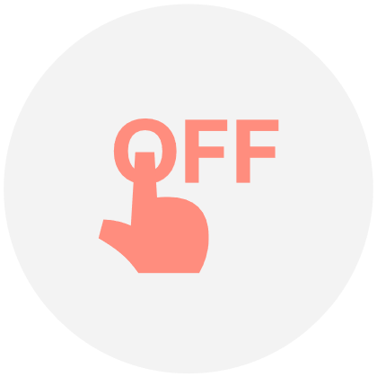

Social Media tips to help protect your personal data

|  |  |
| --- | --- |
| Check your Privacy Settings | Regularly review the privacy settings as software updates can change your settings |
| Turn of Locations Settings | Turn off your location settings for your apps and don’t advertise where you are |
| Close Accounts | Close social media accounts  you don’t currently use |
| Block Other Users | Block anybody that makes  you feel uncomfortable |
| Facebook | Ensure only ‘friends’ can view your profile. Hide your friends list as this can give away details of family members |
| Twitter | Under ‘settings and privacy’ you can protect your tweets so only your current followers see your tweets |
| Instagram | You can set your account to ‘private account’ via the settings button |
| Linkedin | Only link in with people you know and trust |
| Need Help? | If you need help with these steps,  do contact [PROD POC] |



Thank you for being involved in the show!

End of Document