**RECALL NOTICE**

**RING VIDEO DOORBELLS (2ND GENERATION)**

**SOLD FROM JUNE 2020 TO OCTOBER 2020**

**Battery Can Overheat When Wood Screws Are Used For Installation** **Instead Of Security Screws, Posing Fire And Burn Hazards to Consumers.**

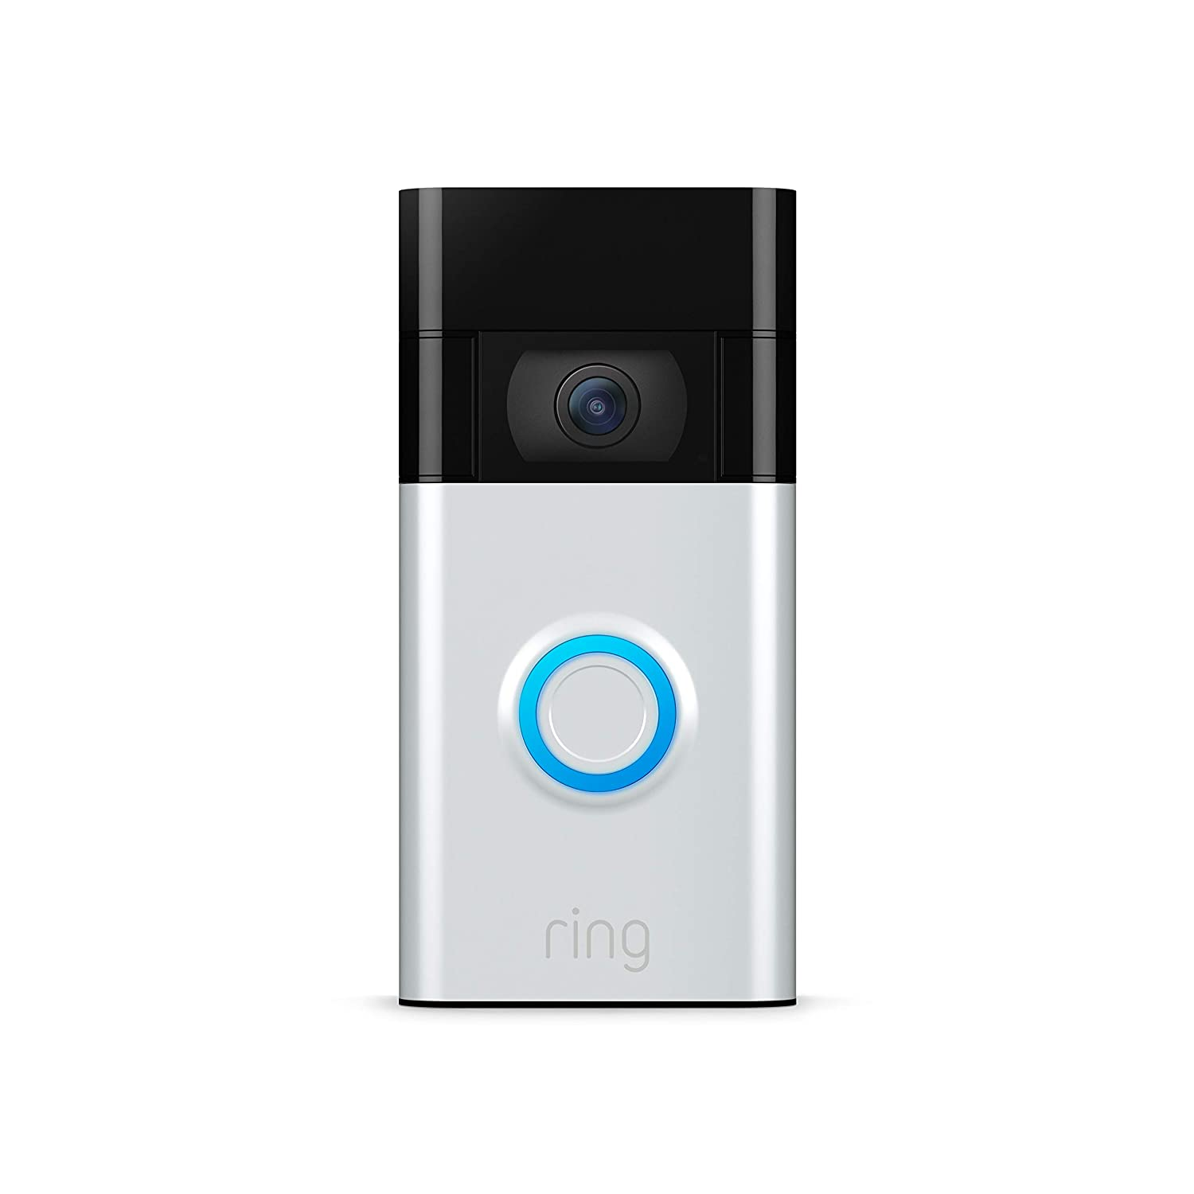

**Updated Instructions Available.**

**If the doorbell is installed correctly, there is no risk to consumers.**

To Receive Updated Installation Instructions Call Ring at

**1-800-656-1918** from 5 a.m. to 9 p.m. PT, Seven Days a Week, or Visit our Website at www.ring.com or App.