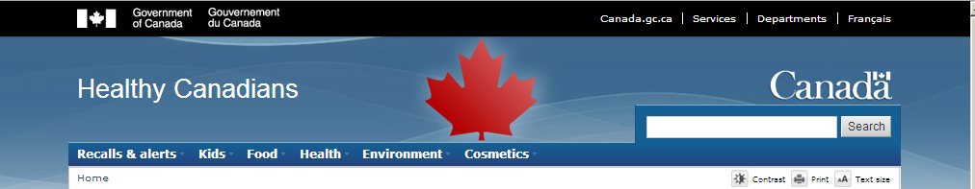

Walker Edison Drawer Chests recalled due to Tip-Over and Entrapment Hazards
Starting date:  Posting date:  Type of communication:  Subcategory:  Source of recall:  Issue:  Audience:  Identification number: |  | (November 4 2020)  (November 4 2020)  Consumer Product Recall  Household item  Health Canada  Product Safety  General Public (GP)  (Generated by system number)
Affected products |  | What you should do

Summary
• Product: Walker Edison Drawer Chests
• Issue: The recalled drawer chests are unstable if they are not anchored to the wall, posing serious tip-over and entrapment hazards that may result in death or injuries to children.
• What to do: Immediately stop using the recalled chests and contact Walker Edison for instructions to dispose of the product and obtain a full refund or free replacement.

Joint Recall
Joint recall with Health Canada, the United States Consumer Product Safety Commission (US CPSC) and Walker Edison Furniture Company

Affected Products
Walker Edison Drawer Chests

Product Description
This recall involves two of Walker Edison’s drawer chest products. The drawer chests are made of wood and either painted white, painted gray, painted with wood stain, or covered in a wood imitation laminate. The chests have drawers that can be removed and are elevated approximately five inches off the ground with wooden legs.

The drawer chests are not marked; however, the model numbers are marked on the boxes.

The following products are included in the recall:
Model Number on Box | Brand
BR3DMILDRDW (840035320847) | Chest of Drawers
BR3DMILDRSG (840035320854) | Chest of Drawers
BR4DDRCA (842158142443) | Spencer 4-Drawer Chest
BR4DDRWH (842158142436) | Spencer 4-Drawer Chest
BR4DDRWT (842158142450) | Spencer 4-Drawer Chest

Hazard Identified
The recalled drawer chests are unstable if they are not anchored to the wall, posing serious tip-over and entrapment hazards that may result in death or injuries to children.

As of October 21 2020, the company has received no reports of incidents or injuries in Canada, or in the United States.

Number Sold
The company reported 932 units of the affected product were sold in Canada and 24, 000 were sold or distributed in the United States.

Time Period Sold
The affected products were sold from August, 2018 to March, 2020.

Place of Origin
Manufactured in China and Brazil.

Companies
Distributor | Walker Edison Furniture Company LLC, of Salt Lake City, Utah  United States

What you should do
Consumers should immediately stop using the recalled chests and contact Walker Edison for instructions to dispose of the product and obtain a full refund or free replacement. Walker Edison will provide packaging and pre-paid shipping labels so that consumers can remove the chest’s drawer slides and return them to the firm for a full refund or free replacement chest.

For more information, consumers may contact Walker Edison toll-free at 1-833-208-3600, email (hyperlink: recall1020@walkeredison.com), or at www.walkeredison.com.

Consumers may view the release by the US CPSC on the Commission’s website.

Please note that the Canada Consumer Product Safety Act prohibits recalled products from being redistributed, sold or even given away in Canada.

Health Canada would like to remind Canadians to report any health or safety incidents related to the use of this product or any other consumer product or cosmetic by filling out the Consumer Product Incident Report Form
(https://www.canada.ca/en/health-canada/services/consumer-product-safety/advisories-warnings-recalls/report-incident-involving-consumer-product.html).

This recall is also posted on the OECD Global Portal on Product Recalls website (http://globalrecalls.oecd.org/). You can visit this site for more information on other international consumer product recalls.

Images
Image 1: Recalled Chest of Drawers and Spencer 4-Drawer Chests

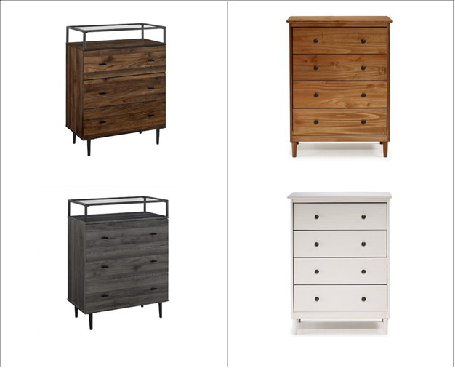

Date modified: (Automatically generated date)
