Organize a Rainbow Room Drive!

By organizing a donation drive, you provide an opportunity for your friends, family, co-workers, classmates, or others to work as a team and support the mission of Partnerships for Children in stocking high need items for the Rainbow Room.
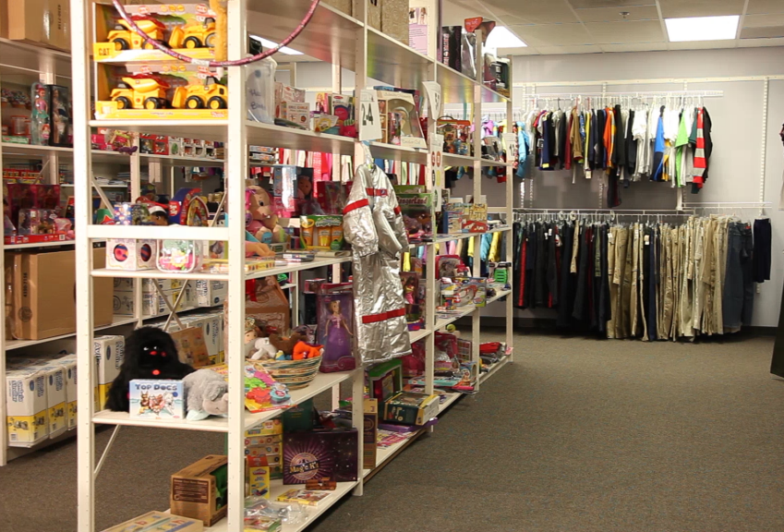
Select a Round Up Theme
- Rainbow Room (Comprehensive high need items)
- Spring Cleaning (Household cleaning items)
- Sweet Dreams (Bedtime basics)
- Health & Hygiene (Hygiene and toiletries)
- Safe & Secure (Essential safety items)
- Baby Basics (All baby items)

Finalize Drive Details:
- Define specific dates of the drive
- Identify a collection site(s)
- Set a goal

Communicate & Connect
- Work with Rainbow Room Coordinator to create and personalize fliers and/or posters with details (marcus@partnershipsforchildren.org or 512-834-4756)
- Promote the drive using formal and informal communication tools including social media, email, fliers/posters
- Our social media accounts: Facebook: PartnershipsforChildren; Instagram:partnershipsforchildren
- Use the hashtag: #givingahand

Deliver & Celebrate
- Set a time to deliver the collections to the Rainbow Room.
- We can schedule a tour and/or photo opportunity to share and celebrate the impact your drive will have for the children.

Helpful Hints:
- Be knowledgeable about why items are needed, who will receive them and why it’s an important issue for our community.
- Inspire participants with a goal or incentive. Capitalize on competition by creating teams or promoting collaboration.
- Celebrate donations, donors, and steps toward your goal.

