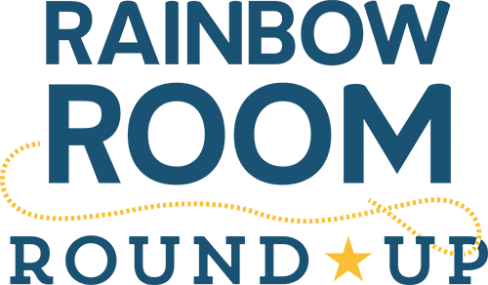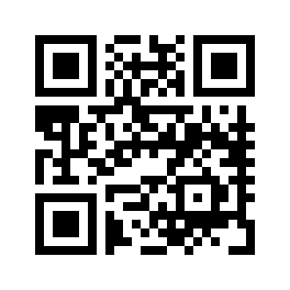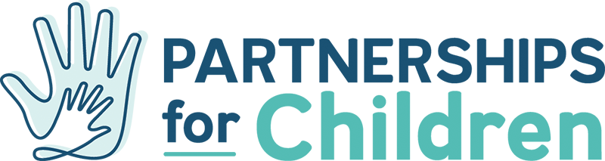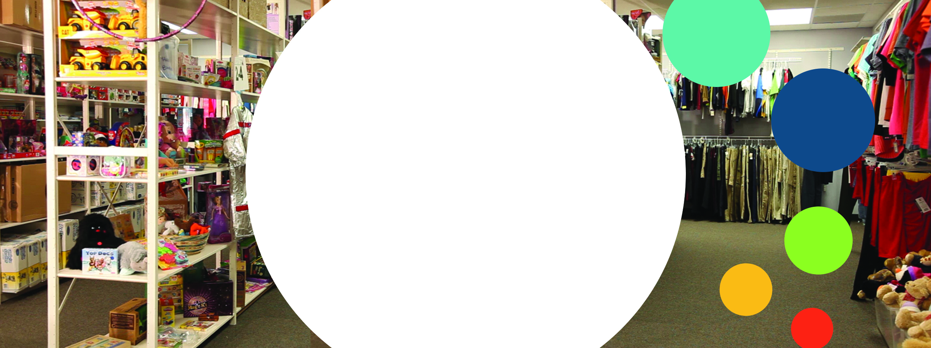

The Rainbow Room is a 24 hours / 7 day resource center located in the Child Protective Services (CPS) office where caseworkers can gather new and essential items needed for the kids in their caseload whose lives are in crisis. The Rainbow Room is in constant need of **brand new items** for the more than 700 children it serves each month.

**Baby Items:** diapers /pull ups (all sizes), baby wipes, shampoo/body wash, rash cream, bottles, sippy cups, pacifiers, onesies, pack ‘n’ plays, car seats

**Clothes:** Teen t-shirts, athletic shorts, socks and underwear. Gift cards to clothing stores, i.e. Old Navy, Marshalls, Academy

**Hygiene Items:** combs, brushes, deodorant, shampoo/conditioner, shaving cream

**Bedding Supplies:** pillows, twin sheet sets, blankets, twin-size air mattresses with hand pumps

**For more information email**

**Marcus@partnershipsforchildren.org**

**www.partnershipsforchildren.org**