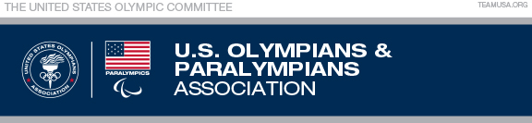

Annual Conflict of Interest Policy Certification
(Approved March 23, 2017)

I, __________________________________ (print name), an officer of the United States Olympians/Paralympians Association (USOPA), an entity recognized by the USOC, do hereby certify that:

- I have received a copy of the USOPA’s Conflict of Interest Policy;

- I have read and understand the Conflict of Interest Policy;

- I agree to comply with the Conflict of Interest Policy:

____ I have no disclosures to make at this time.

____ I have attached a completed Conflict of Interest Disclosure Statement.

NOTE: The disclosure process and form are not limited to a one-time annual review/confirmation. The disclosure document must be completed and submitted to the USOPA Conflict of Interest sub-committee immediately whenever a conflict (or potential conflict) exists.

Signature:______________________________

Date: _______________________________

Please return to: Cindy Stinger, Manager, USOPA

