Olympic and Paralympic Winter Games Milano Cortina 2026
Team USA Media Planning Guide – Feb. 5, 2025

Dear U.S. Media:

Happy New Year! Thanks again for your interest in Team USA, and in covering the Olympic and Paralympic Winter Games Milano Cortina 2026.

We are excited to be headed to Italy, to the stunning city of Milan and the breathtaking mountain regions for the 2026 Games. Italy’s winter sports history, culture and dedication to hosting the world’s best winter athletes truly shines through in the Games plan.

After attending the World Press Briefing last fall and hearing from many of you with questions about what to expect, we are happy to offer a brief overview of the Games layout, expected operations and some insights that may be helpful as you plan your coverage.

For in-depth venue plans/maps, event schedules, transportation guides, accommodation information and more, please visit the MiCo Press Extranet or contact the wonderful MiCo Press Operations team. Links can be found below in the contacts/resources section.
We are always happy to chat live about our plans and experience if you have questions – and will certainly share more information as we have it.

Layout and Coverage Considerations

First and foremost, this is a true Winter Games competition and venue plan. The venues outside of Milan are set in some of the world’s great winter sports communities. That means the venues and the conditions will be outstanding – and it also means that covering the Games will present some challenges given remoteness and travel complexities (*think narrow highways over mountain passes, with access often depending on weather*).

We highly suggest you approach your coverage plans with the assumption that travel between the clusters will be very difficult – and almost certainly can’t be accomplished in a single day (e.g., you will not be able to start your day in Milan, travel to Cortina to cover an event and return to Milan the same day).

The OCOG is working very hard to source housing in the mountain clusters to support media needs. We recommend you identify your primary coverage locations, confirm housing, and plan to base staff there during the competition.

While the Main Press Center will be in Milan (during the Olympics only), the OCOG is offering an enhanced venue media center model that will provide resources for those working in the mountain clusters. Additionally, all press conferences will be live streamed on MediaZone (the new myInfo). Also, there will be the possibility to have an OIS reporter dedicated to ask questions on behalf of media to athletes in the mixed zone.

Venues and Competition Clusters

Below is a quick snapshot of the Games clusters – covering much of Northern Italy geographically and, in most cases, connected by limited travel options. Please see the map enclosed at the end of this document for reference.

Milan:
- OLY: Figure skating, short track speedskating, long track speedskating, ice hockey
- PARA: Sled Hockey
- Main Press Center (OLY), International Broadcast Center (OLY + PARA)
- USOPC Media Office (OLY), Team USA House (OLY/TBD)
- IOC and OCOG Press office (OLY)

Cortina (+ Anterselva):
- OLY: Alpine skiing (women’s), curling, biathlon, bobsled, skeleton, luge
- PARA: Para alpine skiing, Para snowboard, wheelchair curling
- Enhanced Media Center(s)
- USOPC Media Office (PARA)

Valtellina (Livigno and Bormio):
- OLY: Freestyle skiing, snowboarding, alpine skiing (men’s), ski mountaineering
- Enhanced Venue Media Center(s)

Val di Fiemme (Predazzo and Tesero):
- OLY: Cross-country skiing, Nordic combined, ski jumping
- PARA: Para biathlon, Para cross-country skiing
- Enhanced Venue Media Center(s)

Opening & Closing Ceremonies

OLY Opening: Milan > OLY Closing: Verona
PARA Opening: Verona > PARA Closing: Cortina

Transportation

Bus/Train: The OCOG is planning for efficient travel between the Games clusters, but it will require a good deal of advance planning and a lot of patience. Travel times are long and may require multiple transfer and/or modes. Within the clusters, there will be regular bus service to connect competition areas with accommodation areas.

Private cars: If you are experienced in mountain driving and are comfortable driving in inclement conditions, renting a car is certainly an option. Keep in mind that the mountain venues are located in small host communities (assume traffic and parking will be difficult), and you will also need to source a Vehicle Access/Parking Permit (VAAP) through the OCOG Rate Card portal for vehicle entry into controlled Games areas.

Points of Entry

For those arriving by air, you have the primary options of arriving in Milan or Venice. If you are planning to cover events in Cortina, Venice is a more direct route. If you are planning to travel to Livigno or Bormio, Milan is closer. Note that there is a regular express train between Venice and Milan that takes approximately two hours. Our initial understanding is that accreditation centers will be available at both.

Please visit the Arrivals and Departures section of the OCOG extranet or the Press Operations Guide for more information, including timetables for travel from the arrival airports to the venue clusters.

Team USA Media Plans

The USOPC will have an office in the Main Press Center (Milan) during the Olympic Winter Games that will serve as a resource for media requests, high demand event ticketing, press conferences, and all other media needs. The IOC and OCOG will have staff there as well.

We will also have USOPC staff located in both Cortina and Livigno ready to assist, and we will have press officers for every sport located in the respective competition clusters.

We are still planning for athlete access (pre-and post-medal, in person and remote) to best accommodate the most amount of press across the clusters. We look forward to sharing our guidance soon.

For Para, our media operation will be based out of a designated private office space as well as the enhanced venue media center in Cortina and supporting sport press officers at all the competition venues.

For More Information

Milano-Cortina 2026

Press Room: (login and registration portal)
https://milanocortina2026.olympics.com/en/press-room-login

Press Operations Email:
pressoperations@milanocortina2026.org 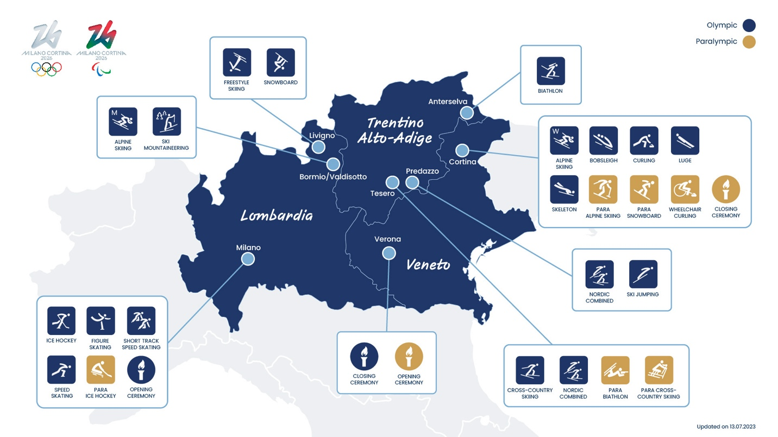

USOPC

Media Portal:
https://www.usopc.org/media

Games Accreditation Questions:
Accreditation@usopc.org

Games Map

