How to start or resume an experience in the Advance Care Planning tool

Step 1:
Click here to log into the Advance Care Planning tool (or type out https://spectrum-acp.uat.vyncahealth.com/patientportal/login into the search bar of your internet browser)

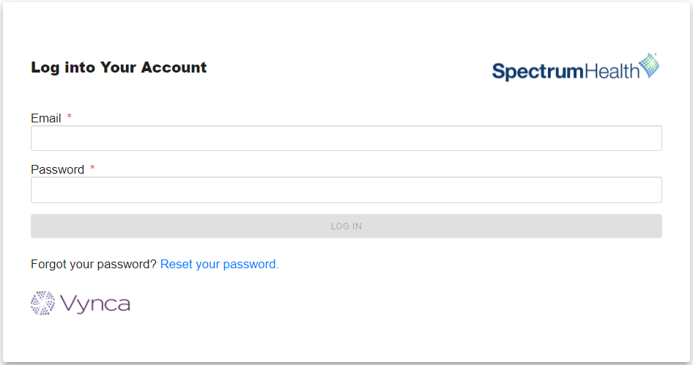

Step 2:
Use the Quick Start buttons on the landing page or the My Documents link at the top of the page to navigate to the available Advance Care Planning activities.

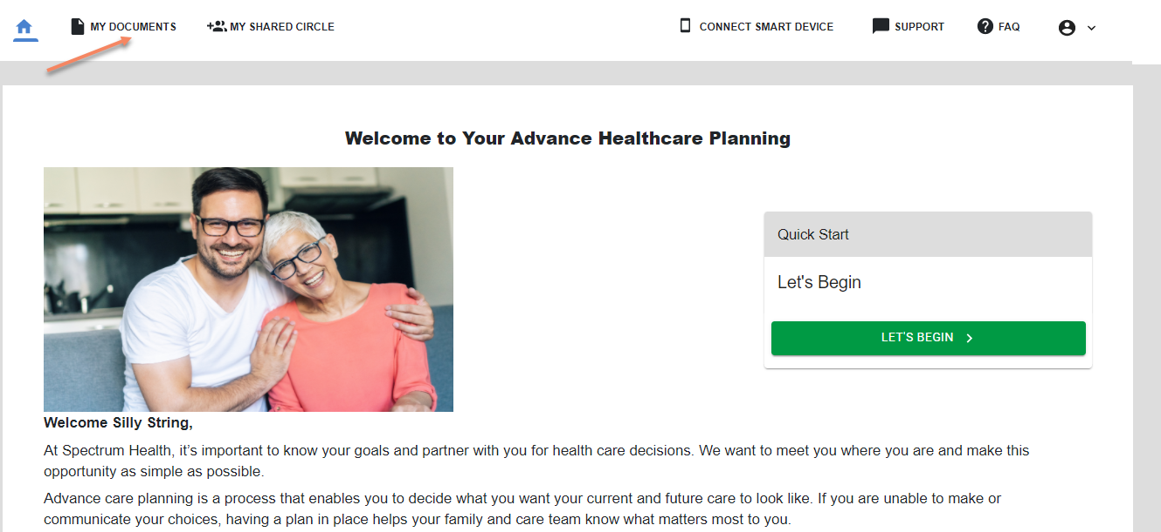

Step 3:
From the My Documents page, click on the menu button to create a new form. You can also click on the Resume button to complete an experience that was started previously.
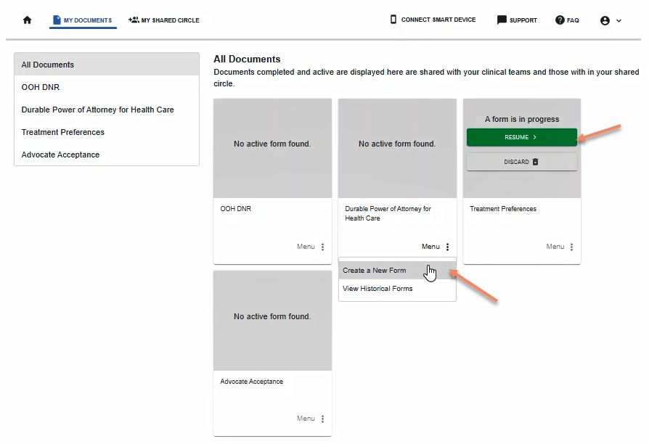

Stuck? We’re here to help.
Call: 616.774.7615
Email: Advancecareplanning@spectrumhealth.org

