Placental Chorioangioma

Chorioangiomas are hypoechoic rounded masses noted on ultrasound ~0.6-1% of the time. These masses can be concerning if they develop an arteriovenous shunt resulting in high output fetal cardiac failure. The risk of AV shunting is low if the mass is less than 4 centimeters.

The anechoic cystic area should be seen distinctly separate to the normal surrounding placental tissue. Some heterogeneous areas caused by degenerative processes and internal hemorrhage can be seen. They rarely appear pedunculated or complex.

Doppler often demonstrates low resistance pulsatile flow within the anechoic cystic areas; which represent enlarged vascular channels. Color flow with these visible vascular channels help to differentiate fibroids, teratomas and/or incomplete moles.

http://www.deepdyve.com/lp/de-gruyter/placental-chorioangioma-literature-review-x9fKo2njl0?utm_source=shareEmail&utm_medium=email&utm_campaign=docViewShareButton

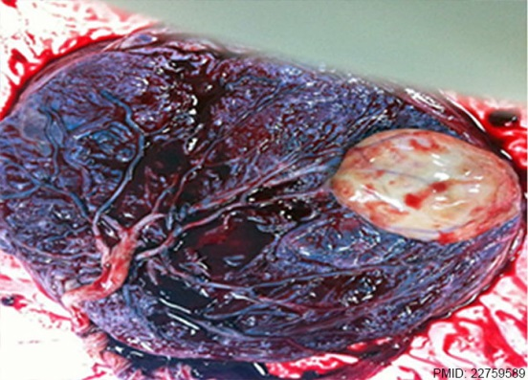
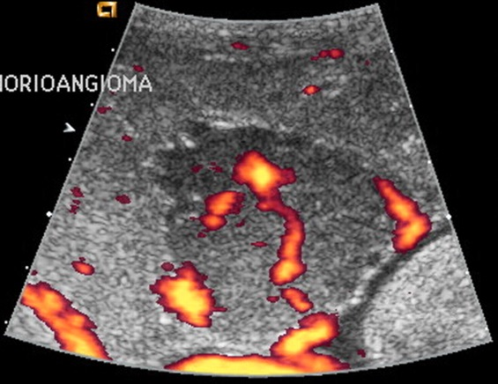
- If >/= than 4cm higher risk for high output cardiac failure and hydropic changes

- MFM consult at time of mass discovery;
- Targeted anatomy scan with MFM at 18-20 weeks

- Screen for fetal anemia, preeclampsia, mirror syndrome, polyhydramnios, IUGR, abruption each visit
- Placenta to pathology at delivery

- Ultrasound to screen for hydrops and fetal anemia (MCA Doppler) q2weeks, growth every fourth week
- If hydrops detected; BPP weekly or per MFM recommendations

- Growth scan at 28 weeks and 34 weeks
- Placenta to pathology at time of delivery

- If less than 4cm

