Spine and Pain Management

WELCOME TO OUR OFFICE

We are looking forward to seeing you at your upcoming appointment. Our goal is to provide our patients the best health care and service available. In order to help us achieve that goal, we are requesting that you complete the attached forms and present them when checking in for your first appointment. Please arrive 30 minutes prior to your appointment time. If you need assistance with completing the form, our staff will gladly help.

Your appointment with __________________________ has been scheduled for

______________________________________ at ___________________

- We will be taking a complete history to better understand your health care needs.
- You will be asked to change into a gown as we conduct a physical exam that includes an evaluation of your abdomen, back, muscles, joints, and your heart and lungs. We ask that you undress down to your undergarments (please remove socks/stockings) and use the gown provided.
- We request you not bring children to your appointment as we want to focus on your health and may have sensitive discussions.
- As a courtesy, please set your cell phone to off, silent, or vibrate.

There is a possibility that we may need to reschedule your appointment if you do not arrive on time. It is necessary for you to honor the appointment time that has been scheduled. We ask you to show consideration by notifying our office at least 24 hours in advance if you are unable to keep an appointment. We would like to have the option to offer that appointment to another patient who needs to see the doctor.

The office hours are Monday – Friday 8:00 AM - 5:00 PM.

We look forward to seeing you.

Sincerely,

The associates of Spectrum Health Medical Group Spine and Pain Management Center.

1900 Wealthy St SE, Suite 290
Grand Rapids MI 49506
Ph: 616-774-8345
Fax: 616-774-8350
www.shmg.org

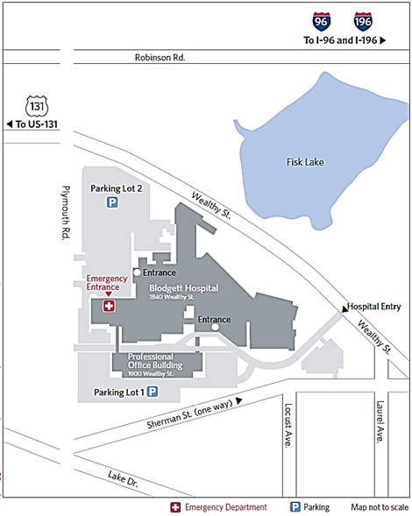
Radiology
Spine and Pain Management Center
1900 WEALTHY SE SUITE 290
GRAND RAPIDS MI 49506
PARKING LOT – TO TOP DECK/HANDICAP RAMP ENTRANCE or C ENTRANCE (STAIRS)
- Enter Parking Lot #1 from Wealthy St
- Drive between the Professional Office Building (POB) and Blodgett Hospital
- Parking Lot Entrance is located on the LEFT just past the Chemist Shoppe
- Turn LEFT into the Parking Structure
- Turn LEFT at the ‘arm’ in the Parking Ramp
- Follow through level 1, turn LEFT at the ‘LEFT TURN ONLY’ sign
- Follow curve – you are now on the TOP DECK
  - ‘Floor 2 Accessible Ramp’ is located between the EAST and CENTRAL entrances to the POB
    - Handicap Accessible ramp can only be opened by pushing the Handicap ‘button’ – located on the left
  - Enter the Central Entrance – There will be five (5) stairs up to the 2nd Floor – Suite 290 is located on the RIGHT
Please note: Suite 290 is accessible from East and West entrances from the top deck. There will be five (5) stairs up to the second floor.

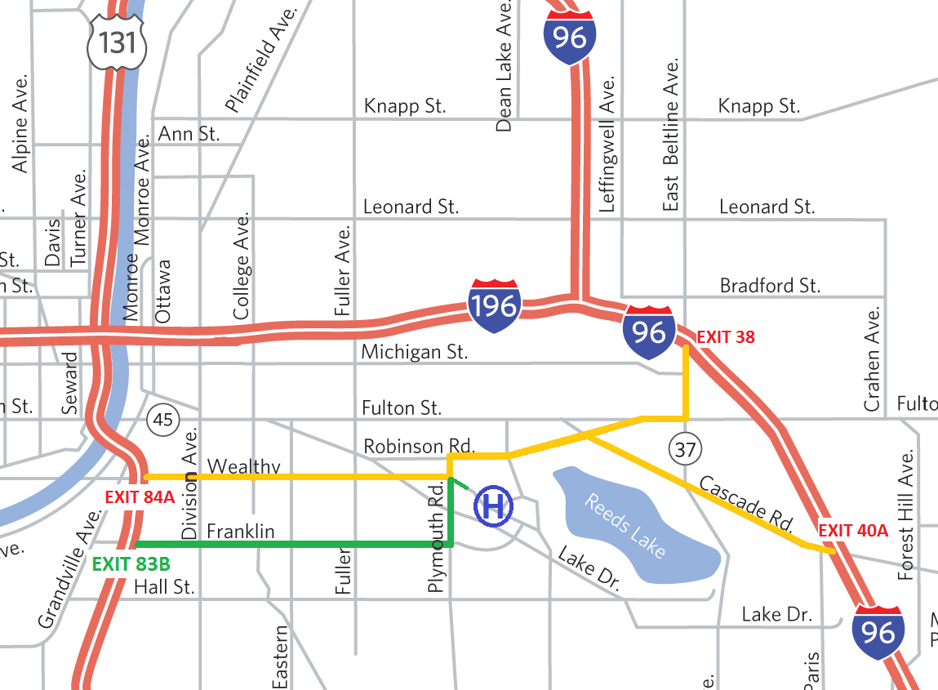
On this map we have highlighted various routes to better assist you on your journey to the Spine and Pain Management Center.
Please note: While Wealthy Street is a more direct route, it involves multiple round-a-bouts and a cobblestone section, which can make for an uncomfortable ride. We recommend taking exit 83B, GREEN route for a smoother trip that is easier on the spine and a more comfortable ride.

Affix Label Here

New Patient Intake Form

We know that completing forms may be difficult and time consuming, but we ask that you please complete them as fully and honestly as possible. Your accurate responses will give us a better understanding of you and your health, so we can provide you with the best health care possible. Thank you for helping us with this.

Name: _________________________________ Date of Appointment: ______________________________
Reason for visit:

Back pain Leg pain Neck pain Arm Pain Widespread pain Other (specify) ____________________
What do you hope to get from your visit today?

1.
2.

When did your CURRENT problem begin? ____________________________________________________

What event(s) caused your current spine problem? (Check all that apply)

No known cause Motor vehicle accident Recreation/ sport
On the job injury Repetitive injury Fall
Other

If any of the above apply, did you have pain in the same area before the event/injury occurred? Yes No

On the diagram below, mark the area of your body where you feel your TYPICAL pain. Include all affected areas.

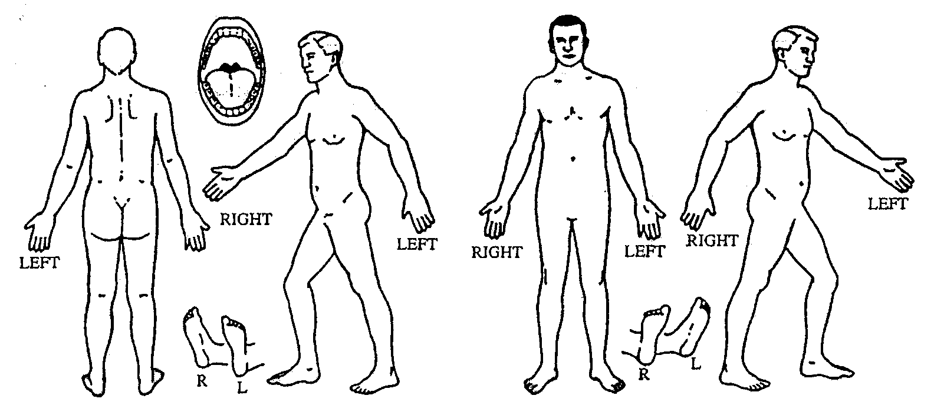

Describe how your pain FEELS. (Circle all that apply.)

sharp dull aching burning throbbing shooting stabbing lightning tight pressing gnawing cramping heavy pinching sore terrifying

If 10 is the worst pain imaginable, and 0 is no pain, please rate your pain over the last SEVEN DAYS:
0 1 2 3 4 5 6 7 8 9 10

Average________________ at its worst_____________ at its best_________________

How much did the pain/condition interfere with your daily activities this past week?
0 1 3 4 5 6 7 8 9 10
None Mild Moderate Severe Completely

Where do you feel the worse pain? Back Neck Leg Arm
Pain is equal in back/leg Pain is equal in neck/arm

What does each of the following activities do to your pain?
 | No Change | Relieves Pain | Increases Pain
Sitting
Standing
Walking
Lying down
Bending forward
Bending backward
Lifting
Turning head to side
Bending neck back
Bending neck forward
Coughing / sneezing

Are there other things you do to relieve your pain? _________________________________________________

Since the pain/condition began has it: Improved Remained the same Worsened

Do you have any of the following symptoms?
arm or leg weakness difficulty sleeping : If yes, describe_______________________________
arm or leg numbness or tingling weight gain weight loss fever or chills
bowel or bladder problems: If yes, describe ________________________________________________

Put an “X” next to each treatment you have had for THIS condition. For each treatment, circle the effect you received on your pain.

Treatment | Effect of Treatment
 | Helped  Symptoms | No change | Increased Symptoms
______ Physical therapy | 1 | 0 | -1
______ Massage | 1 | 0 | -1
______ Chiropractic or Osteopathic treatment | 1 | 0 | -1
______ Spine injections | 1 | 0 | -1
______Counseling or Psychiatry | 1 | 0 | -1
______ Medications | 1 | 0 | -1
______ Other (list) | 1 | 0 | -1

When did you last have physical therapy for this condition? _______________ How many sessions?_________

Do you exercise? Yes No If yes, how often? _______________________
If yes, what do you do for exercise? ___________________________________________________

If you have had surgery on your BACK and/or NECK, please fill in the following for each operation:
Date  (or Year) | Type of Surgery and Surgeon | Pain After Surgery |  |  | (M.D. USE ONLY)
 |  | Worse | Same | Better

Please circle response:
Worker's compensation case: Yes/No.
Automobile accident: Yes/No.
Legal case pending: Yes/No.

Thinking about the last 2 weeks check your response to the following questions:
 |  | Disagree | Agree
 |  | 0 | 1
1 | It’s really not safe for a person with a condition like mine to be physically active | □ | □
2 | Worrying thoughts have been going through my mind a lot of the time in the last 2 weeks | □ | □
3 | I feel that my problem is terrible and that it’s never going to get any better | □ | □
4 | In general, in the last 2 weeks, I have not enjoyed all the things I used to enjoy | □ | □

5. Overall, how bothersome has your condition been in the last 2 weeks?

Not at all | Slightly | Moderately | Very much | Extremely
□ | □ | □ | □ | □
0 | 0 | 0 | 1 | 1

OCCUPATIONAL HISTORY

Are you currently: employed without restrictions employed with restrictions unemployed
retired on disability student worker’s compensation homemaker

Briefly describe your job (if applicable): ________
- How satisfied are you with your job?
Very satisfied Satisfied Dissatisfied
Worst job I’ve ever had N/A

- Are you on or planning to apply for permanent disability such as Social Security Disability (SSDI) or other disability? (e.g., worker’s compensation)
Yes No Not sure

- Is a lawyer helping you with a claim or lawsuit related to your current pain or other symptoms?
Yes No If yes, explain briefly

SOCIAL/ENVIRONMENTAL HISTORY
Education: What is your highest level of education or training?

Marital Status: Single Married/Partner Divorced/Separated Widowed
Living Situation: Live alone With family With friends Homeless Other
What are the ages of your children? No children
Habits:
1. Do you smoke? Yes No If no, did you ever smoke regularly in the past? Yes No
If yes, how many packs/day? For how many years?
If you quit smoking how long ago was that? __________

2. How often do you have a drink containing alcohol?
never monthly or less 2-4 times a month 2-3 times a week 4 or more times a week
If you drink, how many drinks containing alcohol do you have on a typical day when you are drinking?
1 or 2 3 or 4 5 or 6 7 to 9 10 or more
3. Do you now, or have you ever used, recreational drugs? Yes No
If yes, which drugs have you used? _____________________________
How often did you use them? _________________________________
4. Have you ever considered yourself a victim of physical, emotional or sexual abuse? Yes No
If yes, please explain__________________________________________________________________
REVIEW OF SYSTEMS:
Please circle any of the following symptoms if you have noticed them in the last four weeks:
dry mouth chills difficulty urinating shortness of breath anxiety
weight changes fever constipation heart racing low mood
sweating tiredness bloody stools difficulty sleeping
blurred vision skin rash bleeding problems
frequent falls black tarry stools difficulty staying awake
problems with balance sexual difficulties difficulty concentrating

MEDICATIONS: Please list all the medications or supplements you take (include prescribed, over-the–counter, and holistic) and the doses. Use a separate list, if needed.
_______________________________________ _____________________________________________
_______________________________________ _____________________________________________
_______________________________________ _____________________________________________
_______________________________________ _____________________________________________
_______________________________________ _____________________________________________

Please circle any of the medications below that you have tried IN THE PAST. If possible write the dose next to the circled medication.

amitriptyline (Elavil) _______
baclofen (Gablofen, Kemstro, Lioresal) _______
botulinum toxin (Botox) _______
bupenorphine (Suboxone, Butrans) _______
carbamazepine (Tegretol ,Equetro) _______
carisoprodol (Soma) _______
celecoxib (Celebrex) _______
cilatropram (Celexa) _______
codeine/acetaminophen (Tylenol 3 or 4, Co-Codamol, Codrix) _______
cyclobenzaprine (Flexeril) _______
desipramine (Norpramin)_______
desvenlafaxine (Pristiq) _______
diclofenac (Arthrotec , Zipsor) _______
diclofenac gel (Voltaren gel) ______
doxepin (Silenor, Zonalon, Prudoxin) _______
duloxetine (Cymbalta) _______
eletriptan (Relpax) _______
escitalopram (Lexapro) _______
etodolac (Lodine) _______
fenoprofen (Nalfon) _______
fentanyl patch ( Butrans, Lidoderm, Flector) _______
fiorinal (Fioricet) _______
fluoxetine (Prozac, Sarafem) _______
fluvoxamine (Luvox) _______
gabapentin (Neurontin, Gralise, Horizant, Fanatrex) _______
hydrocodone (Lortab,Vicodin ,Vicoprofen, Norco) _______
hydromorphone (Dilaudid, Exalgo, Palladone) _______
ketorolac (Toradol) _______
levetiracetam (Keppra) _______
lidocaine cream (Pennsaid, Ketamine) _______
meloxicam (Mobic) _______
metaxalone (Skelaxin) _______
methadone (Methadose, Diskets) _______
methocarbamol (Robaxin) _______
morphine (Kadian, Avinza, MS Contin) _______
naproxen (Aleve,Vimovo) _______
nortriptyline (Pamelor) _______
oxycodone (Oxycontin, Roxicodone, Oxecta) _______
oxycodone/acetaminophen (Endocet, Percocet, Percodan, Tylox) _______
oxymorphone (Opana, Numorphan) _______
paroxetine (Paxil) _______
pentazocine (Talwin) _______
pregabalin (Lyrica) _______
propranolol (Inderal) _______
rizatriptan (Maxalt) _______
sertraline (Zoloft) _______
sumatriptan (Imitrex) _______
tapentadol (Nucynta) _______
tizanidine (Zanaflex) _______
topiramate (Topamax) _______
tramadol (Ultram, Ultracet, ConZip, Ryzolt) _______
trazodone (Desyrel, Oleptro) _______
valproic acid (Depakote/Depakene/Depacon) _______
venlafaxine (Effexor) _______
viibryd (Vilazodone) _______
vimpat (Lacosamide) _______
zolmitriptan (Zomig)______
ibuprofen (Advil, Motrin) _______
imipramine (Tofranil) _______

indomethacin (Indocin) _______
ketoprofen (Orudis) _______

Please Don’t Forget…
If you had X-Rays, MRI or CT scan done at a facility other than:
- Spectrum Health Blodgett
- Spectrum Health Butterworth
- Spectrum Health Medical Group in Grand Rapids
- Spectrum Health Urgent Care
PLEASE obtain a CD with these images and bring it to your appointment. If you DO NOT bring your CD, your appointment WILL BE rescheduled.

If you have been instructed to have X-Ray imaging done prior to your appointment please arrive 1 ½ hours prior to your scheduled time.

Thank you!

Please call if you have any questions about this: 616.774.8345

