Clinical Diagnostic Sequencing Service Sample Submission Guidelines

Online Sample Submission Portal
Please use our Online Sample Submission Portal on our website at https://gmg-submit.gimr.garvan.org.au/#/login
We have created written instructions and a short video to explain how to easily use the submission portal: https://www.garvan.org.au/research/capabilities/molecular-genetics/documents/qs_15_v1.pdf
https://www.youtube.com/watch?v=8eL-JJ8SIGU&feature=youtu.be
Further information to our services can be found here: www.garvan.org.au/gmg

New clients need to create an account (please follow instructions after clicking on the “Create Account” button on the landing page), existing clients log into their account by selecting the button “Login for clinical samples”:

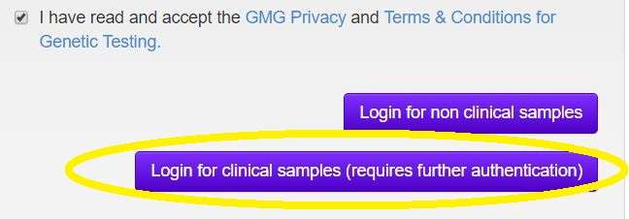

There will be a popup window asking for a two step authentication code which requires the google authenticator app installed on your phone. After entering the authentication code the login is complete and you can create a new Manifest by selecting “New Sequencing Manifest” from these options:



Then in the popup window choose option called “Clinical Diagnostic Sequencing” and enter the amount of samples that will be submitted:

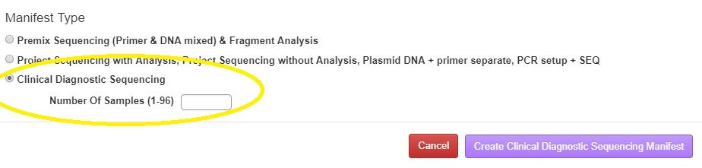
After clicking on the “Create Clinical Diagnostic Sequencing Manifest”-button the new Manifest will open:
In the new Manifest you can automatically fill the sample locations by clicking on the blue arrow down button. Alternatively you can give other locations for your samples manually in the format A:1 etc.

All our forms can be accessed at:
https://www.garvan.org.au/research/capabilities/molecular-genetics/diagnostic-clinical-genetic-services

Garvan Molecular Genetics Privacy Policy
As part of Australian legislation including the Australian Privacy Principles set out in the Privacy Act 1988 and in accordance with Garvan Institute’s general privacy regulations Garvan Molecular Genetics is committed to ensure and enforce the maintenance of patient’s privacy at all times. Our privacy policy details how we maintain the privacy of patient related data.

Garvan Molecular Genetics Terms and Conditions
Our Terms and Conditions apply to all clinical diagnostic services provided by Garvan Molecular Genetics (GMG), a service of the Garvan Institute of Medical Research, on request from Specialists. The obligation of GMG to perform the Services is conditional on acceptance of a Request which is supported by the following documents:
-a completed online Clinical Diagnostic Sequencing Sample Submission
-a completed GMG Patient Consent Form (A Privacy Collection Statement and Consent must be signed by the patient and submitted with the sample)
On acceptance of the Request, GMG will perform the Services in accordance with the Terms and Conditions detailed in the document GMG Terms and Conditions for Clinical Genetic Testing.

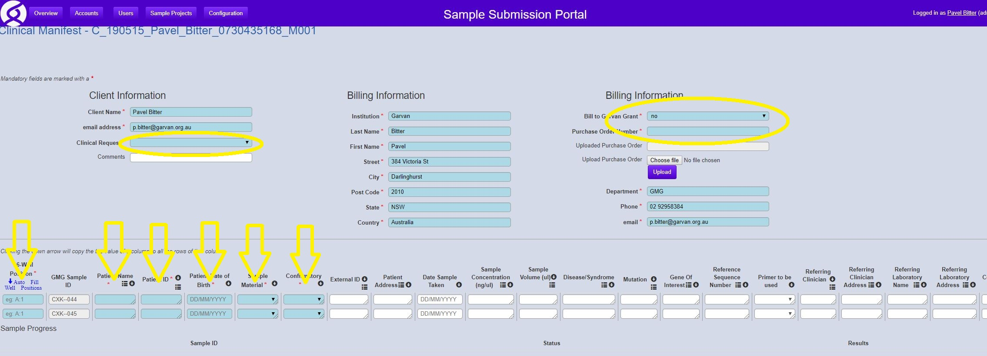
Technical Report
We provide only a technical report. If you require a pathology report with a clinical interpretation of the results our technical report needs to be interpreted by a genetic pathologist who can write a clinical genetic report. Please enquire about additional cost that the genetic pathologist will charge prior to sample submission.
Patient Information fields
Please fill in at least three patient identifying information fields, like date of birth, patient name and patient ID (fields with a red star a mandatory, marked yellow above).
Diagnostic Information field
Please fill in the chromosomal position (like chr5:g.34007971A>G) or the reference sequence with the mutation (like NM203382.2: c.154T>C). Any additional information is helpful like the protein change (for example p.Ser52Pro) or the reference genome (for example GRCh37 (hg19)). The more information you can provide us with the easier we can set up the required PCR reactions. Depending on the required diagnostic strategy we can follow a given procedure or design our own primers and perform predictive or confirmatory testing.
Sample Information field
You can submit DNA that has been extracted elsewhere or blood, cells, tumor tissue, oral swabs or equivalent. If you submit DNA, please make sure the DNA quality has been checked and is sufficient for PCR amplification. Degraded or low concentration DNA, DNA that has not been sufficiently cleaned from contaminating solutions or cell debris will fail our strict quality standards. Depending on the scope of the PCRs needed for the coverage of the gene(s) required to be analyzed we will need sufficient DNA volumes. As a rule of thumb calculate 50ng per PCR needed. 5ml of fresh blood is however most likely sufficient for the most extensive diagnostic analysis.
Billing Information field
Due to our Privacy Policy we cannot process payments by the patient. Invoices can be sent to you or to your institute or organization. You can provide a billing address or an email address for sending the invoice. Please sign the corresponding field indicating that you agree with our Terms and Conditions.

Sending of samples and downloading of results
Packing of samples
Samples need to be accompanied by a printed version of the Sample Submission Manifest
and the signed Patient Consent form. Both documents are ideally placed in a patted envelope
together with the sample(s). We have seen damaged tubes due to rough transport so extensive
protection is advisable. Please send DNA (that is not dried down) cooled at 4C or frozen on dry ice in appropriate containers. Pelleted, dry DNA can be sent without cooling. Blood, cells or tissue should not be frozen and need to be sent cooled at 4C on ice. Please avoid sending samples on a Friday as they might end up over the weekend in transport without sufficient cooling.
Sample quantity and quality
- DNA
At least 100ng of genomic DNA for each patient (either dried down or in a volume <20ul). The quality of your submitted DNA is crucial for the quality of the sequencing results and therefore clients are recommended to prepare genomic DNA with a spin column or magnetic bead kit to achieve best quality DNA (free of residual salts, contaminating lysis products or buffer components). The DNA should be sent cooled on ice on transport.
- Blood
At least 1ml of EDTA blood for each patient for whom samples are submitted. The blood should be sent cooled on ice on transport.
- Cells
At least 5x 10⁶ cells for each patient for whom samples are submitted. Cells are ideally spun down and the supernatant is removed. The pellet should be sent cooled on ice on transport.
- Tissue
At least 20mg of tissue for each patient for whom samples are submitted. The tissue sample should be sent cooled on ice on transport.
- ORAcollect Mouth Swabs
Once the ORAcollect swab has been prepared according to the instructions on the tube the tube can be sent at room temperature.

If other material is sent and you are unsure of quantities or transport please ask us.

Shipping Address:
Our shipping address is:
Garvan Institute
Loading Dock Dock times: 8am to 4pm Phone: 02 9295 8640
West Street (off Burton Street)
Darlinghurst, NSW, 2010

Pricing
Pricing information is available on our website at www.garvan.org.au/gmg > Molecular Genetics Shop.

Results:
Our online sample submission portal will send you an email with a link to download your results within a turnaround time that we will establish once the scope of the analysis has been determined. We will keep you updated about the progress of the project via the designated email address that you have provided.

Contact us:
Garvan Molecular Genetics email: gmg@garvan.org.au internet: www.garvan.org.au/gmg

Pavel Bitter (Molecular Genetics Facility Manager) email: p.bitter@garvan.org.au
phone: 02 92958384


Email: gmg@garvan.org.au
http://www.garvan.org.au/research/capabilities/molecular-genetics

