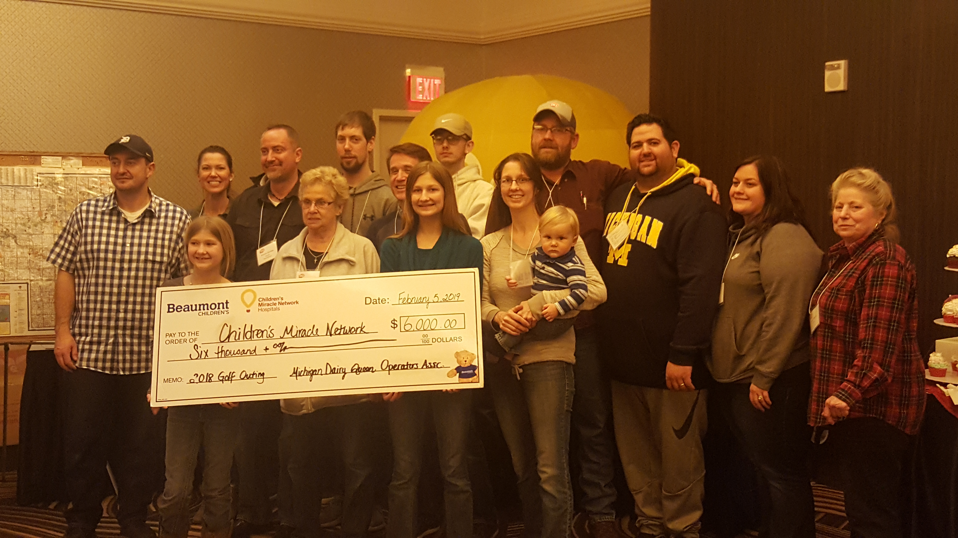  tuesday, august 6th, 2024  michigan dairy queen operators association  Annual Charity Golf Outing benefiting: CHILDREN’S MIRACLE NETWORK HOSPITALS.  Pine Knob Golf Club  5580 Waldon Rd.  Clarkston, MI 48348  248-625-4430  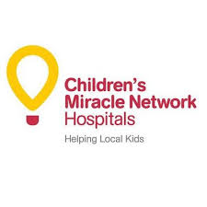  Please come and join your Michigan DQ Operators and Suppliers for a day of Golf and Fun at the beautiful Pine Knob Golf Club. Your participation will also help raise money for CMN Hospitals.  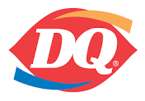 | 8:00 AM Registration, Free Range Balls, Coffee, Bagels, & Donuts.  10 AM Shotgun Start  SKINS GAME & HOLE-n-ONE PRIZES ON ALL PAR 3’S INCLUDING A $10,000 HOLE-n-ONE PAR 3 !  ────  Lunch Served On The Turn, Drink Tickets.  ────  Buffet Dinner After Golf, Prizes & Raffles  ────  Prizes for :  1st, 2nd, & ? Place, Longest Drive & Closest To The Pin (Men and Women).  questions / info Contact:  Ryan Ignasiak  248-760-8996  baldwindq@gmail.com  248-760-8996  baldwindq@gmail.com

Please fill out this form below and mail it along with payment to:

Dairy Queen
1525 Baldwin Rd.
Pontiac, MI 48340
Attn: Ryan Ignasiak, MDQOA Golf Outing.
Or Email to: baldwindq@gmail.com

WE KINDLY ASK THAT YOU TRY TO RESPOND BY June 1st, 2024, THANKS!
------------------------------------------------------------------------------------------------------------------------
Price Per Golfer--------------------------------------: $145.00 X _____ = $____________

Dinner Only : $60.00 X _____ = $____________

Supplier/Corporate Hole Sponsorship $300.00 per hole X _____ = $__________

COMPANY NAME / INFO ON SIGNAGE ________________________________
________________________________
Supplier/Corporate Lunch Sponsorship $500.00 = $____________________
(Banner displayed with Company name and acknowledgements throughout event)

Supplier/Corporate Dinner Sponsorship $750.00 = $____________________
(Banner displayed with Company name and acknowledgements throughout event)

Michigan DQ Operator Hole Sponsorship $150.00 per hole X ____ = $__________
(Discounted price)

OPERATOR NAME / INFO ON SIGNAGE_________________________________
_________________________________
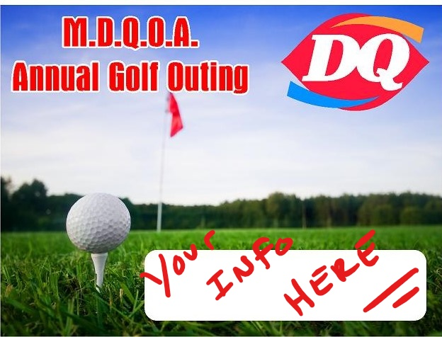 MAKE CHECKS PAYABLE TO: M.D.Q.O.A.

TOTAL AMOUNT = $___________

Golfer 1 __________________________Golfer 2__________________________

Golfer 3 __________________________Golfer 4__________________________

Contact Phone # _____________________________

Please pair me/us with (if available) ______________________________________

____ I WILL NOT GOLF, BUT WOULD BE A VOLUNTEER/WITNESS AT A PAR 3 HOLE.

____ I CAN NOT ATTEND BUT PLEASE ACCEPT MY AUCTON ITEM(S) AND/OR HOLE SPONSORSHIP. Auction items can be sent to Ryan Ignasiak, see address above.

