

Document subtitle
This is the document title
This is a document subtitle
Introductory paragraph or abstract goes here. Lorem ipsum odor amet, consectetuer adipiscing elit. Lacinia fusce pulvinar pulvinar nostra conubia magnis. Tincidunt id ornare lectus lacinia aenean velit. Taciti tempor lacus nostra convallis hac pulvinar vestibulum volutpat hac.

Table of Contents (this is not a smart table of contents and will require manual editing)
1 Introduction 2
2 Document control 2
3 Distribution structure 2
3.1 Report Structure 2
3.2 Meeting Structure 2
4 Documents and Processes 2
5 Escalation 2
6 Updating of Communication Management Plan 3
6.1 Responsibilities 3

This is a section title style
This is a subtitle style
This is body copy style with some placeholder text. … Lorem ipsum odor amet, consectetuer adipiscing elit. Lacinia fusce pulvinar pulvinar nostra conubia magnis. Tincidunt id ornare lectus lacinia aenean velit. Taciti tempor lacus nostra convallis hac pulvinar vestibulum volutpat hac. Nullam justo nisl phasellus eros eros. Mauris integer finibus blandit nostra malesuada arcu mauris fringilla.
Aenean nisl massa etiam ex senectus sociosqu imperdiet bibendum. Interdum eget ut euismod aptent felis purus dapibus posuere. Consectetur blandit habitant ligula tortor maximus duis dolor orci. Conubia quisque aliquam habitasse metus sociosqu diam senectus. Vivamus mi phasellus habitasse ac gravida mattis rhoncus. Litora congue ad ornare turpis eros risus posuere a.
This is a textbox to highlight something important! And some placeholder text. Lorem ipsum odor amet, consectetuer adipiscing elit.
Tempus turpis tempor condimentum felis donec. Purus penatibus in suscipit parturient tincidunt porta a. Eleifend tempor fusce rutrum facilisis, scelerisque nostra integer. Nullam ligula potenti ligula justo, leo habitant platea? Arcu pulvinar nostra litora eu, parturient pellentesque viverra ullamcorper.
This is a subtitle style
This is body copy style with some placeholder text. … Lorem ipsum odor amet.
This is another section for a quote or important statement paired with an image. Yet, this one is different because the copy is on the left side.  Name of quoted person, and their business title | 
Aenean nisl massa etiam ex senectus sociosqu imperdiet bibendum. Interdum eget ut euismod aptent felis purus dapibus posuere. Consectetur blandit habitant ligula tortor maximus duis dolor orci. Conubia quisque aliquam habitasse metus sociosqu diam senectus. Vivamus mi phasellus habitasse ac gravida mattis rhoncus. Litora congue ad ornare turpis eros risus posuere a. In duis potenti sit feugiat bibendum pellentesque vivamus litora. Proin lectus leo himenaeos imperdiet etiam urna nec integer.
This is a subtitle style
This is body copy style with some placeholder text. … Lorem ipsum odor amet, consectetuer adipiscing elit. Lacinia fusce pulvinar pulvinar nostra conubia magnis. Tincidunt id ornare lectus lacinia aenean velit. Taciti tempor lacus nostra convallis hac pulvinar vestibulum volutpat hac. Nullam justo nisl phasellus eros eros. Mauris integer finibus blandit nostra malesuada arcu mauris fringilla.
Support Tier | This is a simple table design
Tier 1  MSP | All support incidents begin with Tier 1 Support Engineers. Tier 1 is where the initial support ticket is created, and the issue is identified and clearly documented. Basic hardware/software troubleshooting is initiated.  Recommended skills and Certifications for Tier 1 Support Engineers; Engineers have completed and passed Cradlepoint Certified Network Associate training and possess Certifications for Basic Networking.
Tier 2  MSP | All support incidents that cannot be resolved with Tier 1 Support Engineers are escalated to Tier 2 Support Engineers. Tier 2 Support Engineers are senior level staff with advanced networking and hardware expertise.  Recommended skills and Certifications for Tier 2 Support Engineers; Engineers have completed and passed Cradlepoint Certified Network Professional and Certified Network Expert (including the Practical) in addition to possessing Advanced Certifications for Networking. Tier 2 Support Engineers are assigned for higher level troubleshooting of networking and hardware/software issues.
Tier 3  Ericsson Enterprise Wireless | All support incidents that cannot be resolved with Tier 2 support may be escalated to Cradlepoint’s Tier 3 Support Engineers. Tier 3 should be for escalations, such as product or code defects, bugs or regressions, RMA requests, subscription management, and for issues that are outside of the MSPs ability to address.  Tier 3 Support Engineers collaborate with MSPs Tier 2 Support Engineers and Cradlepoint Product Engineering teams to resolve the issue. Cradlepoint’s management staff monitors the progress until resolution.
Lorem ipsum odor amet, consectetuer adipiscing elit. Lacinia fusce pulvinar pulvinar nostra conubia magnis. Tincidunt id ornare lectus lacinia aenean velit. Taciti tempor lacus nostra convallis hac pulvinar vestibulum volutpat hac. Nullam justo nisl phasellus eros eros. Mauris integer finibus blandit nostra malesuada arcu mauris fringilla.
Aenean nisl massa etiam ex senectus sociosqu imperdiet bibendum. Interdum eget ut euismod aptent felis purus dapibus posuere. Consectetur blandit habitant ligula tortor maximus duis dolor orci. Conubia quisque aliquam habitasse metus sociosqu diam senectus. Vivamus mi phasellus habitasse ac gravida mattis rhoncus. Litora congue ad ornare turpis eros risus posuere a. In duis potenti sit feugiat bibendum pellentesque vivamus litora. Proin lectus leo himenaeos imperdiet etiam urna nec integer.
This is a callout box for something that is important to highlight but needs a more subtle approach than a big blue box with larger text… Lorem ipsum odor amet, consectetuer adipiscing elit. Lacinia fusce pulvinar pulvinar nostra conubia magnis. Tincidunt id ornare lectus lacinia aenean velit. Taciti tempor lacus nostra convallis hac pulvinar vestibulum volutpat hac. Nullam justo nisl phasellus eros eros. Mauris integer finibus blandit nostra malesuada arcu mauris fringilla.

This is a subtitle style
Lorem ipsum odor amet, consectetuer adipiscing elit. Lacinia fusce pulvinar pulvinar nostra conubia magnis. Tincidunt id ornare lectus lacinia aenean velit. Taciti tempor lacus nostra convallis hac pulvinar vestibulum volutpat hac.
This is a complex table design, Reseller Partner Requirements |  |  |   Registered | Signature | Premier | Elite
Business requirements | Annual volume  (USD MSRP) | USA | N/A | $100,000 | $500,000 | $2,000,000
Business requirements | Annual volume  (USD MSRP) | Rest of world | N/A | $50,000 | $250,000 | $500,000
Business requirements | Signed partner agreement and program guide |  | Or otherwise authorized to sell | 
Business requirements | Due diligence
Business requirements | Business planning and review |  |  | Recommended
Business requirements | Ongoing sales/support training
Business requirements | Partner success story submission |  |  | Recommended | Quarterly | Quarterly
Business requirements | Provide technical support |  |  | Tier 1 | Tier 1 | Tier 1
Skills requirements | Enterprise Wireless Certified Sales Associate |  | Recommended | 2 | 2 | 4
Skills requirements | Mountaineer Discoverer Certification |  |  | 1 | 2 | 3
Skills requirements | Certified Network Expert - Theory |  |  |  | Recommended
Skills requirements | Certified Network Expert - Practical |  |  |  |  | Recommended
Lorem ipsum odor amet, consectetuer adipiscing elit. Lacinia fusce pulvinar pulvinar nostra conubia magnis. Tincidunt id ornare lectus lacinia aenean velit. Taciti tempor lacus nostra convallis hac pulvinar vestibulum volutpat hac. Nullam justo nisl phasellus eros eros. Mauris integer finibus blandit nostra malesuada arcu mauris fringilla.
Lorem ipsum odor amet, consectetuer adipiscing elit. Lacinia fusce pulvinar pulvinar nostra conubia magnis. Tincidunt id ornare lectus lacinia aenean velit. Taciti tempor lacus nostra convallis hac pulvinar vestibulum volutpat hac. Nullam justo nisl phasellus eros eros. Mauris integer finibus blandit nostra malesuada arcu mauris fringilla.
This is a bulleted list:
- This is the first line item
- This is the second line item
- This is the third line item
This is a textbox to highlight something important! And some placeholder text. Lorem ipsum odor amet, consectetuer adipiscing elit.
This is a numbered list:
- This is the first line item
- This is the second line item
- This is the third line item
Aenean nisl massa etiam ex senectus sociosqu imperdiet bibendum. Interdum eget ut euismod aptent felis purus dapibus posuere. Consectetur blandit habitant ligula tortor maximus duis dolor orci. Conubia quisque aliquam habitasse metus sociosqu diam senectus. Vivamus mi phasellus habitasse ac gravida mattis rhoncus. Litora congue ad ornare turpis eros risus posuere a.

Here are some other useful elements
Chart styles:
Column heading | Rank | X Value | Y Value | % | Example
Lorem ipsum | 1 | 23 | 13 | 14% | Lorem ipsum dolor sit
Dolor sit | 2 | 43 | 23 | 23% | Nulla tristique turpis sed urna
Nullam nec | 3 | 53 | 54 | 56% | Orci vari natoque penatibus
Fusce enim | 4 | 23 | 34 | 74% | Donec justo risus
*Footnote for data sourcing or additional table context (this is a chart row, delete entire row in not needed)

Column heading | Rank | X Value | Y Value | % | Example
Lorem ipsum | 1 | 23 | 13 | 14% | Lorem ipsum dolor sit
Dolor sit | 2 | 43 | 23 | 23% | Nulla tristique turpis sed urna
Nullam nec | 3 | 53 | 54 | 56% | Orci vari natoque penatibus
Fusce enim | 4 | 23 | 34 | 74% | Donec justo risus
Lorem ipsum | 5 | 23 | 13 | 76% | Lorem ipsum dolor sit
Dolor sit | 6 | 43 | 23 | 83% | Nulla tristique turpis sed urna
*Footnote for data sourcing or additional table context (this is a chart row, delete entire row in not needed)

Column heading | Rank | X Value | Y Value | % | Example
Lorem ipsum | 1 | 23 | 13 | 14% | Lorem ipsum dolor sit
Dolor sit | 2 | 43 | 23 | 23% | Nulla tristique turpis sed urna
Nullam nec | 3 | 53 | 54 | 56% | Orci vari natoque penatibus
*Footnote for data sourcing or additional table context (this is a chart row, delete entire row in not needed)

This is an in-table title
Column heading | Rank | X Value | Y Value | % | Example
Lorem ipsum | 1 | 23 | 13 | 14% | Lorem ipsum dolor sit
Dolor sit | 2 | 43 | 23 | 23% | Nulla tristique turpis sed urna
*Footnote for data sourcing or additional table context (this is a chart row, delete entire row in not needed)
Images:
Image with footnote:

This is a footnote for the image

Image with right-side copy block:
This is a block for an image and related copy. A featured quote or testimonial that supports the content of the document is a great addition.

Name of quoted person, and their business title

Image with left-side copy block:
This is another section for a quote or important statement paired with an image. Yet, this one is different because the copy is on the left side.

Name of quoted person, and their business title

Charts:
(Ericsson color themes will auto-populate when you create a new chart)

Important brand rules to know
These rules differ from our former Cradlepoint, Part of Ericsson brand. They are general rules for all externally facing Ericsson documentation.
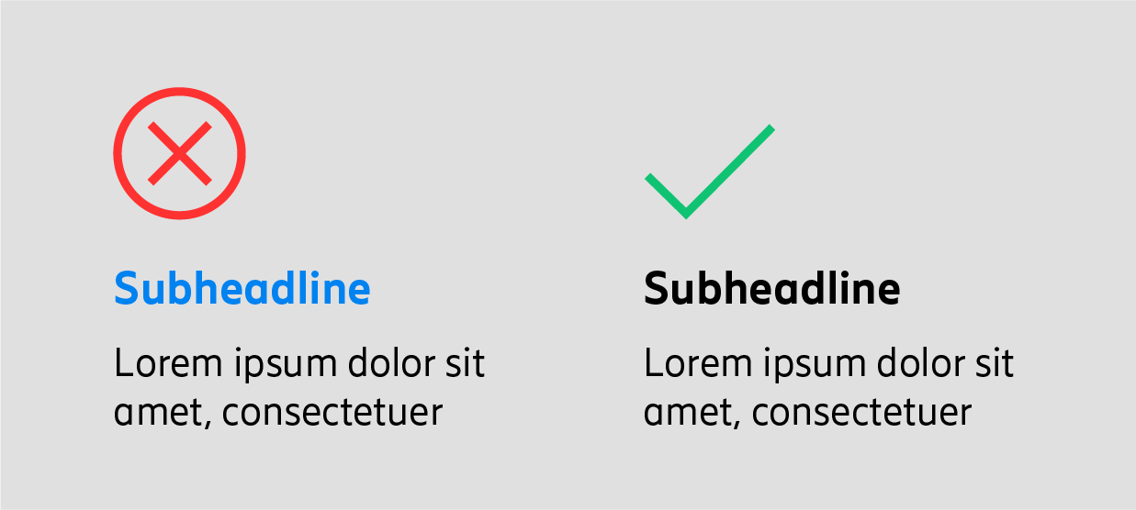 | 
No colored text  Reason: This is a best practice for legibility. It optimizes the experience and accessibility for persons with vision differences or those using document reading aids. This is a brand-wide rule.  Exception: Links in digital documents can be color, the best color for links is Ericsson blue. | No capital case  Reason: Ericsson brand does not use all caps for any copy. Sentence case is more accessible and supports the Ericsson voice and tone.  Exception: In all cases where all capitals is grammatically correct, such as acronyms. i.e. Wireless WAN, SD-WAN, API, etc.

Helpful tips
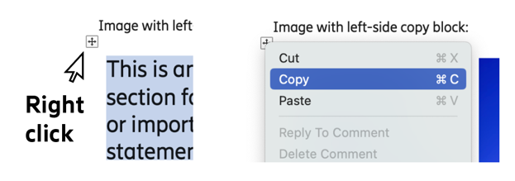
For ease of re-using, the block elements like images and data tables are built as word tables. To quickly move the element where you need it…
- Select the element block you want to reuse
- Right-click the box with arrows in top-left corner
- Choose copy
- Then move place cursor to where you want the element. Right-click again to paste the item.
- Edit content inside element as needed.

