Contact: Oakridgepark@quinn.pr

Oakridge Park to Open on Thursday, May 28, Redefining Retail in Vancouver

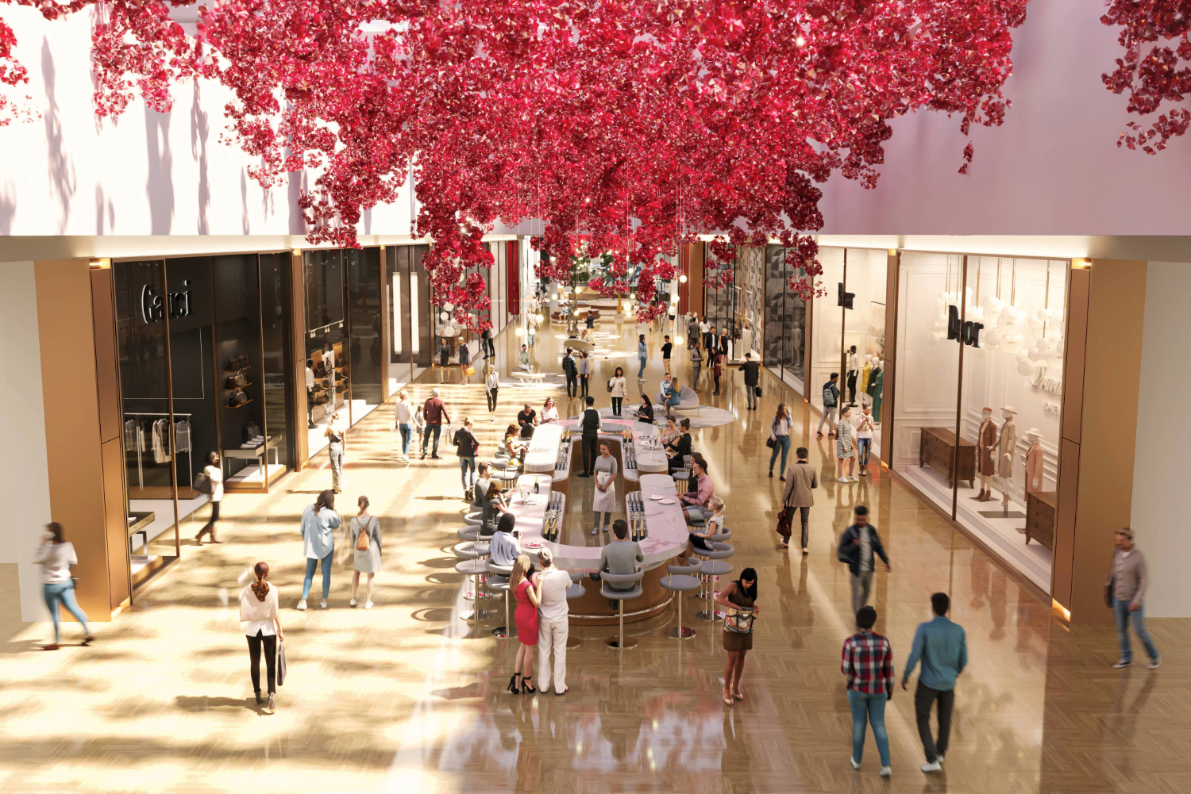
Rendering Courtesy of Oakridge Park

Vancouver, BC (MAY 12, 2026): Oakridge Park, Canada’s largest redevelopment from QuadReal Property Group and Westbank, is officially opening on Thursday, May 28th at 11am. Upon opening, the development will redefine retail and dining in Vancouver.

Spanning 650,000 square feet and featuring more than 100 premier brands, the highly anticipated destination brings together a dynamic mix of luxury labels, contemporary fashion, beauty and lifestyle concepts, reinforcing Vancouver’s position as a growing global hub for luxury retail.

Among the newest brands announced at the retail hub are luxury fashion houses, Chanel and Ferragamo, joining a curated roster of retailers including:

- Luxury Fashion & Leather Goods: Acne Studios, Alexander Wang, Brunello Cucinelli, Canada Goose, Christian Louboutin, Coach, Dolce&Gabbana, Harry Rosen, Loewe, Longchamp, Loro Piana, Louis Vuitton, Maison Margiela, Max Mara, Miu Miu, Moncler, Prada, Thom Browne, Versace and Valentino.
- Jewelry & Watches: Bvlgari, Chaumet, Chow Tai Fook, David Yurman, Leah Alexandra, Rolex, Swarovski, TAG Heuer, Tiffany & Co. and TUDOR.
- Contemporary, Services and Beauty & Wellness: Aritzia, Browns Shoes, BOSS, lululemon, Lush Brow Bar, Maje, Mophead, Petit Pont, Sandro, Sephora, Sisley Paris, Sporting Life, Veronica Beard and Weekend Max Mara.

“The official opening of Oakridge Park marks a significant milestone in bringing our long-term vision for this destination to life,” said Chrystal Burns, Executive Vice President, Canadian Retail Experience at QuadReal Property Group. “We set out to create more than a retail centre; we wanted to build a place where world-class shopping, dining, culture and community come together. With an exceptional collection of global brands and the debut of Time Out Market Vancouver, Oakridge Park delivers an unparalleled destination for residents, visitors and the community. The development reflects the energy of the city, complementing Vancouver’s vibrant culture while shaping the future of retail and lifestyle experiences in the region.”

Oakridge Park will also debut Delysees Champagne Bar, a luxury champagne bar concept offering a refined, indulgent experience where every pour feels exclusive, elegant and effortlessly glamorous. This offering is a rare feature within a shopping centre, introducing a new social ritual to Vancouver retail by inviting guests to pause, toast and savour moments of effortless sophistication.

At the heart of the culinary program, Time Out Market Vancouver will open its doors, uniting the city's top chefs, restaurateurs and cultural talents. The market features a curated mix of local concepts including Feenie’s, Mee Bar, Lunch Lady, MaKaam, DownLow Chicken, Barnacle by Bar Bravo, Peacock, Via Tevere, Kishimoto, SANTO TACO, Heritage Asian Eatery, Mello, and Boba Run, with more to be announced soon.

Further strengthening its connection to the community, Oakridge Park will also host a year-round calendar of community programming and events, including activations centered around food, wellness, jewelry, fashion and the holidays. Upcoming programming and promotions will include:
- A series of live music running on weekends from Thursday to Sunday at the North Atrium for the entire month of June
- Experiential floral installations by Fleurs de Villes to spark joy throughout the shopping centre from May 28 – June 7
- Complimentary floral bouquets when you purchase an Oakridge Park gift card greater than $200 during the opening weekend and Fridays – Sundays from May 28 to June 7
- Complimentary portrait illustrations with purchases greater than $200 on Fridays - Sundays from June 8-21
- Complimentary pilates classes with Sporting Life x Vuori on June 26 and 27
- Complimentary barre classes for adults and seniors, as well as children’s ballet classes with Goh Ballet
Oakridge Park will open to the public at 11:00 am on Thursday, May 28th following a ribbon cutting ceremony.

About Oakridge Park
Co-developed by QuadReal Property Group and Westbank, Oakridge Park serves as a bespoke and captivating cultural destination for Vancouver and is designed to seamlessly encompass every aspect of people’s lives — where living, working, and playing converge harmoniously, offering a space for inspiration, personal growth, and relaxation. Spanning over five million square feet and strategically designed around a sprawling nine-acre park, Oakridge Park creates a distinctive enclave within the expansive 28-acre footprint. A monumental redevelopment project, that stands out as one of Metro Vancouver's largest undertakings and ranking among the most significant ongoing transformations in North America, is poised to become an unparalleled addition to the city unlike anything Vancouver has ever seen.

Comprising residential, retail, office, public realm, civic, and cultural components, Oakridge Park is a world-class, master-planned community. Once fully completed, it will offer a top-tier retail experience totaling 650,000 square feet with 140+ leading global brands, including flagship and boutiques stores, accommodations for over 6,000 residents through 3,000+ residences, 720,000 square feet of meticulously designed office space for over 3,000 creative economy professionals, one of Vancouver’s largest community centres and busiest libraries, six dynamic indoor and outdoor live-music venues, and will be home to the second Time Out Market in Canada. www.oakridgepark.com

Media Resources - Vancouver's Cultural Hub (oakridgepark.com)

About QuadReal Property Group
QuadReal Property Group is a global real estate investment, development and operating company headquartered in Vancouver, British Columbia. Its assets under management are $98.5 billion. From its foundation in Canada as a full-service real estate operating company, QuadReal has expanded its capabilities globally for investments in equity and debt in both the public and private markets. QuadReal invests directly through operating platforms in which it holds an ownership interest and via programmatic partnerships.

QuadReal seeks to deliver strong investment returns while creating sustainable environments that bring value to the people and communities it serves. Now and for generations to come.

QuadReal: Excellence lives here.

www.quadreal.com

About Westbank
Westbank is a practice dedicated to the creation of inspiring environments. Established 30 years ago, we are a private company that concentrates primarily on large projects in our core cities of focus: Vancouver, Toronto, Seattle, Tokyo, and San Jose. As a global leader in net zero development and the co-owner of one of North America's largest district energy providers, we are committed to largescale net zero carbon initiatives. Our body of work includes residential, hotels, retail, creative workspace, district energy, affordable housing, exhibitions, and public art, with over $50 billion of projects completed or under development. As our practice has evolved, we have woven together an ecosystem of cultural enterprises, including restaurants, gyms, spas, music venues, private members clubs, fashion, dance schools and food halls. We bring this ecosystem to life through collaborations with some of the most talented artists, architects, designers, and entrepreneurs in the world. We look for every opportunity to strengthen the bonds that unite us – to bring people together and help build more inspiring, sustainable communities. Through these and other endeavours, our evolution continues as we become a cultural platform for the creative city.

https://westbankcorp.com/

