Contact: Oakridgepark@quinn.pr
Oakridge Park in Vancouver, Canada Introduces the Newest Brands to Open at its Premier Shopping Centre

Loewe, Dolce & Gabbana, Valentino, Thom Browne, and Loro Piana, Among Others, Join Prestigious Retail Line-Up

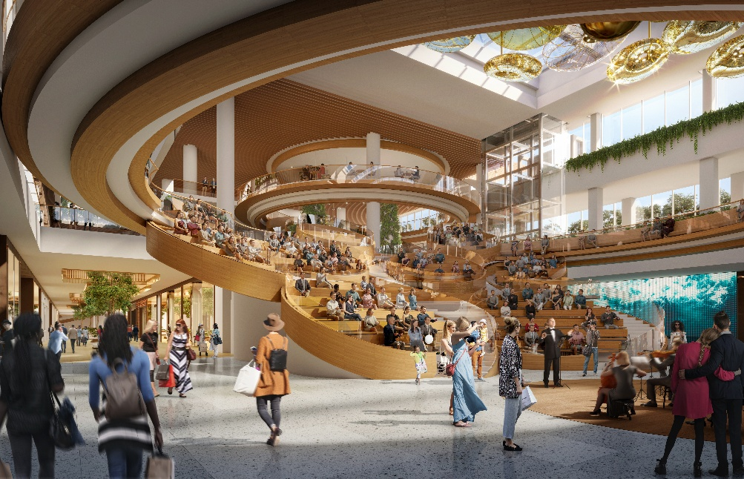

Rendering Courtesy of Oakridge Park
Vancouver, BC (October 9th, 2025): Oakridge Park, Canada’s largest redevelopment from QuadReal Property Group and Westbank., is setting a new standard in Vancouver’s luxury retail scene. As part of this world-class destination, a collection of prestigious global brands will make their debut in Spring 2026, transforming the city’s retail landscape and offering an unparalleled shopping experience. Several esteemed returning brands also reaffirm Oakridge Park as a leading shopping destination in Canada.
The latest brands joining Oakridge Park and solidifying Vancouver's position as a premier global shopping hub include:
- Loewe: The Spanish heritage brand celebrated for its contemporary leather craftsmanship and artistic collaborations will join the curated collection of global fashion houses with its first standalone boutique in Vancouver at Oakridge Park.
- Loro Piana: Renowned for its unrivaled quality in cashmere and fine textiles, Italian label Loro Piana will introduce its refined elegance to Oakridge Park.
- Valentino: Renowned for its timeless elegance and iconic craftsmanship, Valentino will make its mark at Oakridge Park.
- Dolce & Gabbana: Oakridge Park will be home to the Italian luxury fashion house’s first standalone store in Vancouver.
- Thom Browne: Known for redefining classic tailoring with a distinct American sensibility, across luxury menswear, womenswear, childrenswear, accessories and home, Thom Browne will soon make a striking debut at Oakridge Park.
- Acne Studios: The Stockholm-based fashion house known for its minimalist designs, high-quality materials, and contemporary Scandinavian aesthetic will be opening its first boutique in Vancouver
Contemporary, beauty and wellness retailers joining Oakridge Park include ALO, Sporting Life, Veronica Beard, Sandro, Maje, Petit Pont, Sisley Paris, Sephora, Diptyque, Lush Brow Bar and Mophead. Returning to the centre are retailers, BOSS, Coach and Swarovski.
“Oakridge Park is poised to redefine Vancouver’s luxury retail landscape with the arrival of these additional world-renowned brands," said Chrystal Burns, Executive Vice President, Canadian Retail Experience at QuadReal Property Group. "As the city continues to attract global attention, this new development offers an unparalleled shopping experience that perfectly complements Vancouver’s vibrant culture. The centre is set to become the focal point of the city’s evolution, meeting the needs of consumers, travellers and the community."
Leading up to the centre’s opening, Oakridge Park continues to introduce new experiences that connect fashion, beauty and innovation. This season, the centre launches The Autumn Palette, a six-week pop-up experience running from October 16 to November 20 inside the Oakridge Park Gallery. The activation offers guests a curated journey through colour, style and self-expression, including a 1:1 colour analysis and personalized styling session. Participants will receive a full-sized Dior lip butter matched to their ideal shade, a custom initial charm and a personalized Fall lookbook curated by a Vancouver-based fashion stylist. Reservations are required and can be made at oakridgepark.com.
As one of Canada’s fastest-growing cities, Vancouver has become a key destination for global investment and tourism. With a population exceeding 2.6 million in the metropolitan area, Vancouver continues to be a major player on the international stage, particularly in sectors like luxury retail and real estate.

With a sophisticated showcase of 100+ premier brands across 650,000 square feet – including Alexander Wang, Arc’teryx, Aritzia, BC Liquor, Brunello Cucinelli, Bvlgari, Canada Goose, Chaumet, Chow Tai Fook, Christian Louboutin, David Yurman, Green Tee Golf Shop, Harry Rosen, Jacob & Co., Louis Vuitton, Lululemon, Maison Margiela, Max Mara, Miu Miu, Moncler, Prada, Rolex, Safeway, TAG Heuer, TUDOR, and Tiffany & Co., – Oakridge Park is set to become Vancouver’s new retail hub.

Beyond retail, Oakridge Park will be a multi-faceted destination, defined by experience, culture and community. Spanning 28 acres, the first phase of the development features four residential towers, office space, a community centre and the largest library on Vancouver’s West Side, a nine-acre park, a one-kilometre running loop, and more. Oakridge Park will also enhance Vancouver’s already vibrant culinary scene with Time Out Market – a food and cultural market bringing the best of the city together under one roof – alongside other highly anticipated dining options.

About Oakridge Park

Co-developed by QuadReal Property Group and Westbank Corp., Oakridge Park serves as a bespoke and captivating cultural destination for Vancouver and is designed to seamlessly encompass every aspect of people’s lives — where living, working, and playing converge harmoniously, offering a space for inspiration, personal growth, and relaxation. Spanning over five million square feet and strategically designed around a sprawling nine-acre park, Oakridge Park creates a distinctive enclave within the expansive 28-acre footprint. A monumental redevelopment project, that stands out as one of Metro Vancouver's largest undertakings and ranking among the most significant ongoing transformations in North America, is poised to become an unparalleled addition to the city unlike anything Vancouver has ever seen.

Comprising residential, retail, office, public realm, civic, and cultural components, Oakridge Park is a world-class, master-planned community. Once fully completed, it will offer a top-tier retail experience totaling 650,000 square feet with 140+ leading global brands, including flagship and boutiques stores, accommodations for over 6,000 residents through 3,000+ residences, 700,000 square feet of meticulously designed office space for over 3,000 creative economy professionals, one of Vancouver’s largest community centres and busiest libraries, six dynamic indoor and outdoor live-music venues, and will be home to the second Time Out Market in Canada. www.oakridgepark.com

Media Resources - Vancouver's Cultural Hub (oakridgepark.com)

About QuadReal Property Group
QuadReal Property Group is a global real estate investment, development, and operating company headquartered in Vancouver, British Columbia. Its assets under management are $94 billion. From its foundation in Canada as a full-service real estate operating company, QuadReal has expanded its capabilities to invest in equity and debt in both the public and private markets. QuadReal invests directly through operating platforms in which it holds an ownership interest and via programmatic partnerships.

QuadReal seeks to deliver strong investment returns while creating sustainable environments that bring value to the people and communities it serves. Now and for generations to come.

QuadReal: Excellence lives here.

www.quadreal.com

About Westbank
Westbank is a practice dedicated to the creation of inspiring environments. Established 30 years ago, we are a private company that concentrates primarily on large projects in our core cities of focus: Vancouver, Toronto, Seattle, Tokyo, and San Jose. As a global leader in net zero development and the co-owner of one of North America's largest district energy providers, we are committed to largescale net zero carbon initiatives. Our body of work includes residential, hotels, retail, creative workspace, district energy, affordable housing, exhibitions, and public art, with over $50 billion of projects completed or under development. As our practice has evolved, we have woven together an ecosystem of cultural enterprises, including restaurants, gyms, spas, music venues, private members clubs, fashion, dance schools and food halls. We bring this ecosystem to life through collaborations with some of the most talented artists, architects, designers, and entrepreneurs in the world. We look for every opportunity to strengthen the bonds that unite us – to bring people together and help build more inspiring, sustainable communities. Through these and other endeavours, our evolution continues as we become a cultural platform for the creative city.

https://westbankcorp.com/

###

