TOP END SAFARI

6 DAYS (ESCORTED)

LORD'S SAFARIS, DAVIDSON'S ARNHEMLAND SAFARI CAMP & BAMURRU PLAINS
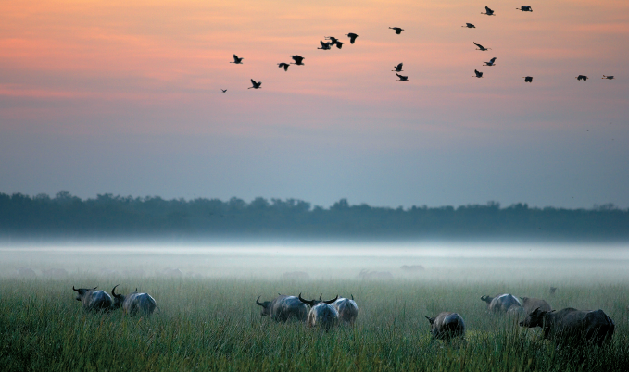

Day 1
Depart Darwin for the start of your Top End Safari.
Our first stop en route is Fogg Dam Reserve - an important feeding and roosting site for a wide variety of both water birds and other animals. Next we travel on to the Adelaide River where we have the opportunity to witness the fabulous jumping crocodiles and other wildlife. A short detour off the highway is the beautiful Leaning Tree Lagoon; this billabong is often covered in water lilies making it a popular stop for photographers.
Lunch is at the Bark Hut Inn; this Aussie roadhouse was built during the buffalo era and is a reminder of earlier, wilder times.
Our last stop for today is at Cooinda - Here we will experience one of Kakadu's icons - a Yellow Water Cruise. This 10sq. km pristine environment supports a truly wonderful variety of plants, birds, crocodiles and Top End wildlife.
Overnight: Camping (Private Permanent bush camp) (L, D)
Day 2
Today we visit Aboriginal Lands (Arnhem Land) access to this area is restricted to a select group of tour operators. While we are in Arnhem Land a traditional Aboriginal guide will show you excellent examples of rock art on Injalak Hill (Long Tom Dreaming). This area has some of the best rock art examples in Western Arnhem Land and some say Australia. At the award winning Injalak Arts and Crafts Centre there is time to watch the traditional Aboriginal people painting and to see the women weaving pandanus baskets.
After leaving the Injalak Art & Craft Centre we head onto Davidson's Arnhemland Safaris situated in the North West corner of Arnhemland and adjacent to Kakadu National Park and Coburg Peninsular in Australia's Northern Territory. Access to the safari lodge is by 4WD during the dry season (May-October).
The camp is fully licensed and has a wide selection of wines, spirits and beer. The facilities are situated in a natural bush setting. The centre of the lodge is a new and tastefully furnished communal area encompassing a dining room, lounge, bar, library, internet zone and a large outdoor deck area for alfresco dining, all over looking the sandstone paved pool.
Overnight: Davidson's Arnhemland Safaris (B, L, D)
Day 3
Davidson's Arnhemland Safaris at Mt Borradaile is a registered aboriginal sacred site in a remote 700sq-km, exclusively leased area nestled against the Arnhemland escarpment.
While at Davidsons we shall enjoy a range of activities and attractions, from fishing, Aboriginal rock art, a billabong cruise to the unique landscape.
Overnight: Davidson's Arnhemland Safaris (B, L, D)
Day 4
After leaving Davidson's we then head onto Bamurru Plains which is an exclusive wildlife experience on the magnificent Mary River floodplains. Located on Swim Creek Station, this safari-style camp is surrounded by savannah woodland teeming with an amazing assortment of wildlife, reptiles and birds. The camp boasts comfortable free-standing safari bungalows that are spacious and expose guests to the sounds of the floodplains, a dining area with commanding views across the vast wetlands, a 10 metre wet edge pool and a library. We will experience a sunset over the floodplains while enjoying a glass of wine.
Overnight: Bamurru Plains (B, L, D)
Day 5
While we are at the camp we shall enjoy a variety of activities, from airboat rides to four wheel drive safaris. The floodplains abound with waterfowl, wild buffalo and wallabies. The floodplains of the Mary River region form one of the most significant ecosystems in Australia. Dominated by the climatic extremes of the tropical monsoon, the wetlands and savannah woodlands that fringe the coastal regions between Darwin and Kakadu National Park harbour an extraordinary diversity of flora and fauna. This morning we will take an airboat ride across the floodplains of the Mary River catchments.
Overnight: Bamurru Plains (B, L, D)
Day 6
The morning chorus of tens of thousands of Magpie Geese, after whom the camp is named, is an experience in itself. The Mary River catchments are home to some 236 species of bird, many of which are found at Bamurru Plains. The significance of this particular property comes in the variety of habitat: black soil floodplains, paper bark swamps, savannah woodland, river mangroves and coastal beaches support an extraordinary diversity of birdlife.
Return to Darwin in the afternoon.
