outback adventure

5 nights

BULLO RIVER STATION, BAMARRU PLAINS
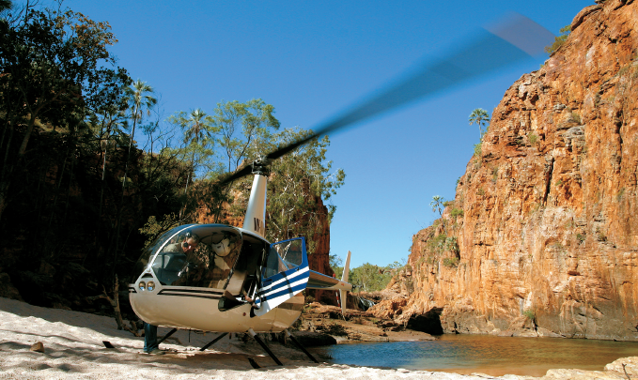

Day 1
Depart Darwin accommodation on charter flight to Bullo River Station
Bullo River Station is situated on 500,000 acres in the remote outback of the Northern Territory in what is referred to as the East Kimberley region, on a busy working cattle station. This is a Top End cattle station (ranch) from the classic mould. Half a million acres of grassy plains with Brahman-cross cattle and many more wallabies, brown rivers where crocodiles lurk on the muddy banks, rugged hills inscribed with Aboriginal rock art, gushing streams and crystal clear swimming holes, termite mounds, boab trees, stock horses, wild buffalo, and a few great yarns to tell. Guests have the opportunity to enjoy endless activities at Bullo River.
Overnight: Bullo River Station (L,D)
Day 2
A 4WD safari on the property offers the opportunity to explore the vast and beautiful landscape of the area and showcases the abundance of wildlife, flora and Aboriginal art sites while taking in the spectacular scenery.
Overnight: Bullo River Station (B,L,D)
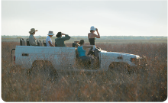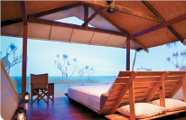
Day 3
Visit Aboriginal rock art sites and discover more about this ancient culture with one of our guides. The station is home to a number of galleries of dramatic Aboriginal rock art, and each year, Franz and Marlee uncover more sites. Combine this with a river cruise up the spectacular Bullo River Gorge to fish or spot crocodiles, or simply take in the pristine landscape that is northern Australia.
The view of Bullo's vastness from a chopper is truly breathtaking and comes highly recommended. There are several large freshwater swimming holes and waterfalls high up in the escarpment away from the crocodiles which can only be accessed by helicopter and whilst it is an additional cost, this is a wonderful way to explore parts of the property that are inaccessible by any other means
Overnight: Bullo River Station (B,L,D)
Day 4
Following a hearty breakfast, take a 90-minute Charter flight to Bamarrru Plains.
Bamurru Plains is located just to the west of Kakadu National Park on the Mary River floodplains. A profusion of bird and wildlife are on the doorstep of a unique bush lodge that exudes 'Wild Bush Luxury' and brings a touch of style to the discovery of a remote and beautiful wilderness
View the wildlife with a wetlands airboat tour - the floodplain wetlands of the Mary River catchment are the key natural feature of this area and some of the most important in the country, home to thousands of Magpie Geese, Plumed Whistling-Duck, Egrets, Ibis and a host of other birds. Enjoy sundowners before a sumptuous gourmet dinner.
Overnight: Bamurru Plains (B,L,D)
Day 5
Cruise the Sampan Creek, which is part of the Mary River System, and forms the western boundary of the station This system harbours one of the largest crocodile densities in the world. But it's not just the crocodiles, many bird species call this mangrove-lined environment home. Relax in the shade provided on our canopy covered cruise as you meander along this creek system, learning about these animals from our skilled guides
Spend the afternoon bird watching - the Mary River catchment is home to some 236 species of bird, many of which are found at Bamurru Plains. The significance of this particular property comes in the variety of habitat black soil floodplains, paperbark swamps, savannah woodland, river mangroves and coastal beaches support an extraordinary diversity of birdlife.
Overnight: Bamurru Plains (B,L,D)
Day 6
After breakfast take a 30-minute charter flight to Darwin.
Return to Darwin
